31/1/24

6. Outline the role of an accountant working for a small business.
The essential role of an accountant is to provide managers with the information they need to maximise the entity’s financial performance, and may include several functions, including recording financial transactions, producing financial reports for the information of managers and other relevant 3rd parties.

12. Define and explain the purpose of management accounting.
The process of producing reports and providing useful financial information for decision-making purposes to the managers of an enterprise in the daily management of trading operations.

13. Define and explain the purpose of financial accounting.
The process of producing general purpose financial reports used by external parties such as shareholders, investors, lenders, suppliers, customers, employees and government.

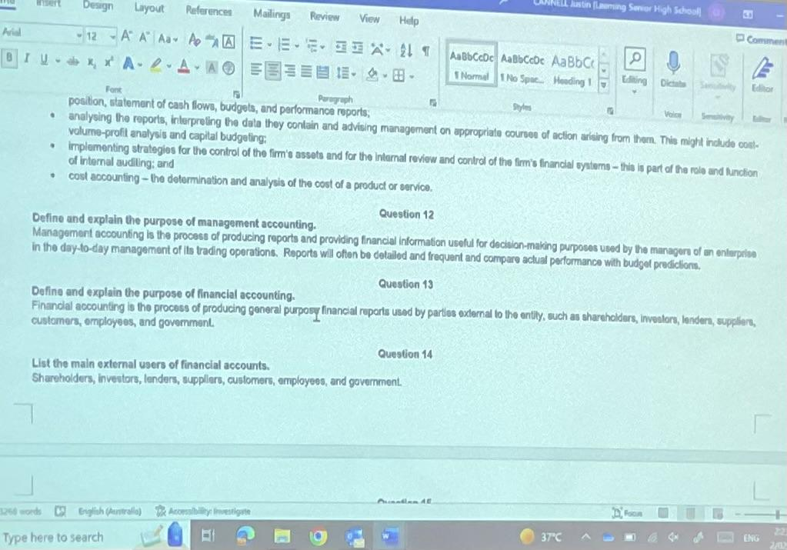

2/2/24

14. List the main external users of financial accounts.
Shareholders, investors, lenders, suppliers, customers, employees and government.

15. What types of enterprises need to have their accounting systems and reports regulated?
Public companies. This is to protect shareholders as they rely on these reports as their sole or main source of information to assist them in making economic decisions about that organisation (e.g., whether to buy, maintain or sell a shareholding in it).

16. What is a ‘reporting entity’ as defined by SAC 1? Give two examples.
An organisation that must comply with standards in the production of its financial reports.
- Public company
- Large proprietary companies

17. What is a ‘general purpose financial report’ as defined by SAC 2? What is the purpose of financial accounting?
A report whose users rely on it as their sole or main source of information to assist their economic decision making.

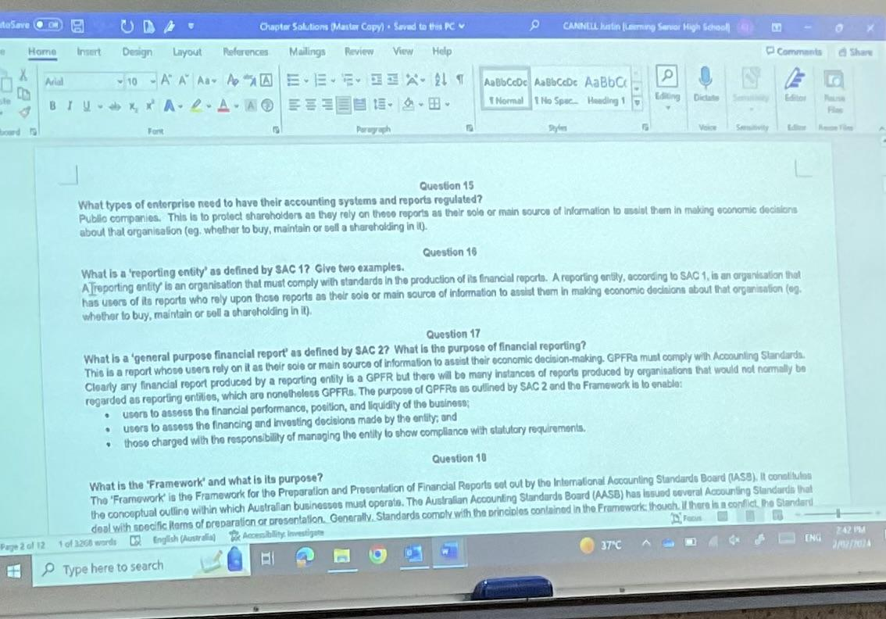

5/2/24
18. What is the ‘Framework’ and its purpose?
Up until 2005, the Framework defined the sort of organisation that needed to comply with Accounting Standards in the production of its financial reports and what those reports needed to include, and it consisted of four Statements of Accounting Concept. After 2005, Australia adopted the Framework for the

19. What is the role of an external auditor?
To check the company’s systems and records to ensure they have properly maintained them and that the reports at the end of the financial period accurately represent the company’s performance and position for that period.

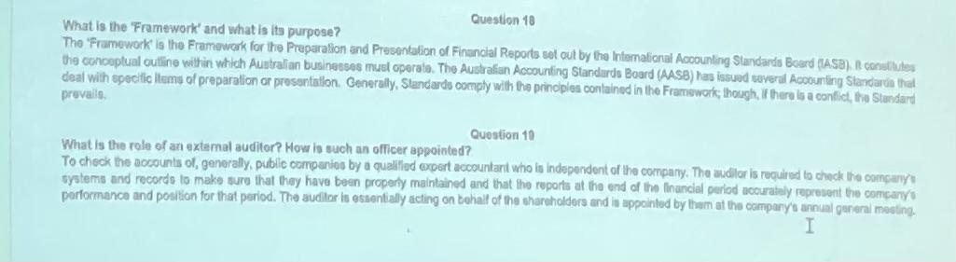

20. Outline the principles and purpose of internal control.
The principles of internal control include:
- segregation of duties
- Established lines of responsibility
- Appropriate security of assets and records
- Installation of mechanical and electronic devices
- Adequate recording and documentation systems
- Installation of verification and checking processes
- The existence of authorisation processes
- Employment of competent and reliable staff.

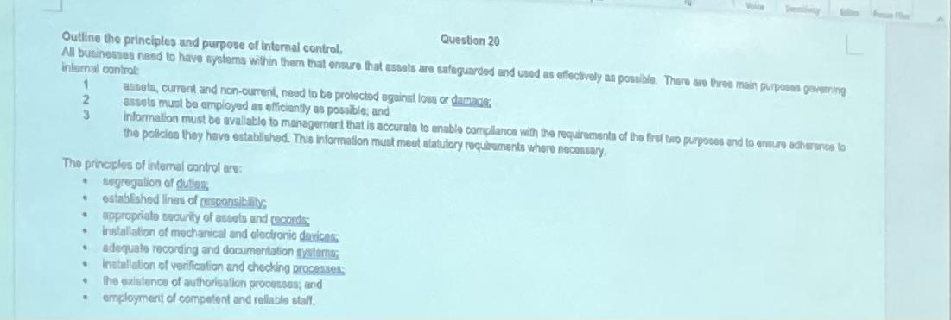

The purposes of internal control include:
- Assets, current and non-current, need to be protected from loss or damage
- Assets must be employed as efficiently as possible
- Information must be available to management that is accurate to enable compliance with the requirements of the first two purposes and to ensure adherence to the policies they have established. This information must meet statutory requirements where necessary.

21. State the main categories of assets over which a business must exercise control. Outline the reasons for and methods of control in each case.
- Cash control: requires systemic and separate authorisation of payments, proper documentation of receipts and payments, regular reconciliation with the bank’s records and an audit trail that will enable transactions to be traced, enabling the cause of any losses to be identified.
- Stock or inventory: The stock control system should ensure that the firm has the stock it needs, but not an excessive amount and that this stock is safeguarded against loss or damage. With the use of computers, firms can control their stock effectively. CCTV and electronic marking of stock items have also rendered shoplifting more difficult.
- Debtors: For firms which do a significant amount of their business on credit, their debtors may represent a large investment of resources. Firms need to ensure that the minimum amount of funds are tied up this way and that bad debts are minimised. Measures can include:
- Vetting credit customers -> avoid selling to those with poor credit history
- Identifying, by means of regular debtor’s reports, those who are not paying within the required period.
- Following up slow payers with reminders of increasing severity, which can culminate in legal action and/or the refusal to sell to that customer on credit until the debt is repaid.
- Non-current assets; Investment in non-current assets is a significant part of the total funds employed. It is clearly important that this investment be adequate but not excessive. These controls can include:
- Complete, up-to-date and accessible records of all assets so managers are aware of what is available, its age, location, cost, operating details etc.
- Operating policies for machinery and vehicles to ensure the safety and effectiveness of the assets and those who are operating them.
- Training of staff to ensure that those using assets will do as efficiently as possible.

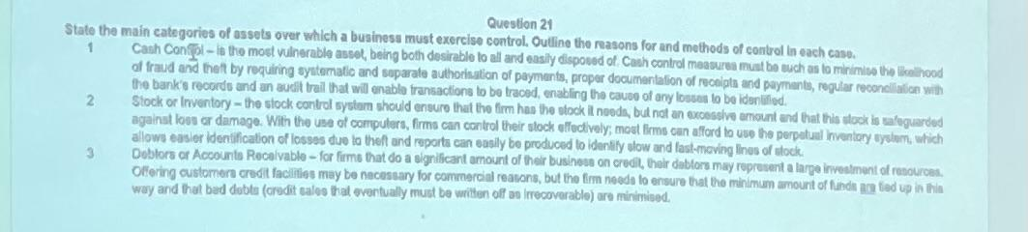

12/2/24
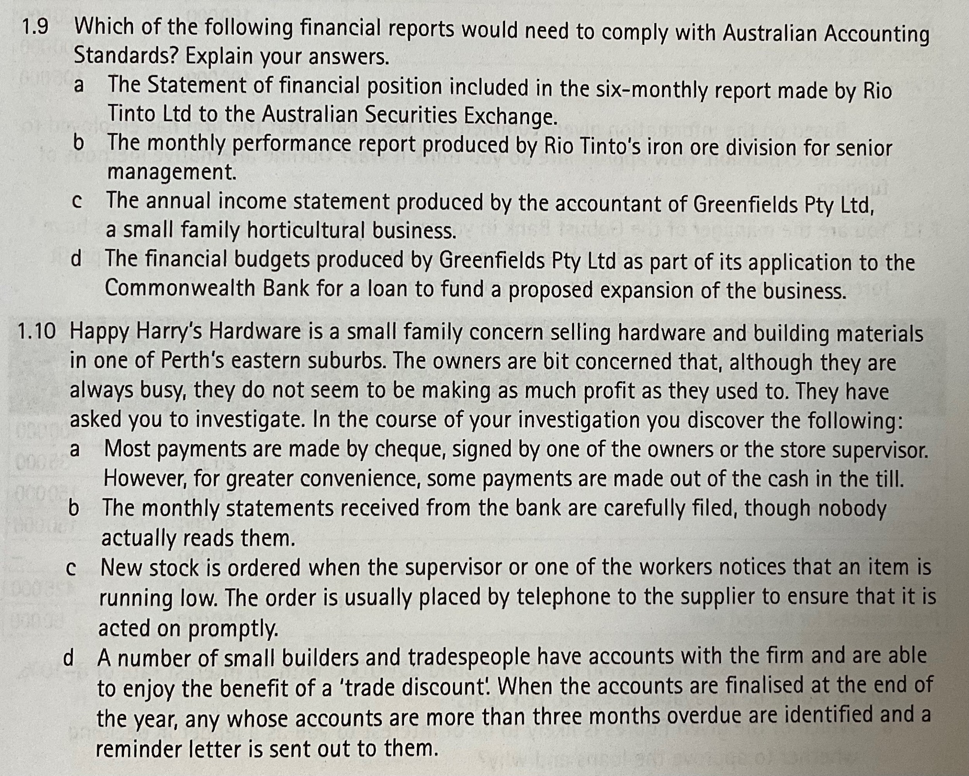

- a.
This is because Rio Tinto Ltd is a publicly traded company and the report is to be made for a party external to itself (I.e. the ASX) and as per SAC 1, it is a reporting entity (because they are an organisation with users who rely on those reports as their main source of information to assist them in making economic decisions.

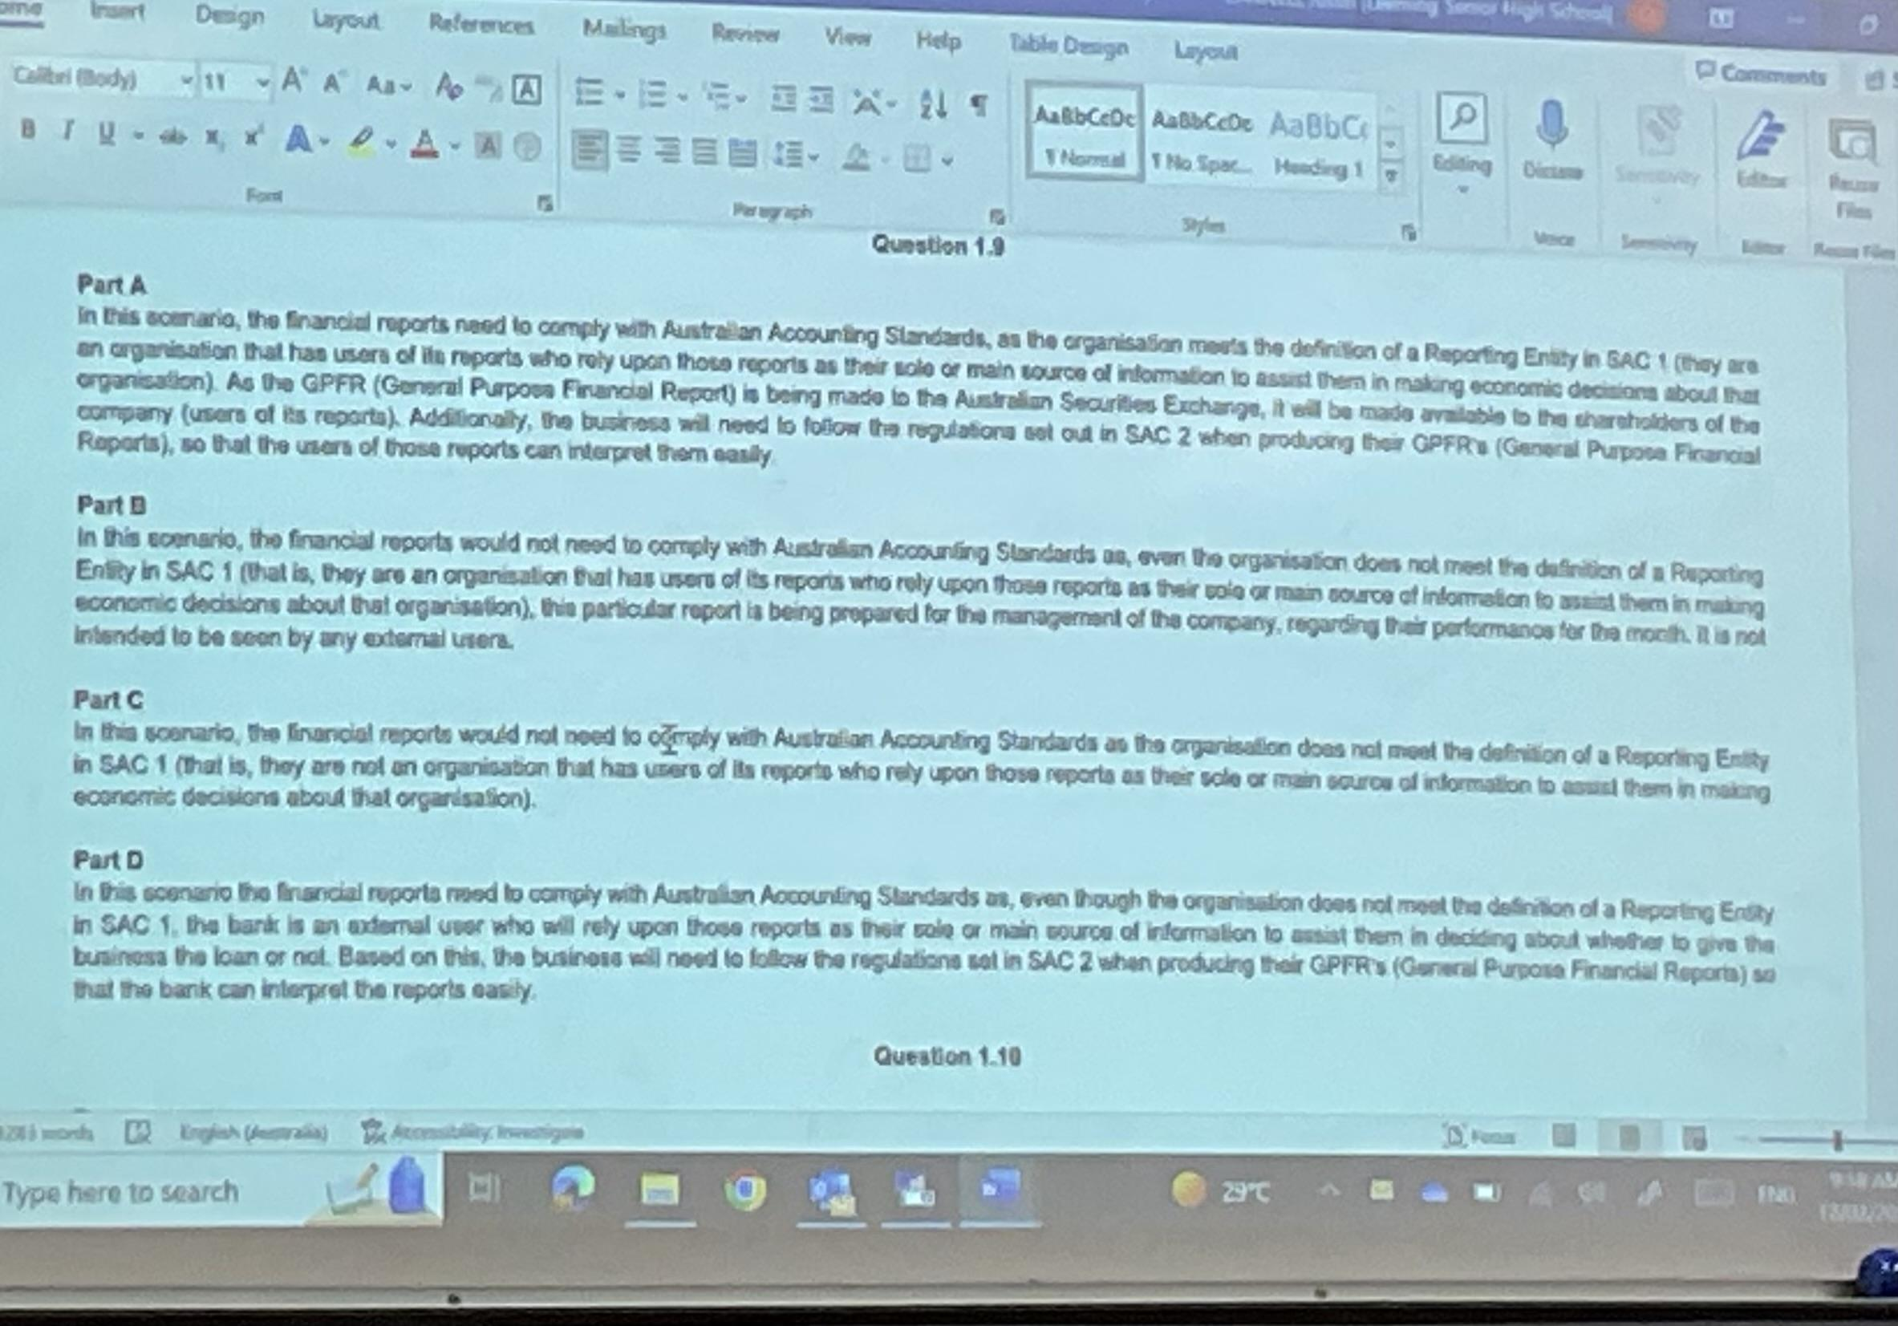
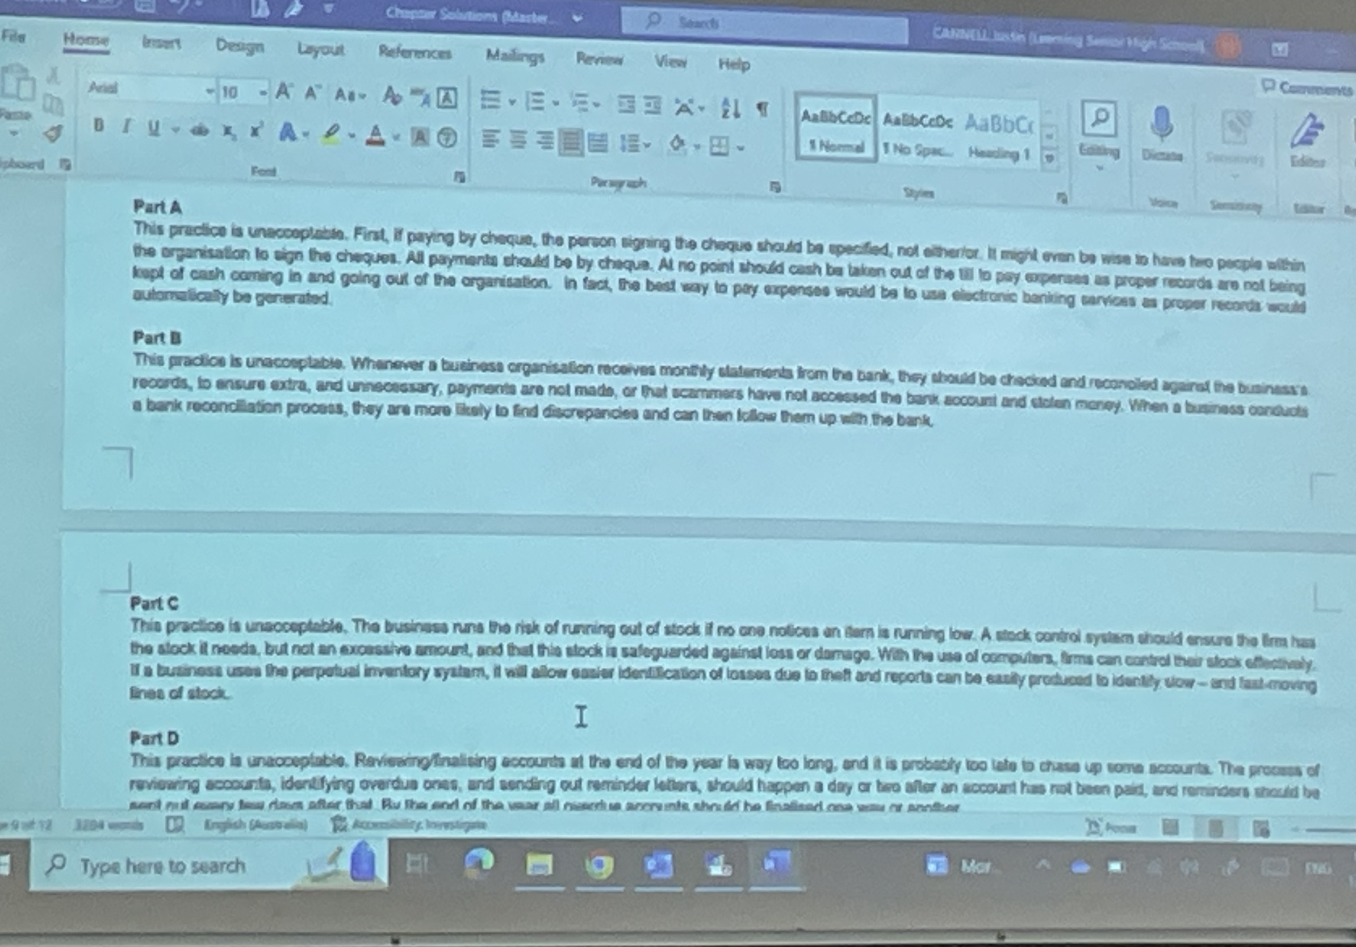

13/2/24
1.13
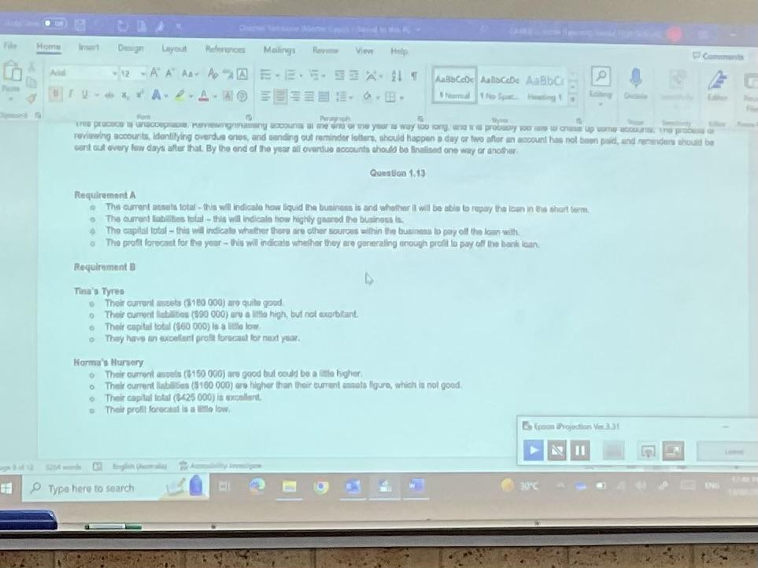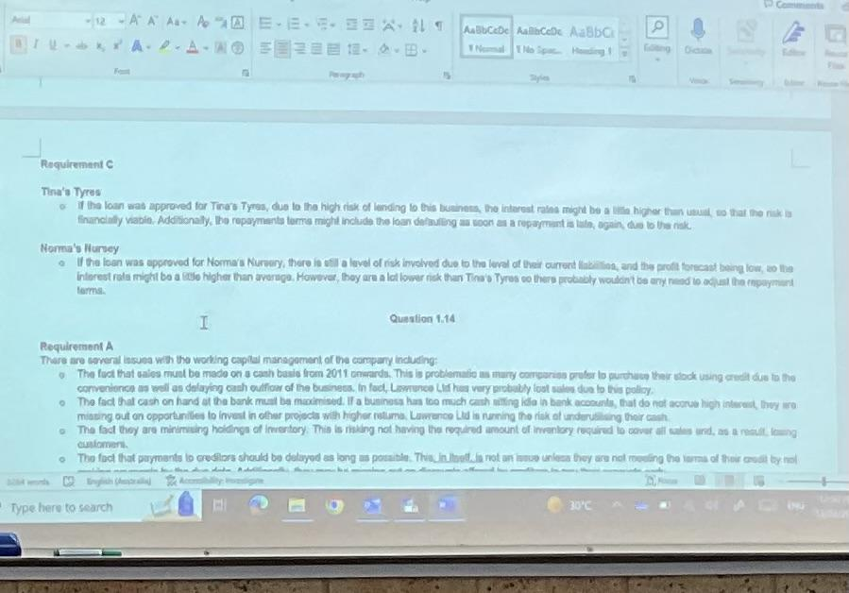

1.14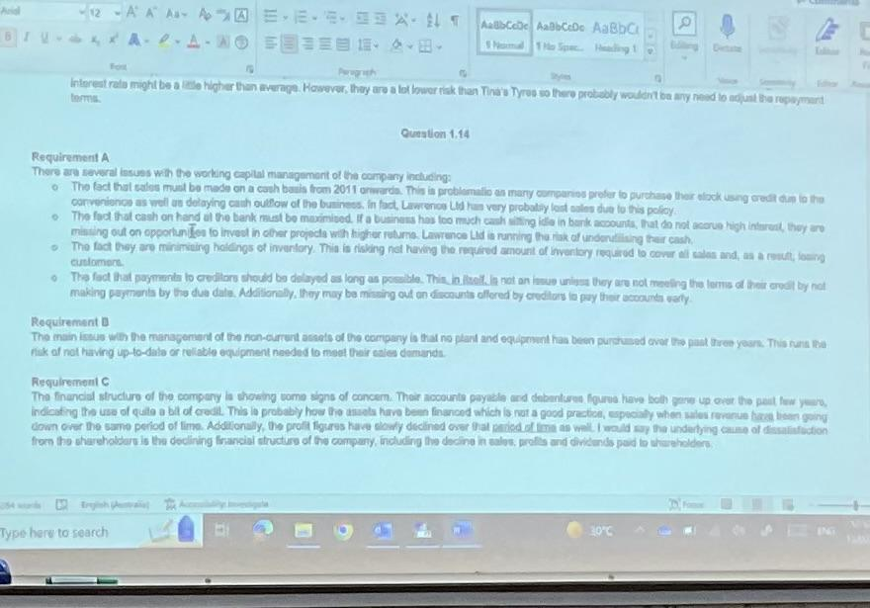

14/2/24

- Distinguish between a direct and indirect cost and give examples to illustrate the difference.
A direct cost is a cost that can be easily traced back to the product or service produced with a high degree of accuracy. Materials used directly to produce a good is an example of a direct cost. However, indirect costs cannot be easily and accurately traced to the product it is used to help produce. These items are either not incorporated into the product or are too insignificant to make it worth tracing the cost for. An example can include electricity used in a factory to run the machines.

- Why is the difference between direct and indirect costs important in a costing system?
Some costs can be direct in producing one product and then become indirect for another product. Hence, distinguishing between them is important because it allows for the determination of the cost of an object to be more accurate.

- What factors are likely to affect the classification of a cost as direct or indirect?

- What is meant by cost behaviour and why is it important to understand cost behaviours in a costing system?
Cost behaviour is the relationship of the cost to the cost object and this is important to understand in a costing system because depending on the cost behaviour, it can increase or decrease depending on business activity or stay the same and this is important to take into account when assessing the cost of business operations.

- Distinguish between fixed costs, variable costs and mixed costs and give examples to explain the difference.
Fixed costs are those that don’t change when the level of activity changes. For example, rent of a factory building won’t increase or decrease in price in accordance with how much is produced. However, a variable cost is liable to change with activity and an example of this is the raw materials used to manufacture goods which will obviously increase as more computers produced means more raw materials needed to make them. Lastly, mixed costs contain elements that are both variable and fixed, for example, a telephone bill contains the line rental cost (fixed) and the cost of phone calls made (variable).

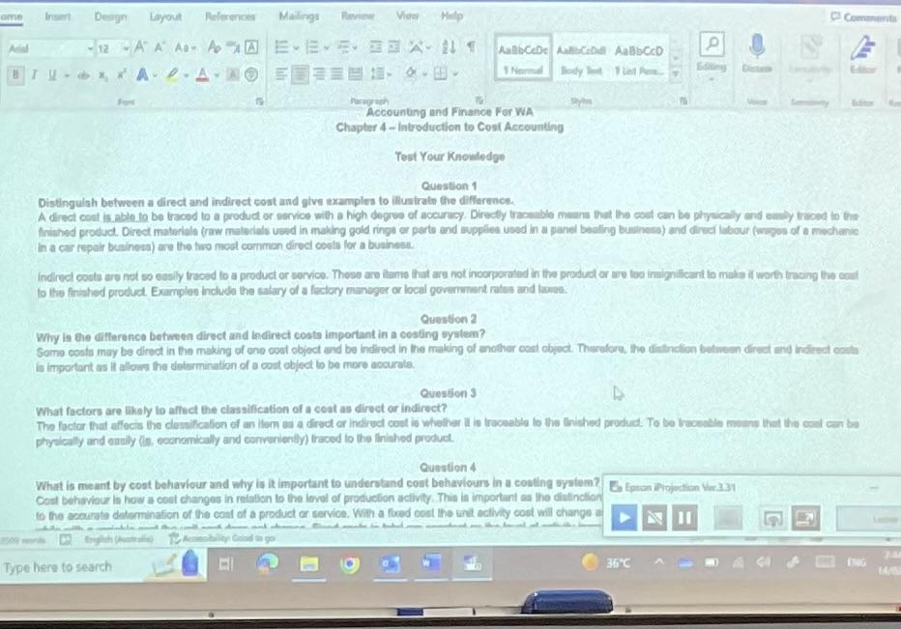
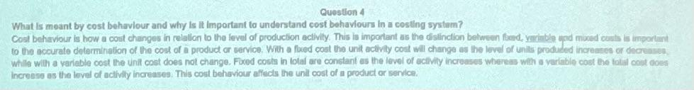
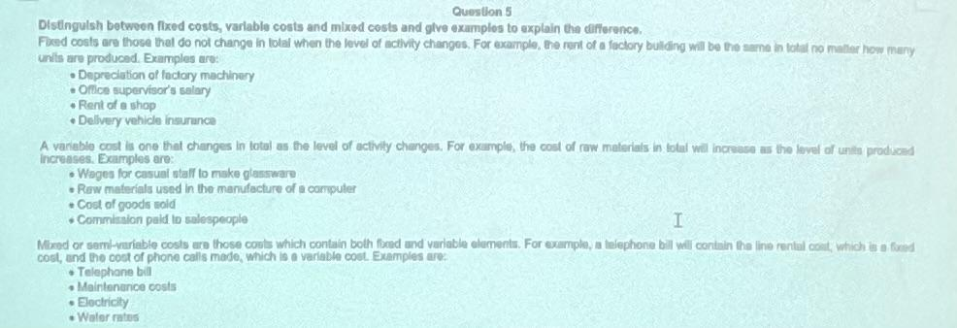

19/2/24
- Define each of the following and give an example of each for a manufacturing, merchandising and service business: direct materials, direct labour and overheads.

Direct materials: raw materials that are directly traceable to the product being made.
- 1. Manufacturing- buttons in the making of a suit
- 2. Merchandising-
- 3. Service-

Direct labour: amount paid to the employees that is traceable to the finished product.
- 1. Manufacturing- machine operators in a factory
- 2. Merchandising- retail store workers
- 3. Service- panel beaters fixing cars

Overheads: manufacturing overheads represent costs that aren’t direct materials or labour, but still part of the manufacturing process.
- 1. Manufacturing: factory building insurance
- 2. Merchandising: rent of the shopfront
- 3. Service: cleaners of a restaurant (indirect labour)

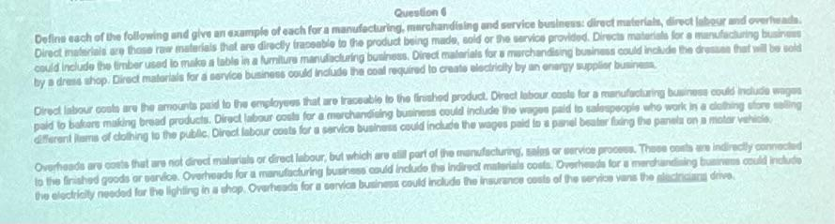

- What are non-manufacturing costs?
Costs of operating a business that aren’t incurred in the manufacturing process (also known as period costs). Can be further categorised as selling or marketing costs, distribution or transport costs, administration costs and financial costs.

- Distinguish between a product cost and a period cost.
Product costs include all costs that are attributable

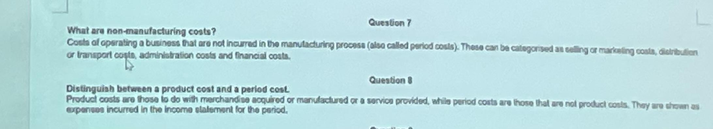

- Clothing factory equipment maintenance: indirect cost
- Wages of vehicle factory assembly workers: period cost
- Salaries of marketing staff: non-manufacturing cost
- Depreciation of office equipment in a law practice: indirect cost
- Surfboard factory supervisor’s salary: indirect cost

20/2/24

- What is cost accounting and how is it useful to the management of a business?
The measuring, analysing, recording and reporting on the cost of a product or service. It is useful for managing a business because:
- control of costs: comparing actual product costs with planned costs and, if necessary, taking corrective action so that the predetermined targets are met in the future.
- Planning: using past product costs to estimate future product costs
- Inventory valuation: calculating the value of products that are complete (finished goods) and products that are partially complete (work in progress) at the end of each accounting period for inclusion in the financial statements.
- The settling of selling prices: often set with reference to the cost of the product or service
- Determining profitability: management can determine if it is worth producing or selling the product or service.

- Define absorption costing.
The method whereby all fixed manufacturing costs and variable manufacturing costs are included in the product cost.

- Describe a job order costing system.
It is the process of recording all the costs of a distinct product or service. It is used when a business creates a single unit or multiple units of a distinct product, makes a product to a customer order or provides a service to meet specific customer requirements.

- What is a predetermined overhead application rate?
It allocates the indirect costs of production to the actual quantity of the product or service produced. Calculated by dividing the budgeted manufacturing overhead cost by the budgeted allocation base.

- What is a normal costing system?
It determines the cost of a product or service with job order costing using actual direct materials, actual direct labour and a predetermined overhead rate.

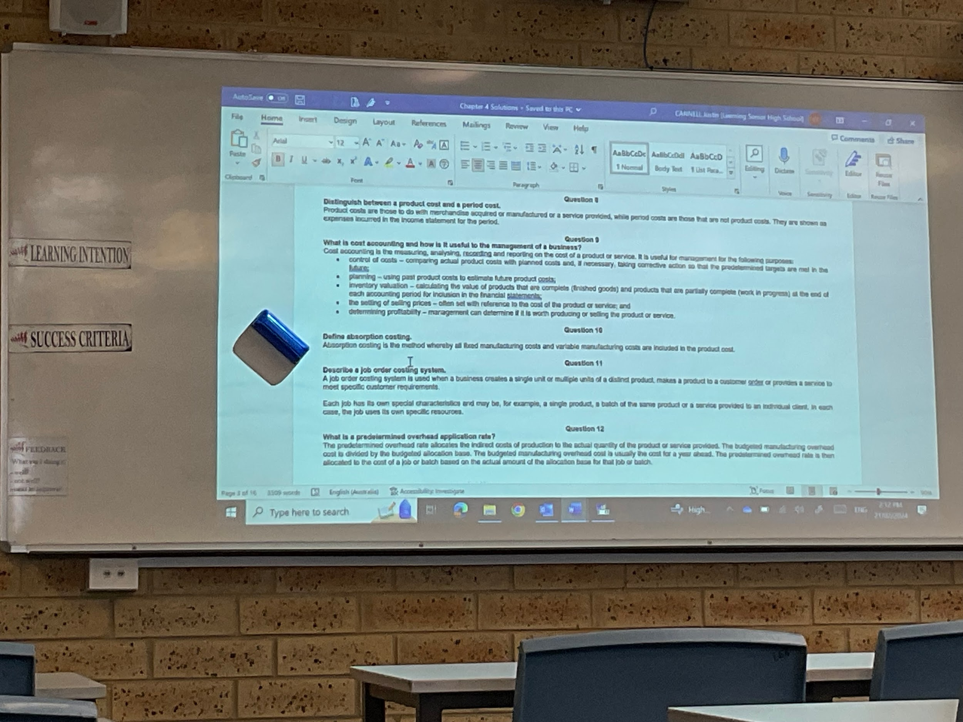

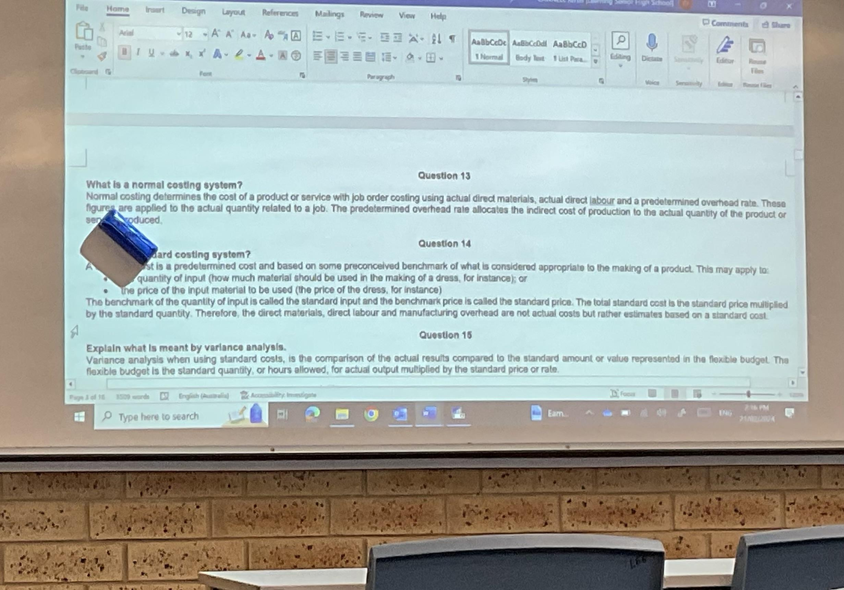

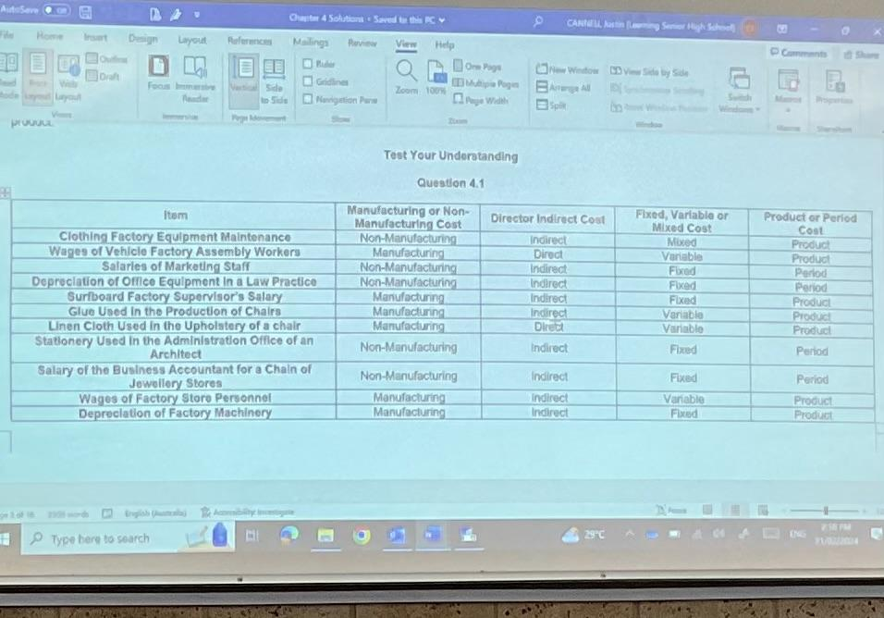

21/2/24
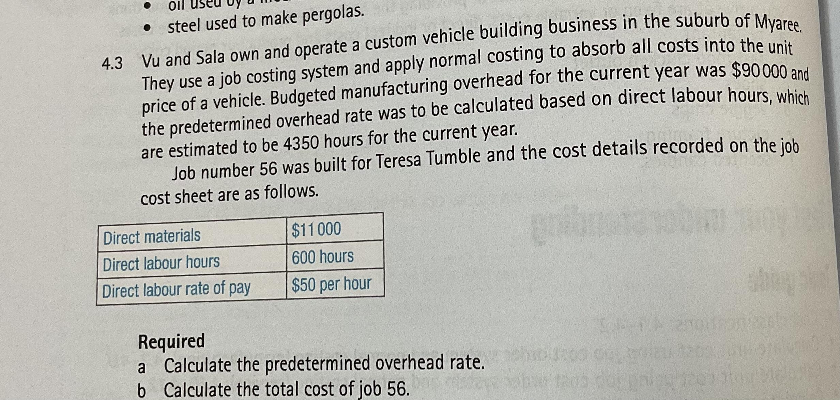
- 90000/4350 = $20.69
- 20.69(600) + 50(600) + 11000 = $53413.40

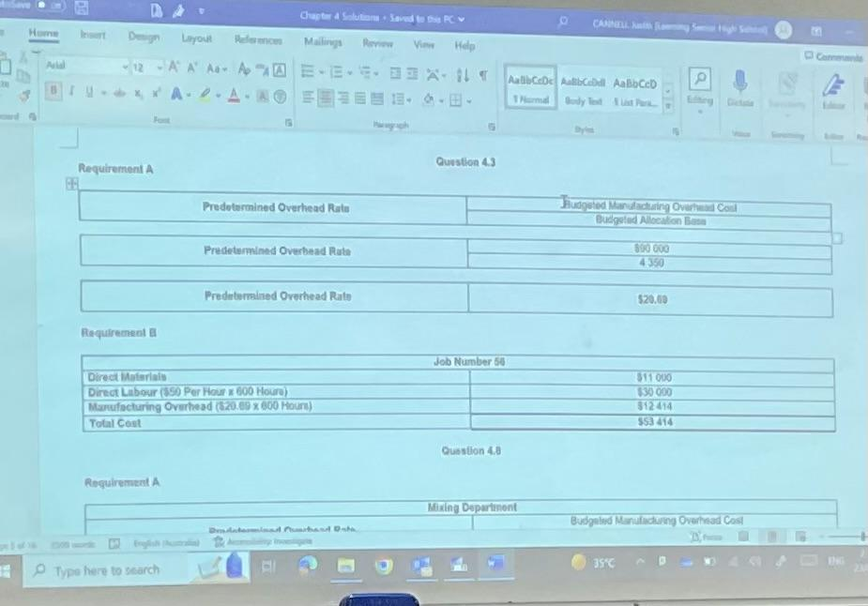

23/2/24

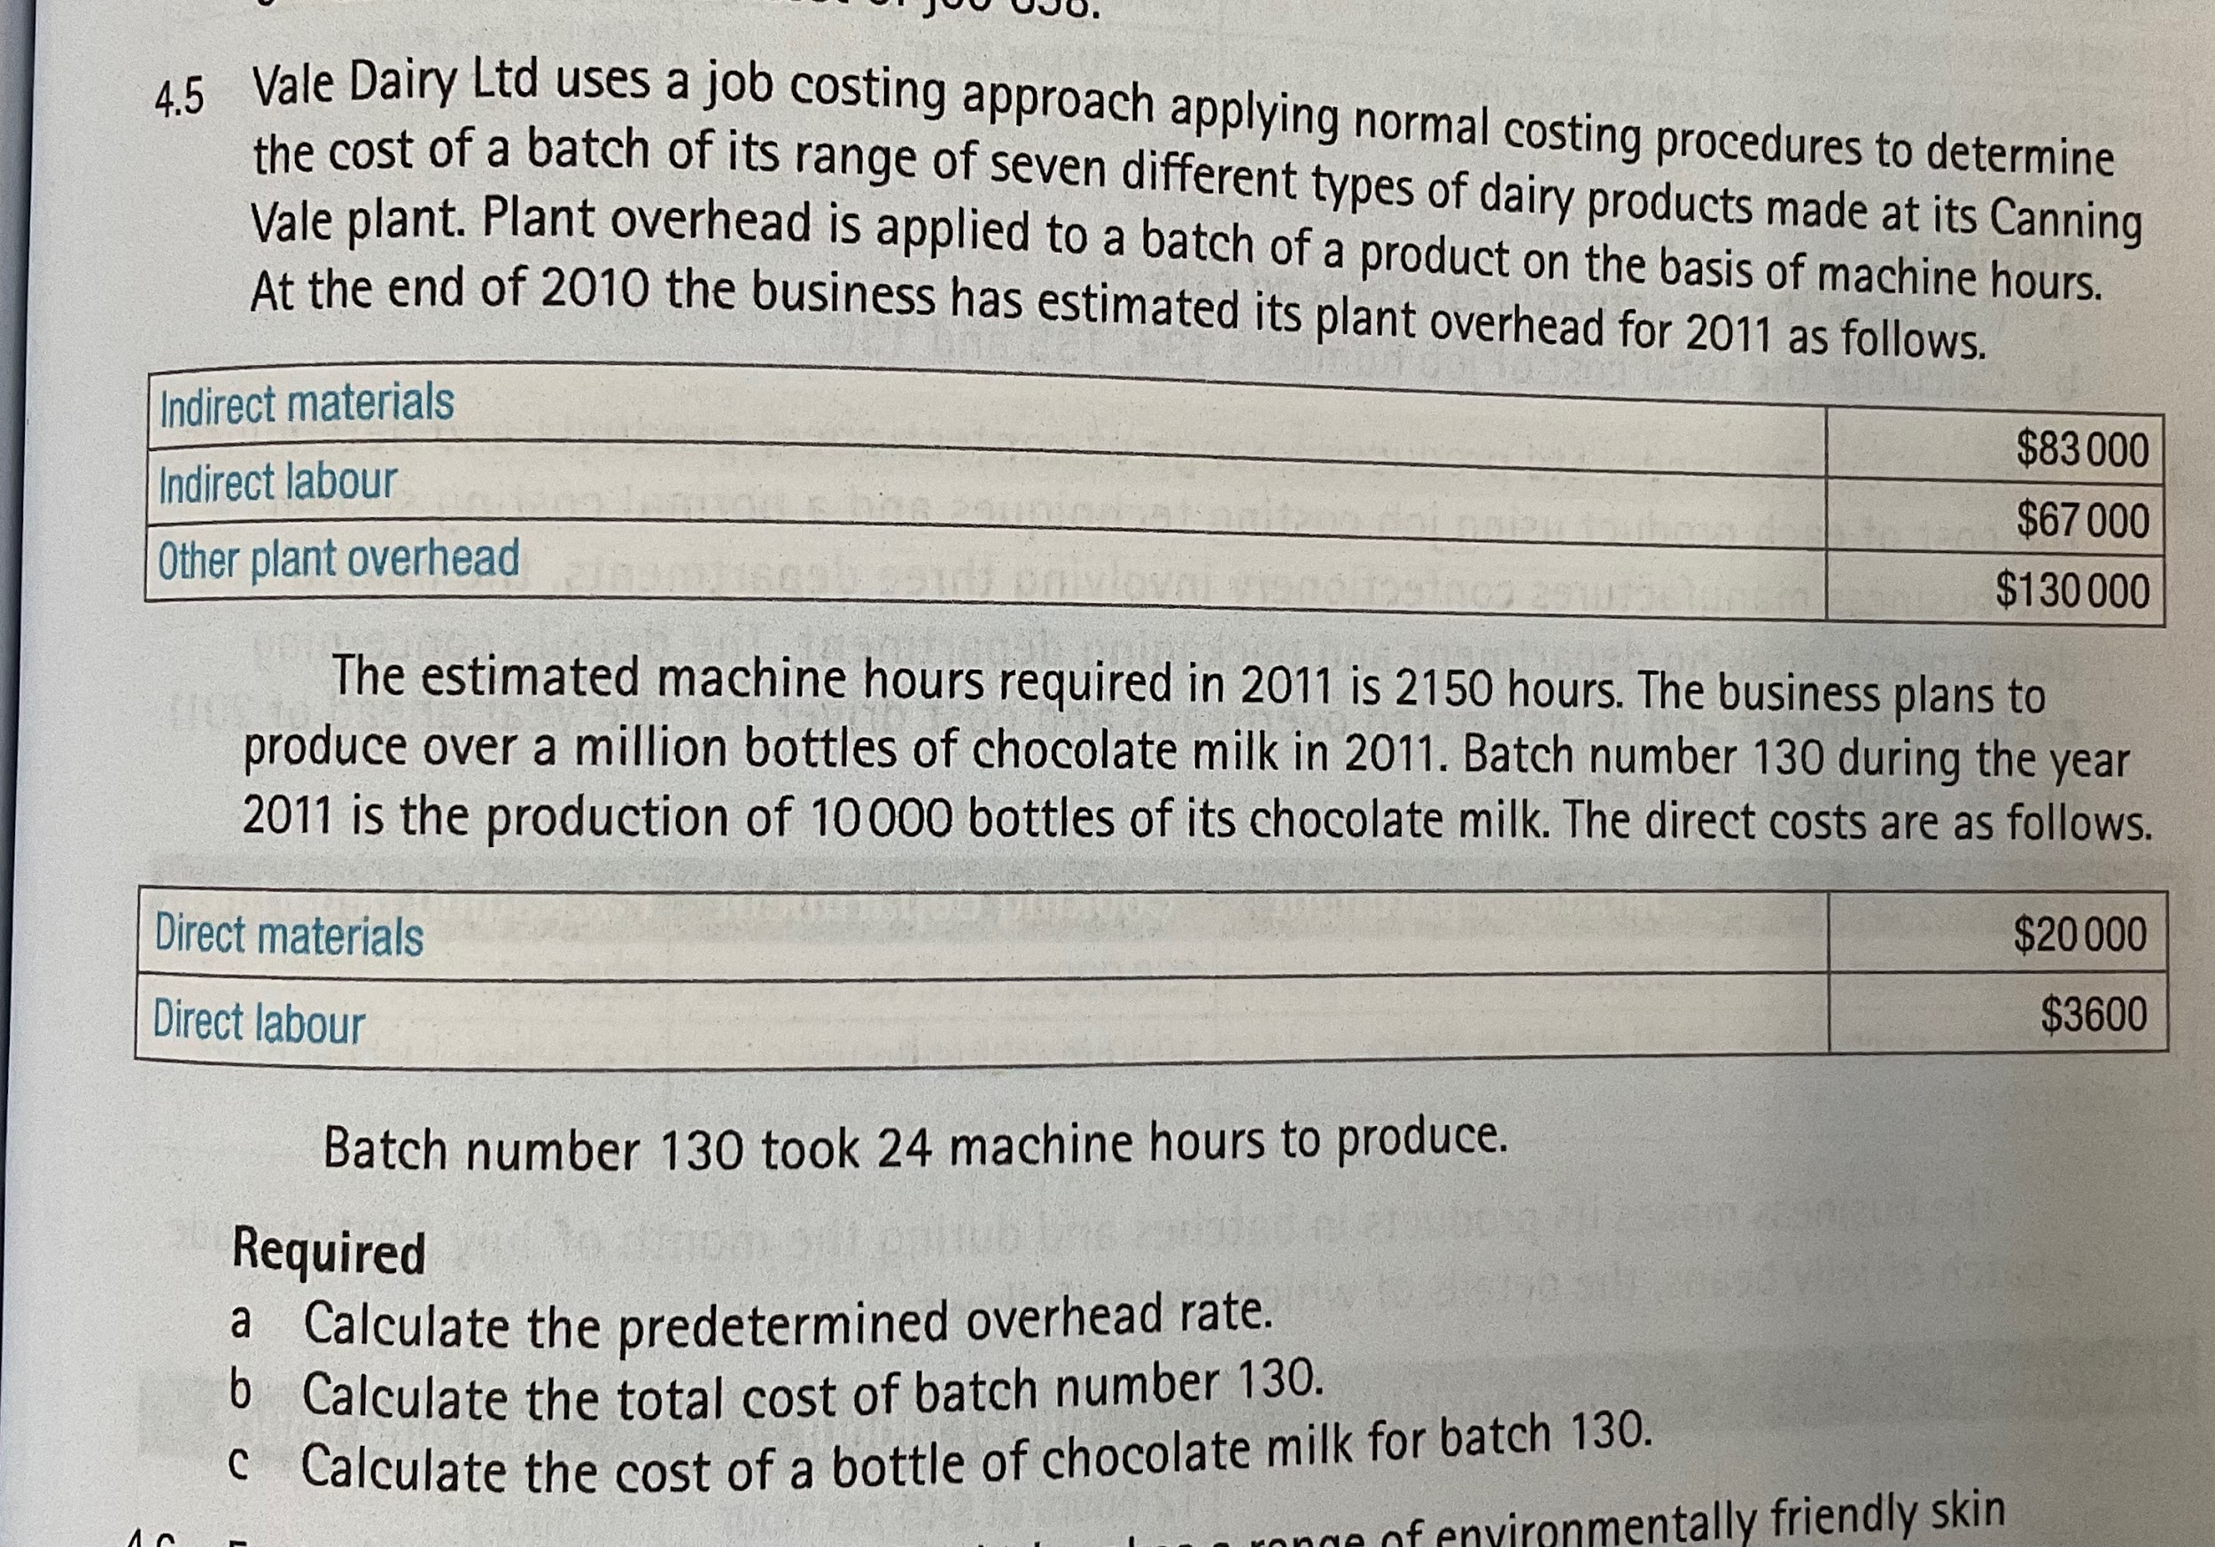

- 130000 / 2150 = $60.47
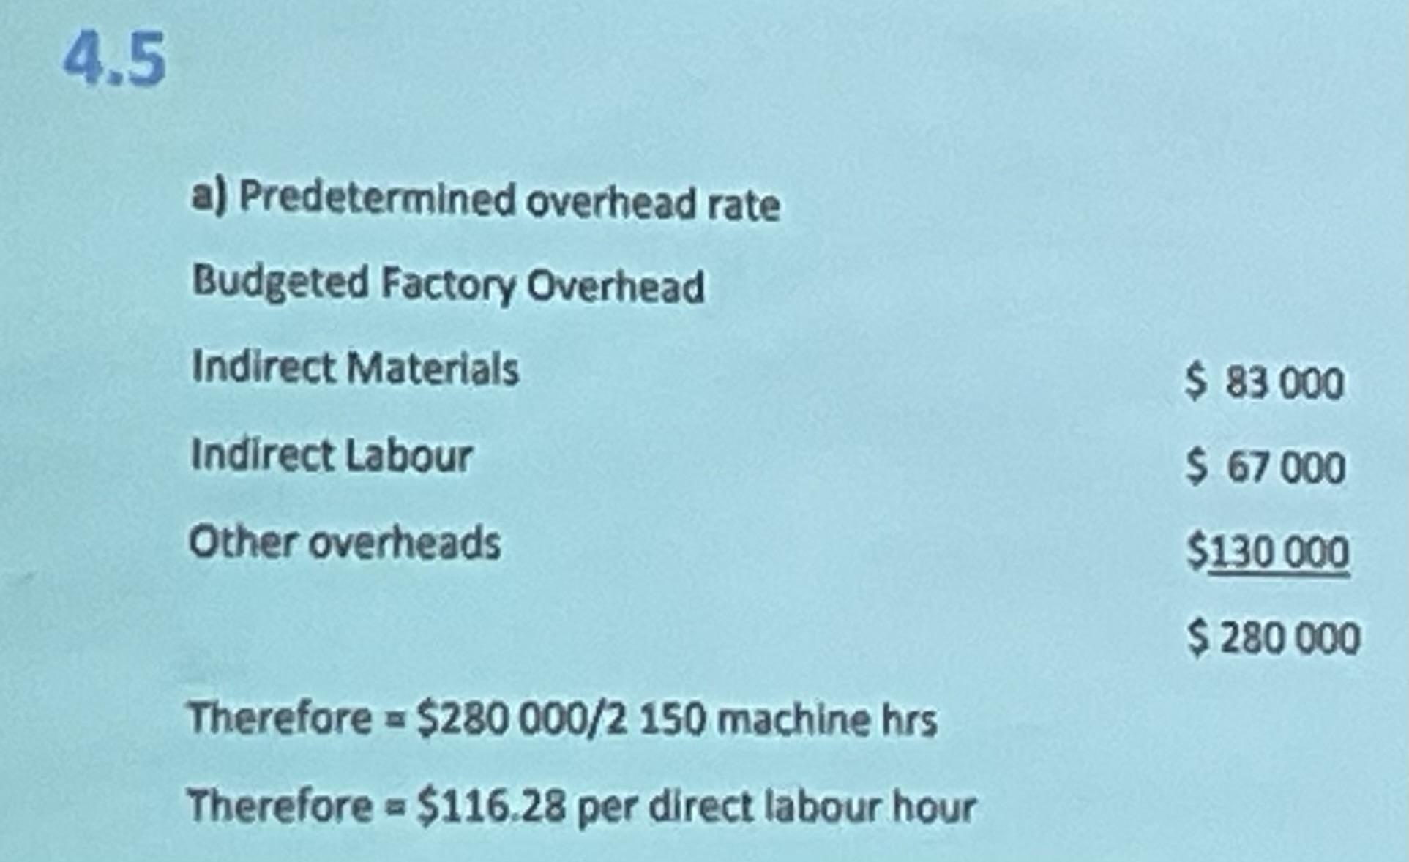
*$130.28 per direct labour
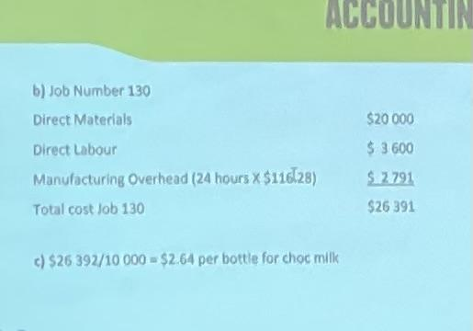

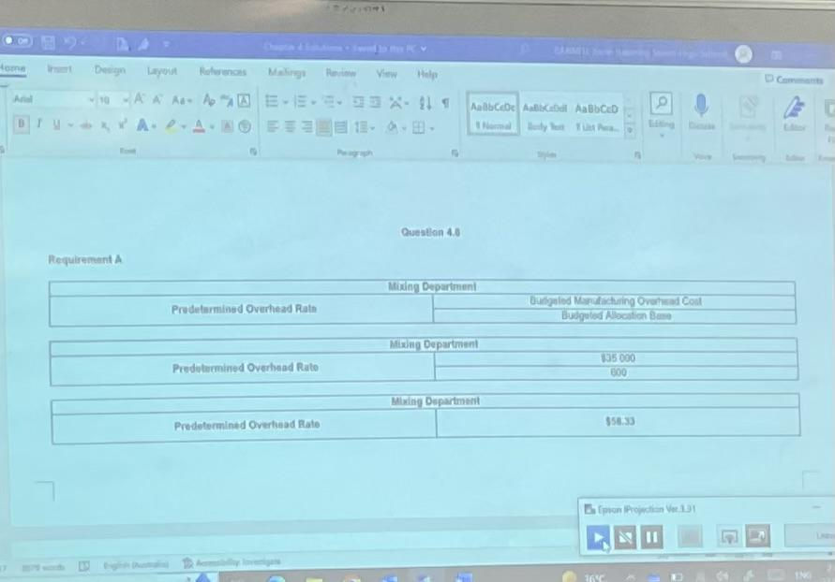

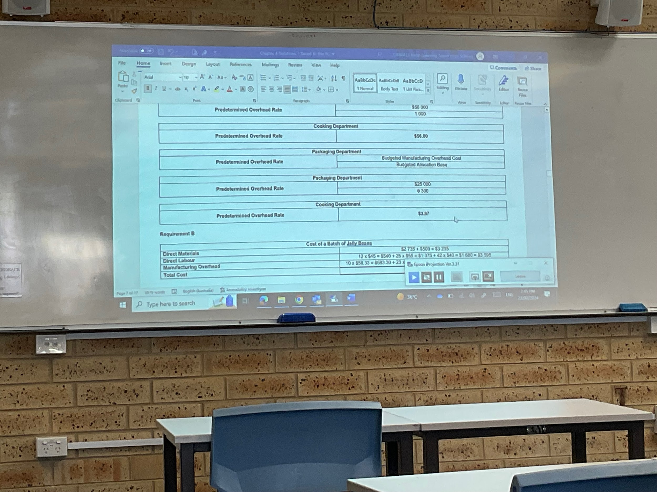
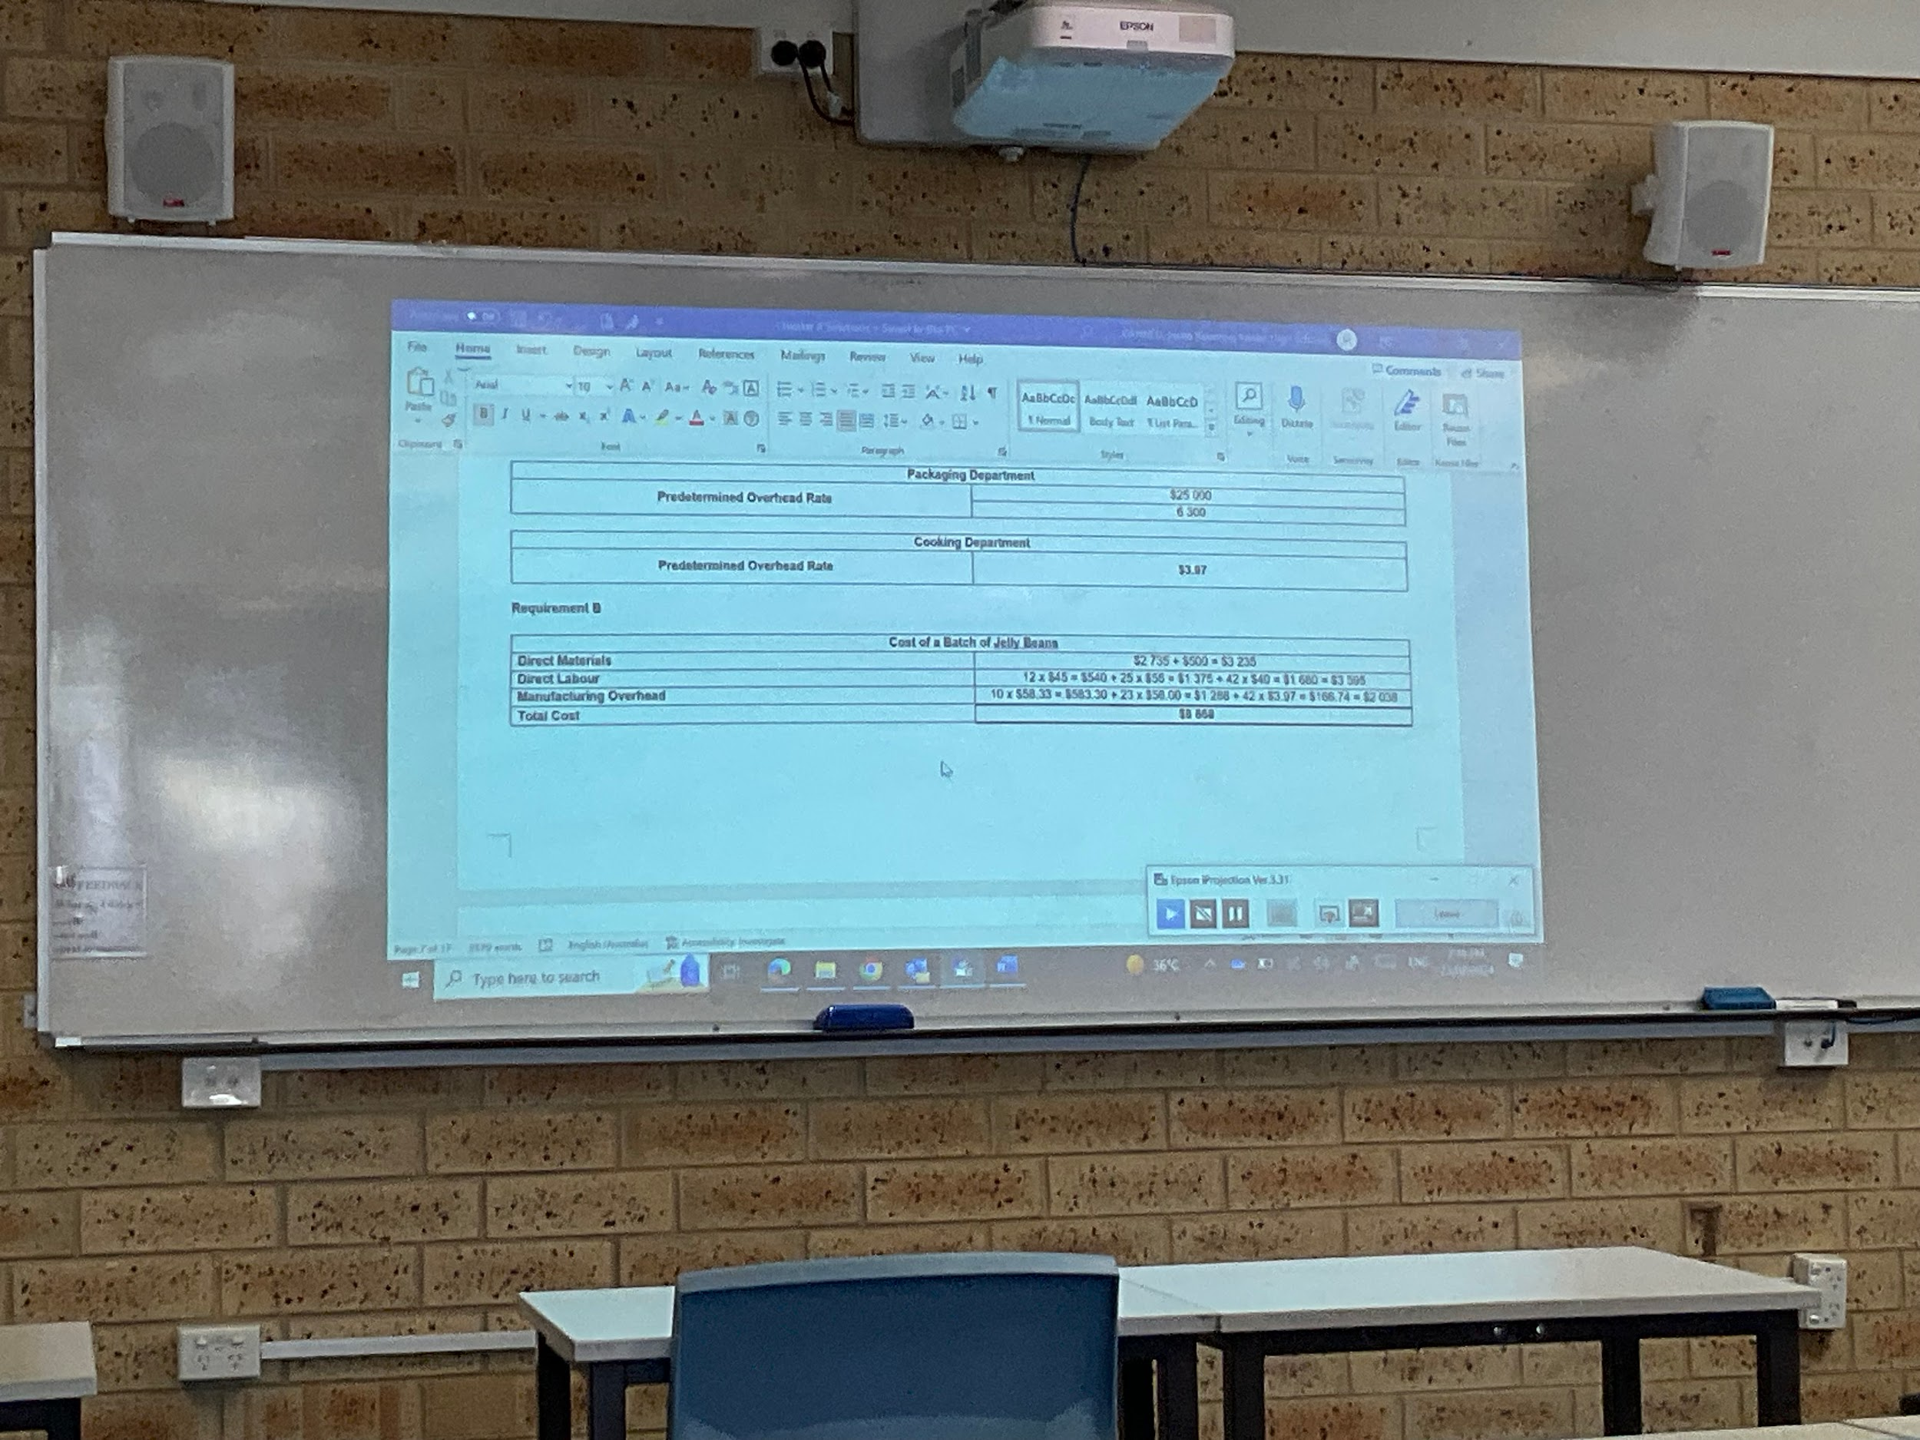

4.10
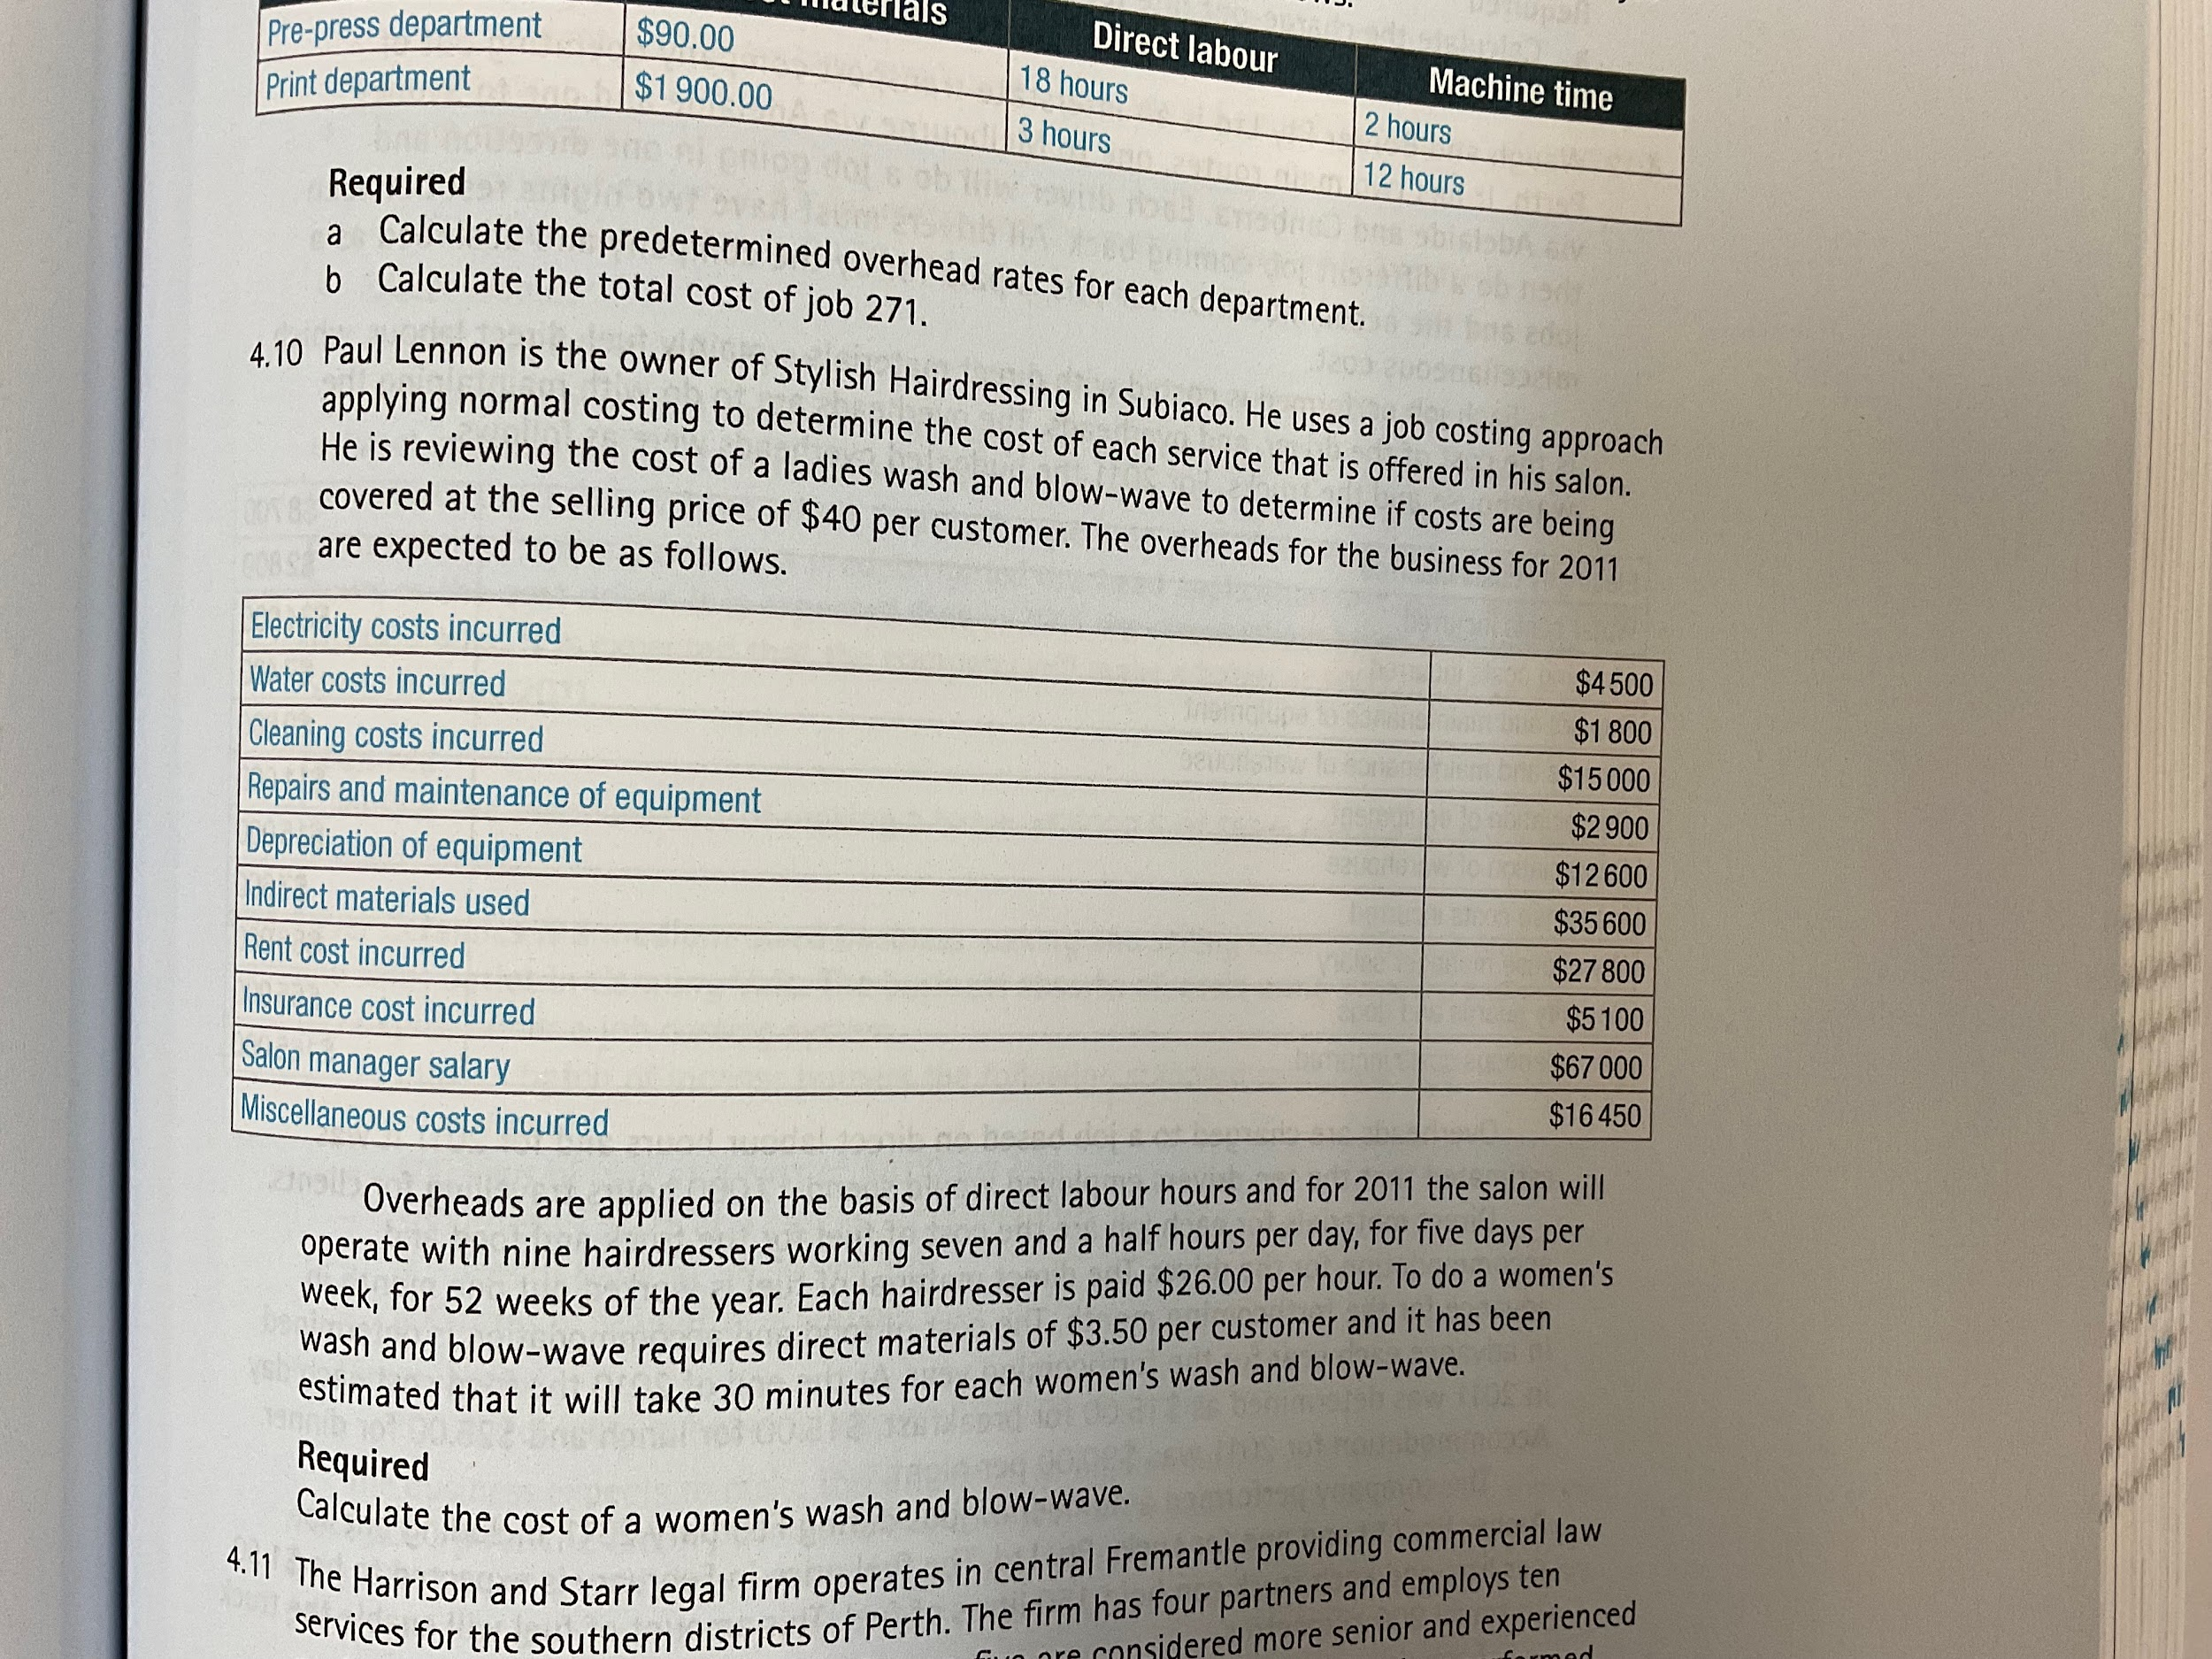
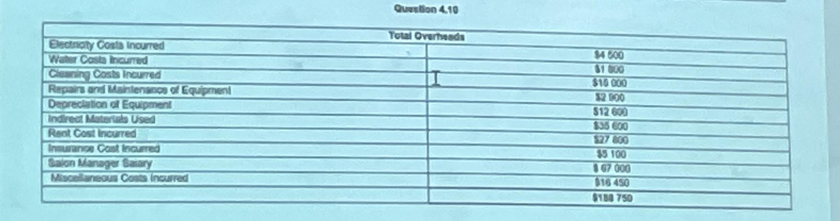
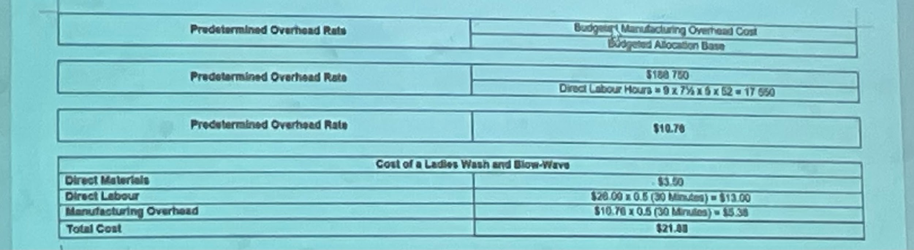

26/2/24
4.13
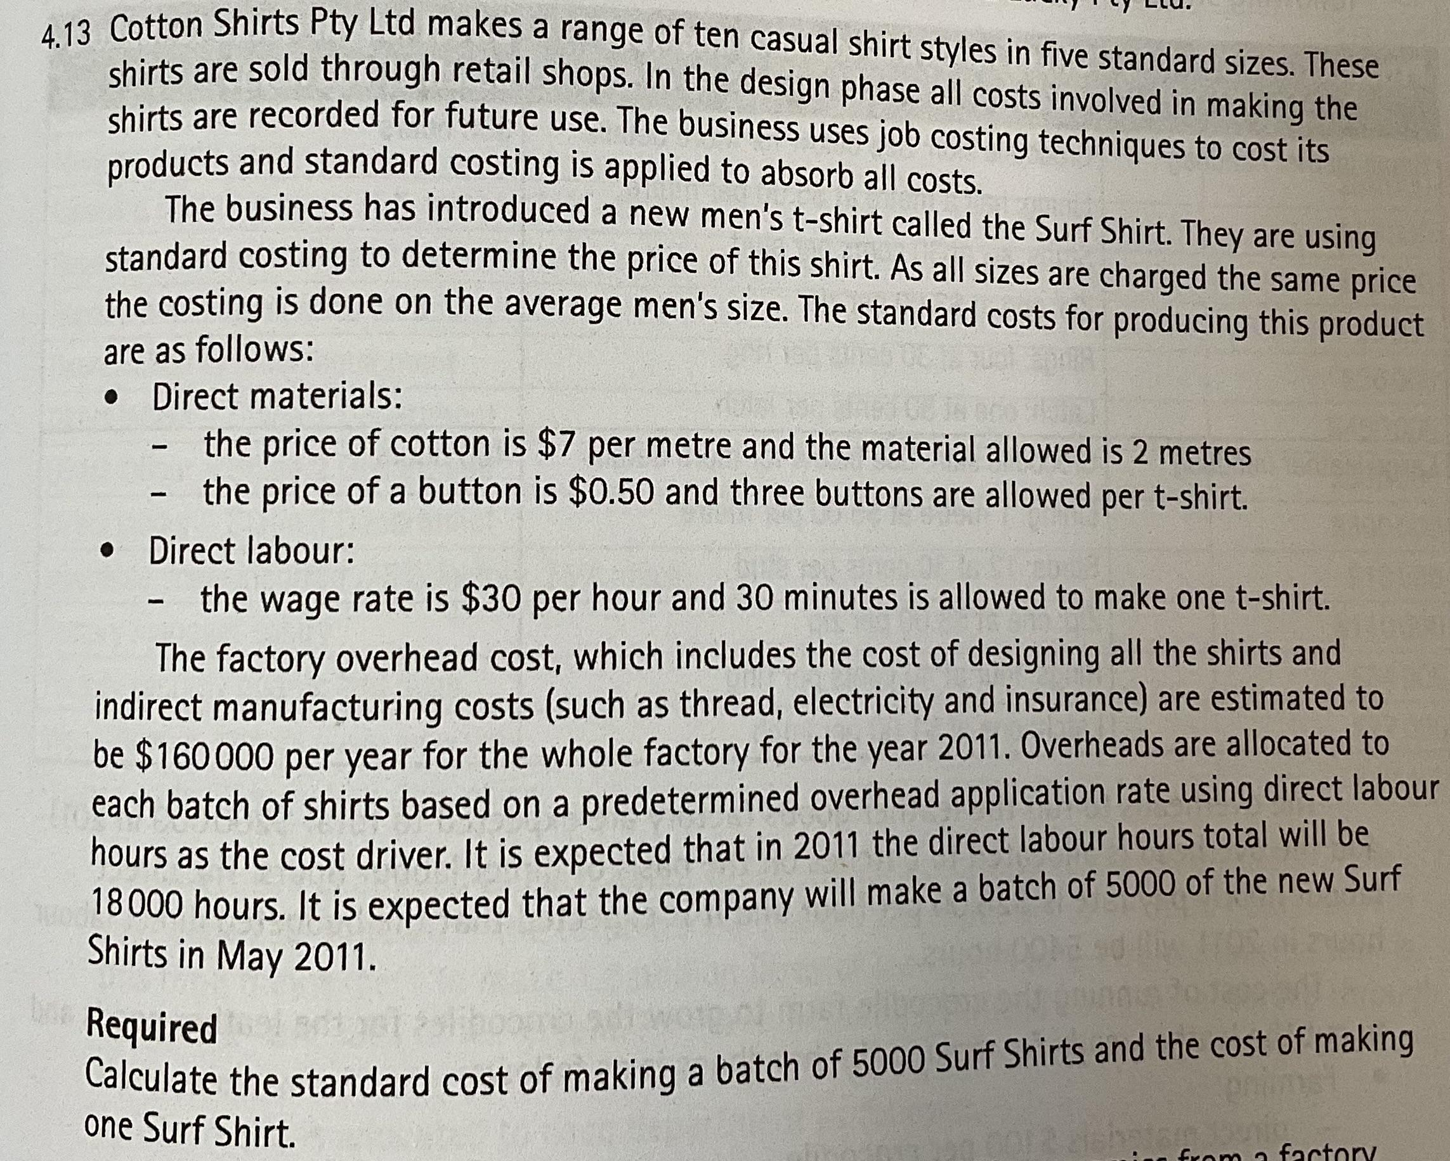

Direct materials per shirt
7(2) + 0.5(3) = $15.5

Direct labour per shirt
30(0.5) = 15

Factory overhead
$160000

Indirect labour
18000

Predetermined overhead rate
160000/18000 = $8.89

Cost of a shirt
15 + 15.5 + 8.89(0.5) = $34.94

Standard cost
5000(34.94) = $174725

27/2/24
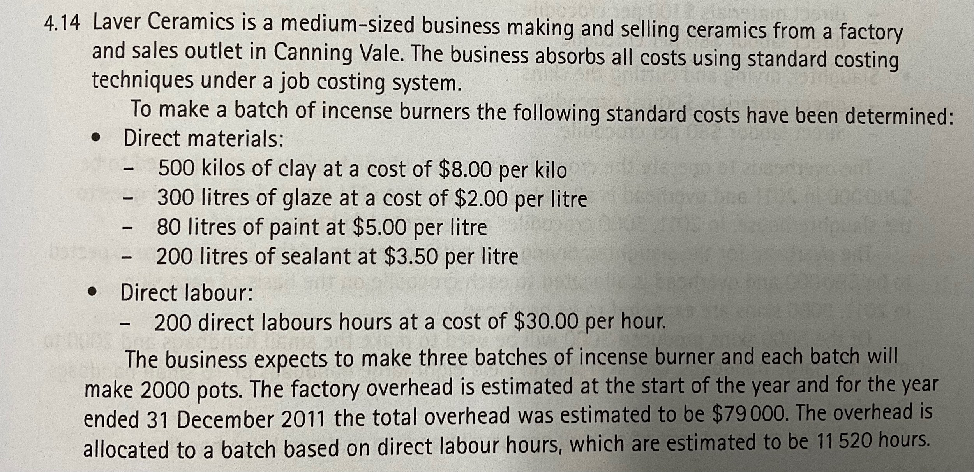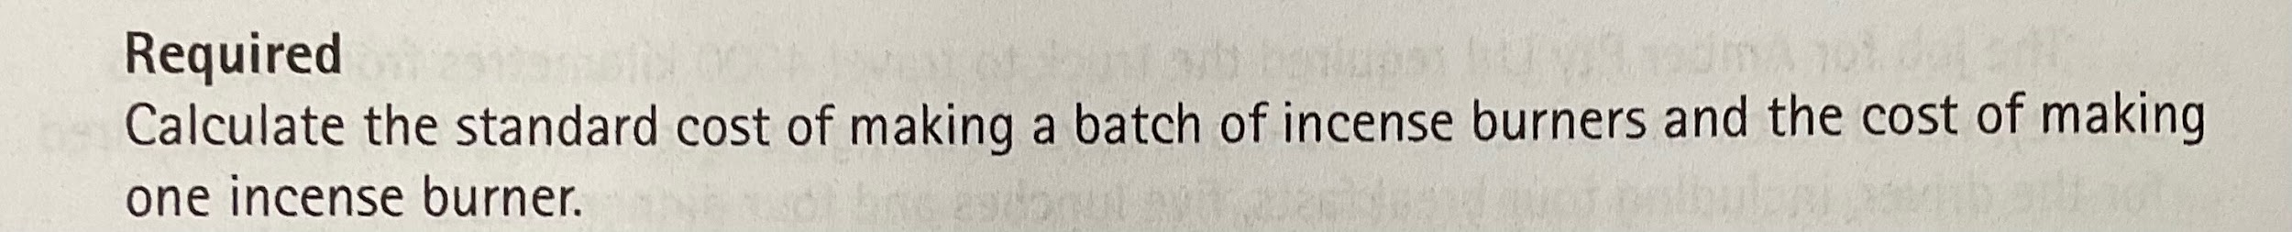

Direct materials per batch
500(8) + 300(2) + 80(5) + 200(3.5) = $5700

Factory overhead
$79000

Direct labour
200(30) = $6000

Direct labour
11520 hours

Predetermined overhead rate
79000/11520 = $6.86 per hour

Batch standard cost
5700 + 6000 + 6.86(200) = $13072

Cost of one burner
13072 / 2000 = $6.54

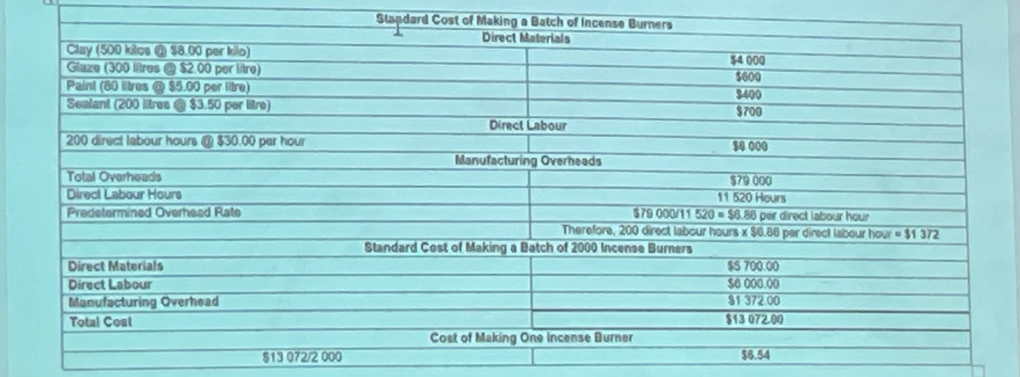

Variance
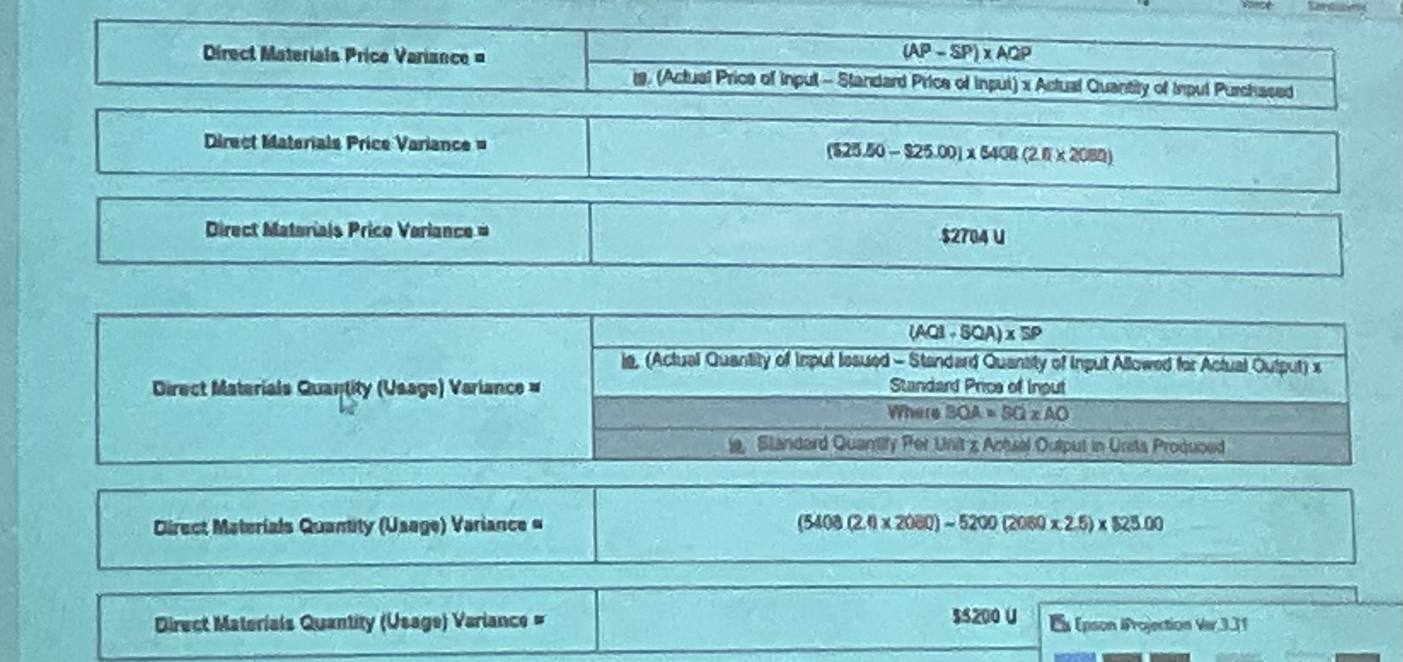

1/3/24
4.17
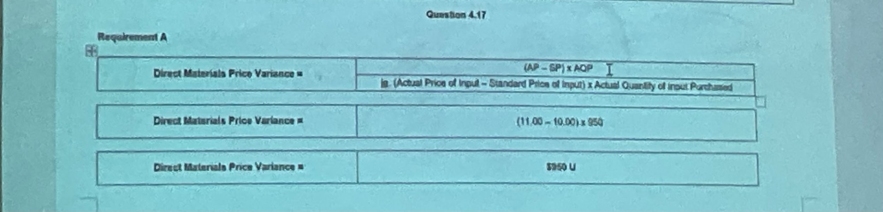
- Direct materials price variance: (11-10) * 950= $950 (unfavourable)
- Direct materials quantity (usage) variance: (950 - 1(1000))*10 = ($500) Favourable
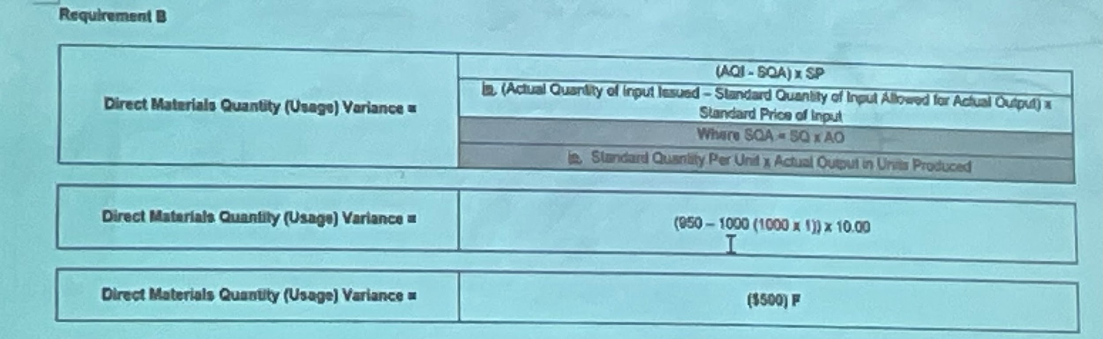
- Direct labour rate variance: (18.3 - 18) 550 = $165 Unfavourable
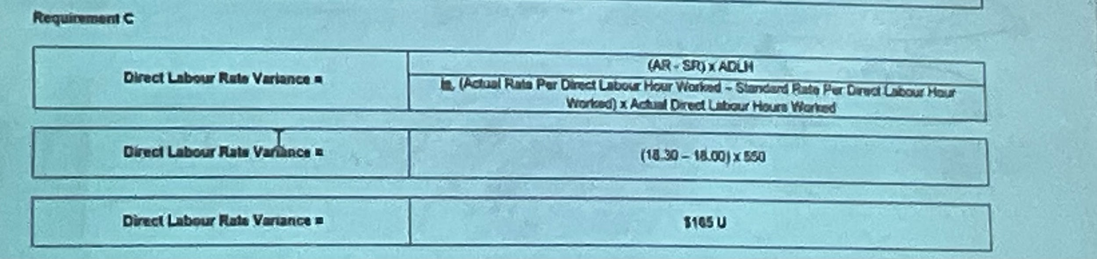
- Direct labour efficiency variance: (550 - 0.5*1000)*18 = 900 Unfavourable
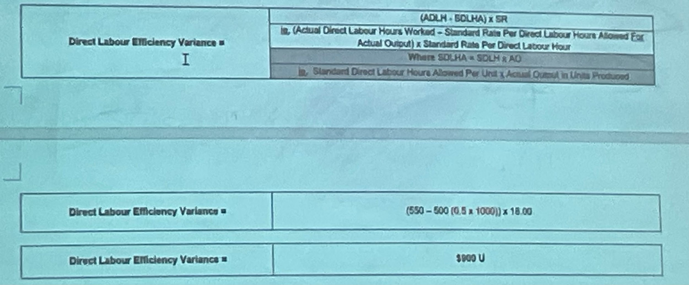

4.21
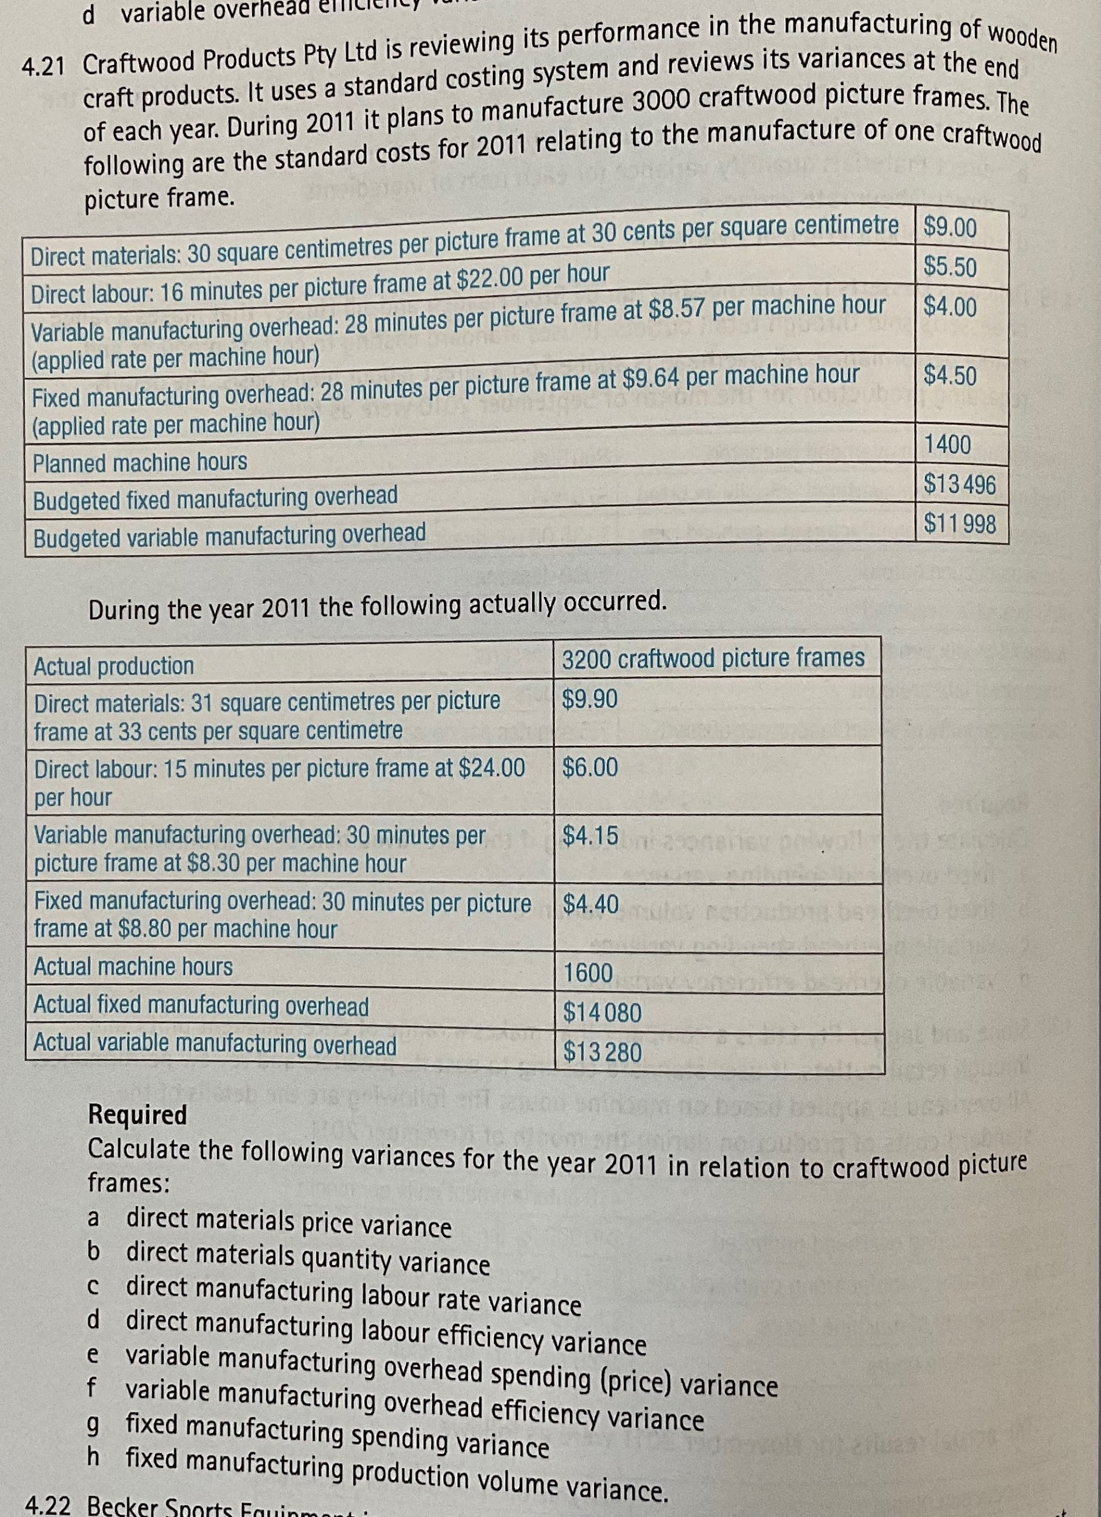
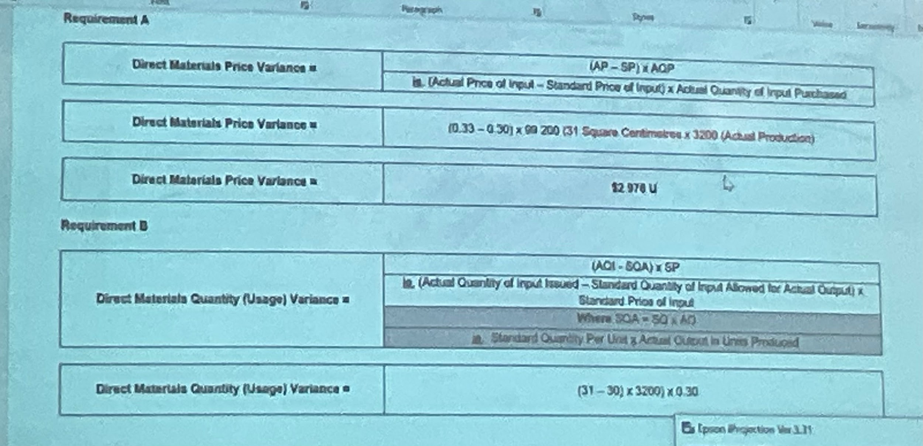
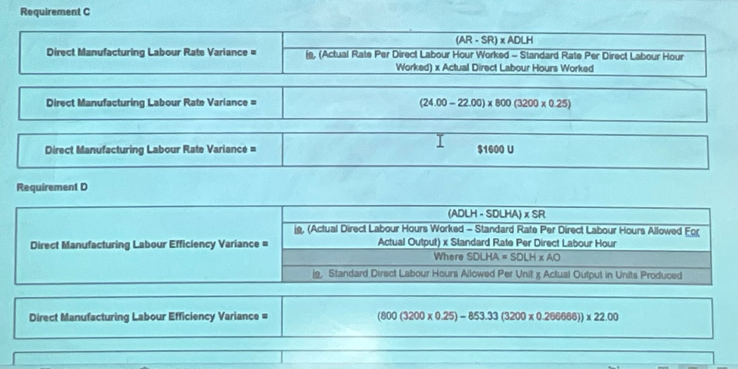
- DMPV: (0.33-0.3)99200 = $2978 U
- DMQV: (31-30)3200*0.3 = $960 U
- DMLRV: (24-22)(3200*0.25) = $1600 U
- DMLEV: ((3200*0.25) - (3200*0.266))*22 = ($1172.87) F
3/3/24

14. What is a standard costing system?
A system of product costing where the cost of a product is based on standard costs for direct materials, direct labour and manufacturing overheads.

15. Explain what is meant by variance analysis.
The comparison of actual results compared to the standard amount or value represented in the flexible budget (the standard quantity or hours allowed for actual output multiplied by the standard rate or price).

16. Define the concept of the mark-up.
The amount (either in dollars or in percentages) added to the unit cost price of a product or service to determine its selling price.

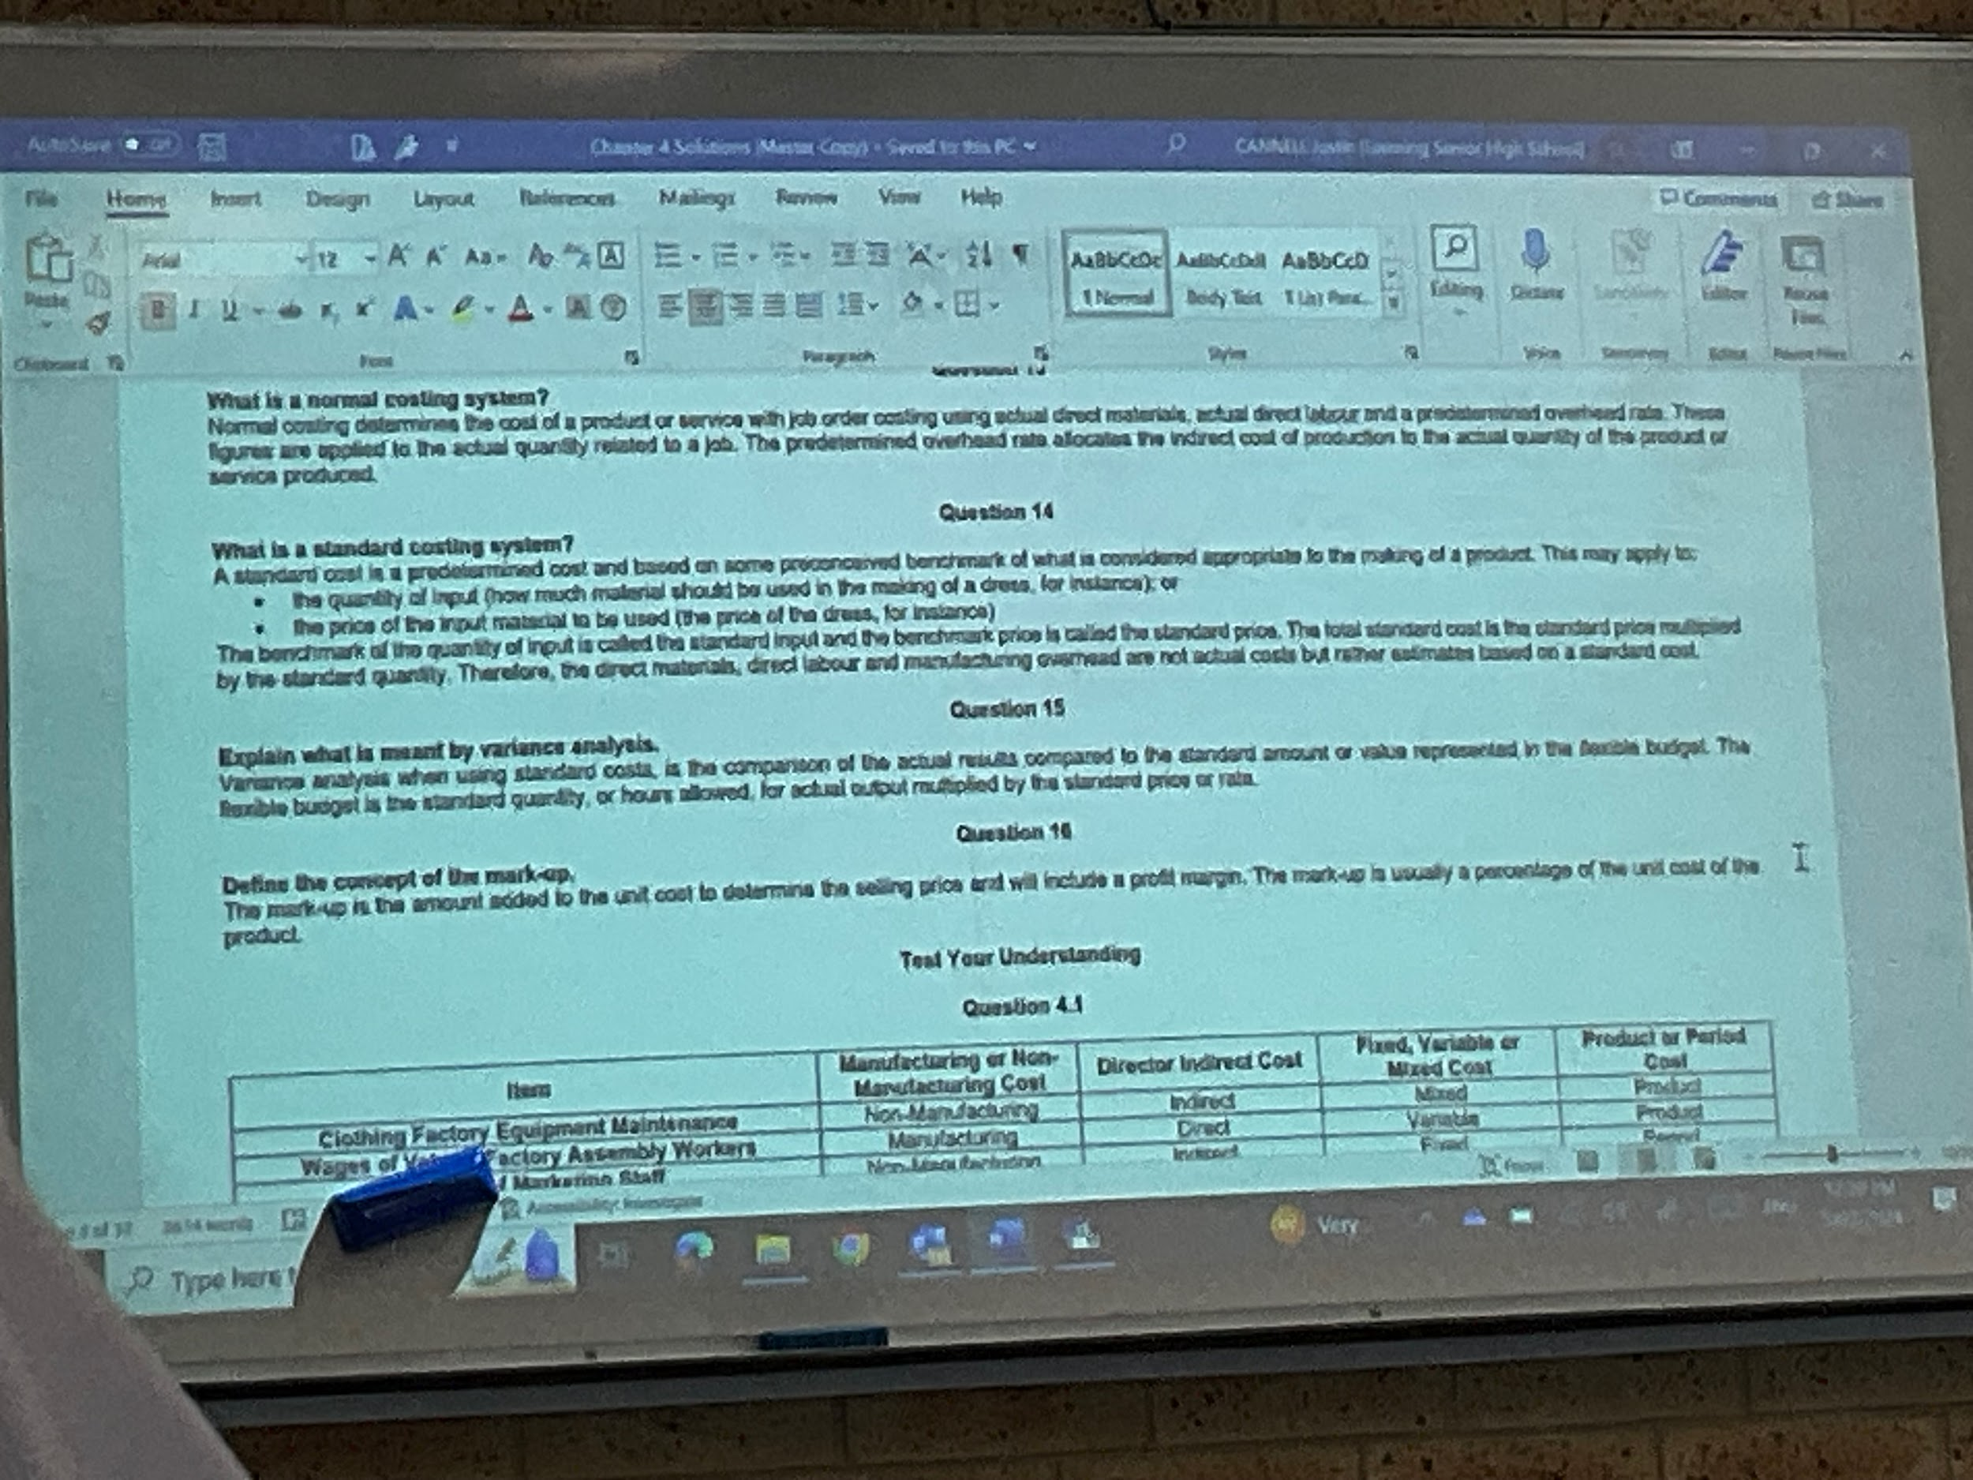

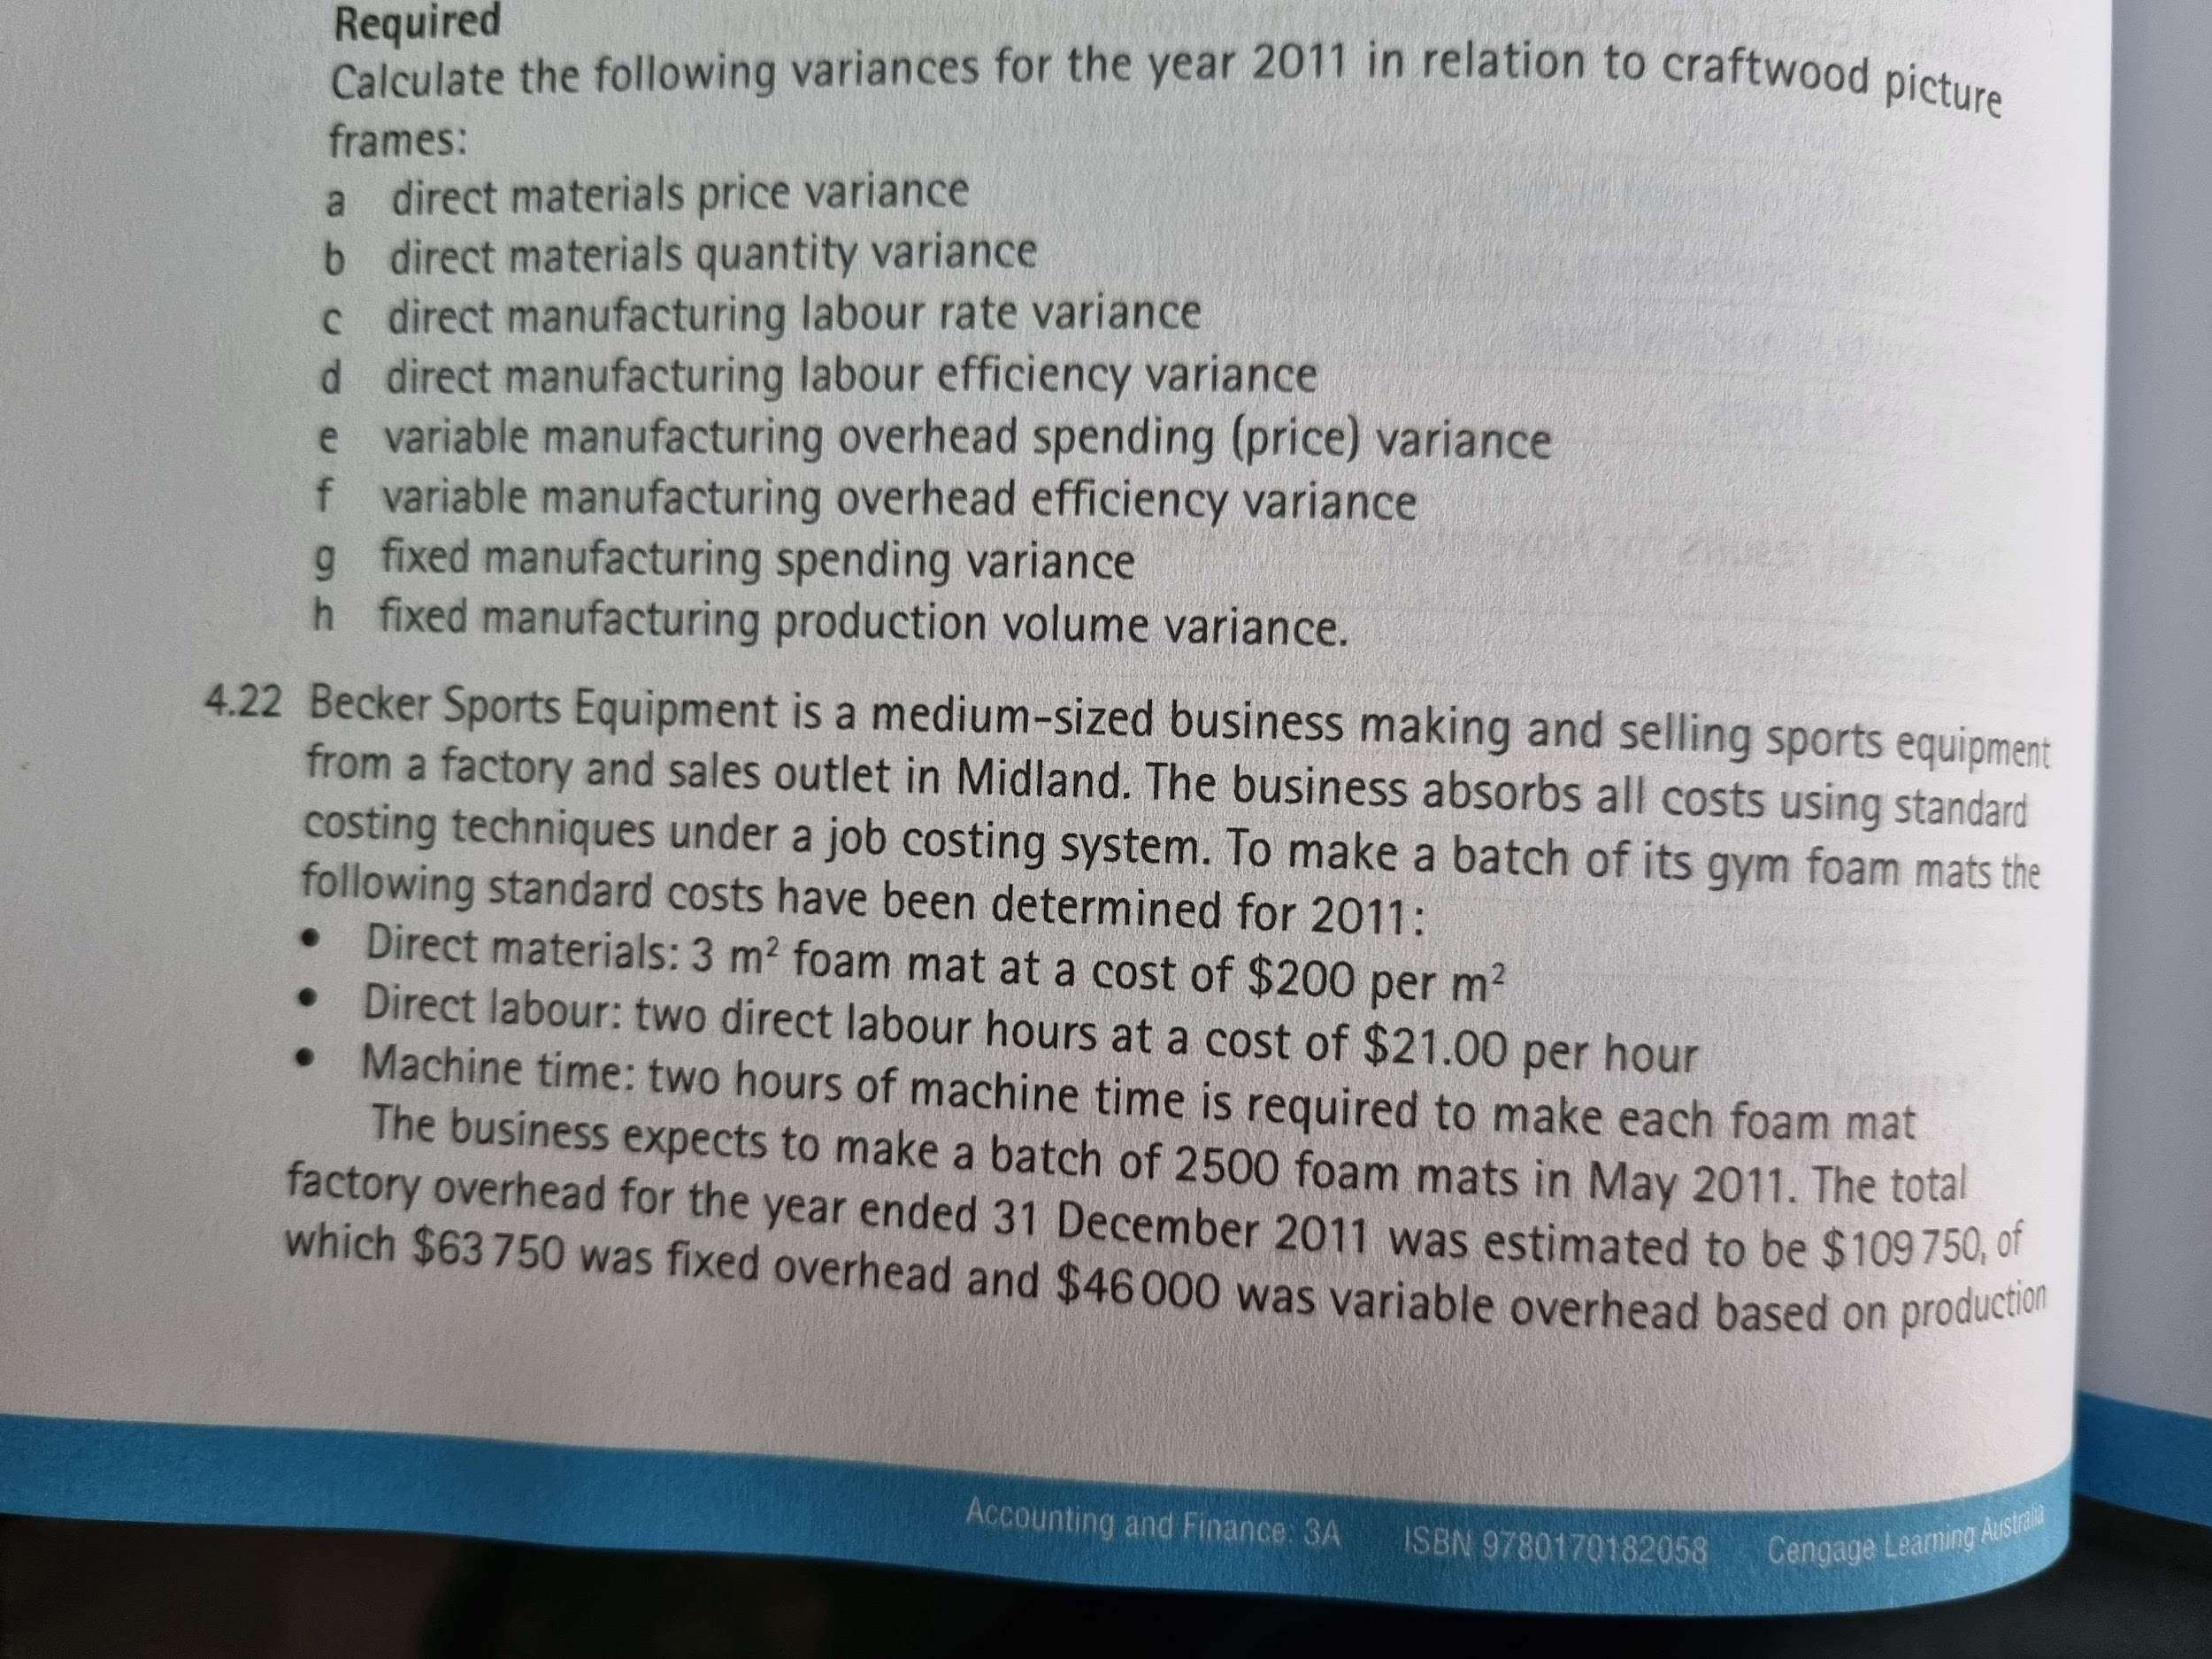
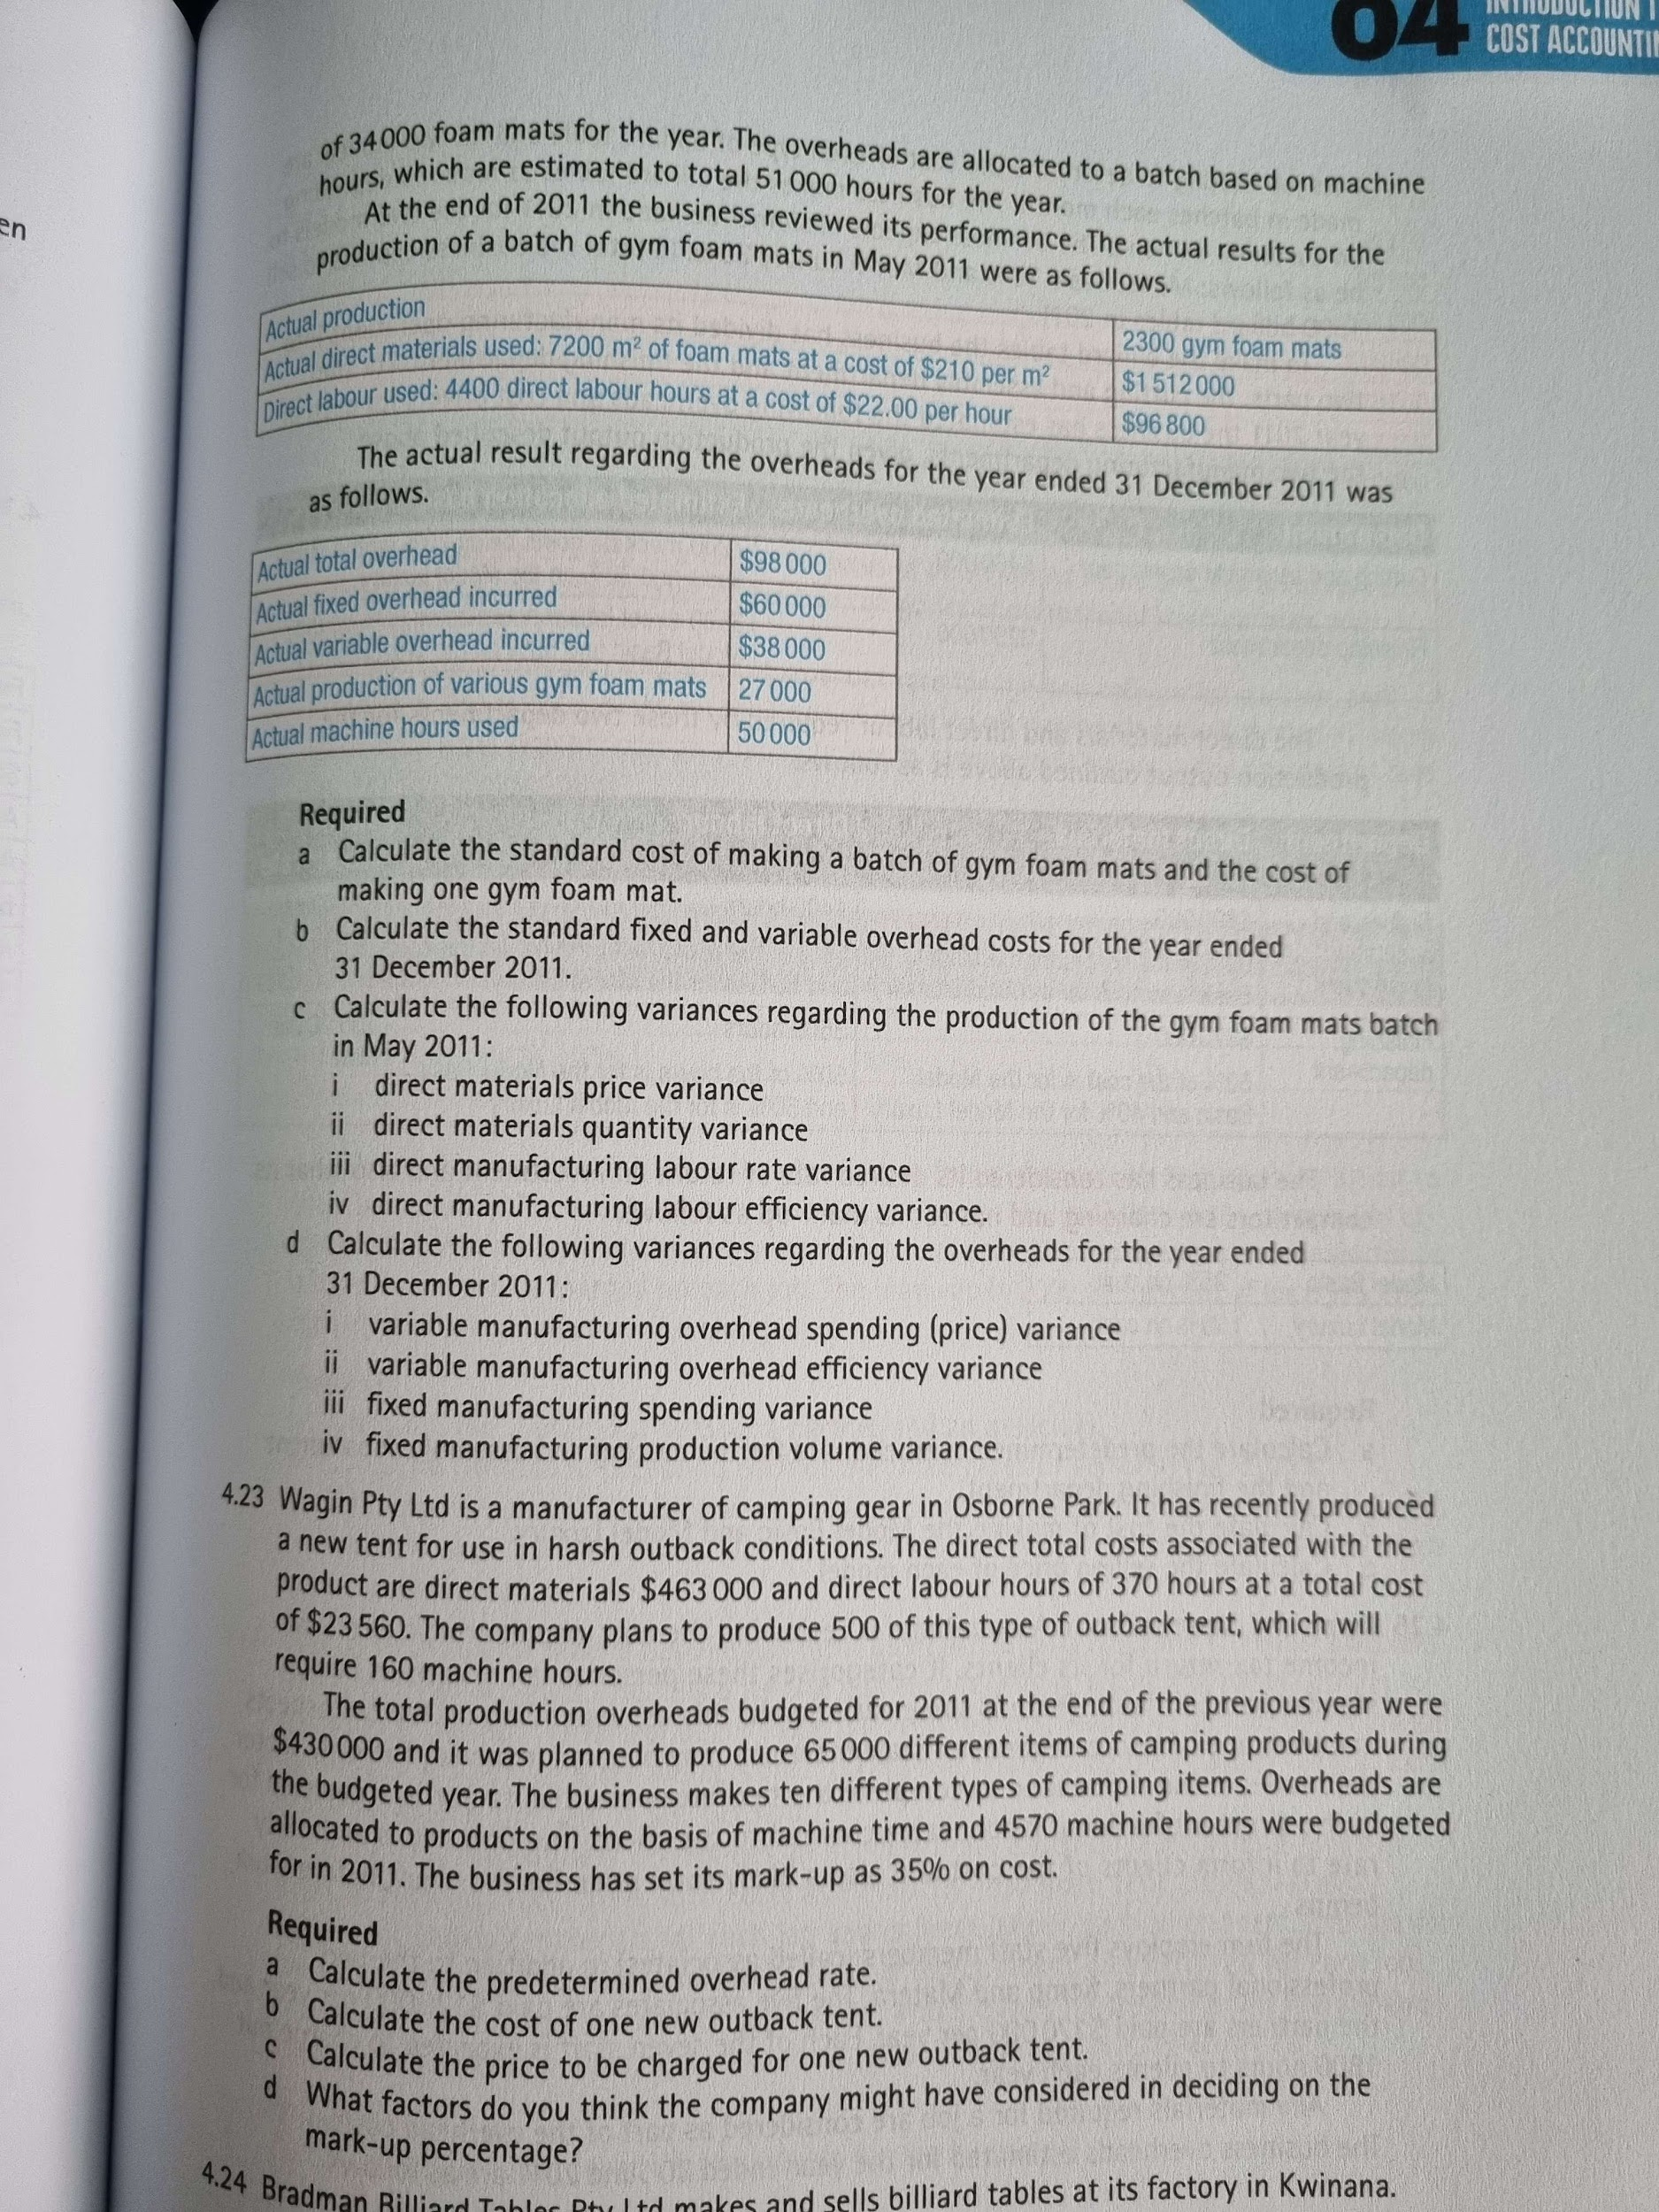

4.22

Direct materials per batch
7500(200) = $1500000

Factory overhead
$109750

Direct labour
2(21)*2500 = $105000

Machine hours
51000 hours

Predetermined overhead rate
109750/51000 = $2.15 per hour

Overheads
2(2.15)(2500) = $10750

Batch standard cost
1500000+10750+105000 = $1615750

Cost of one
1615750/2500 = $646.30

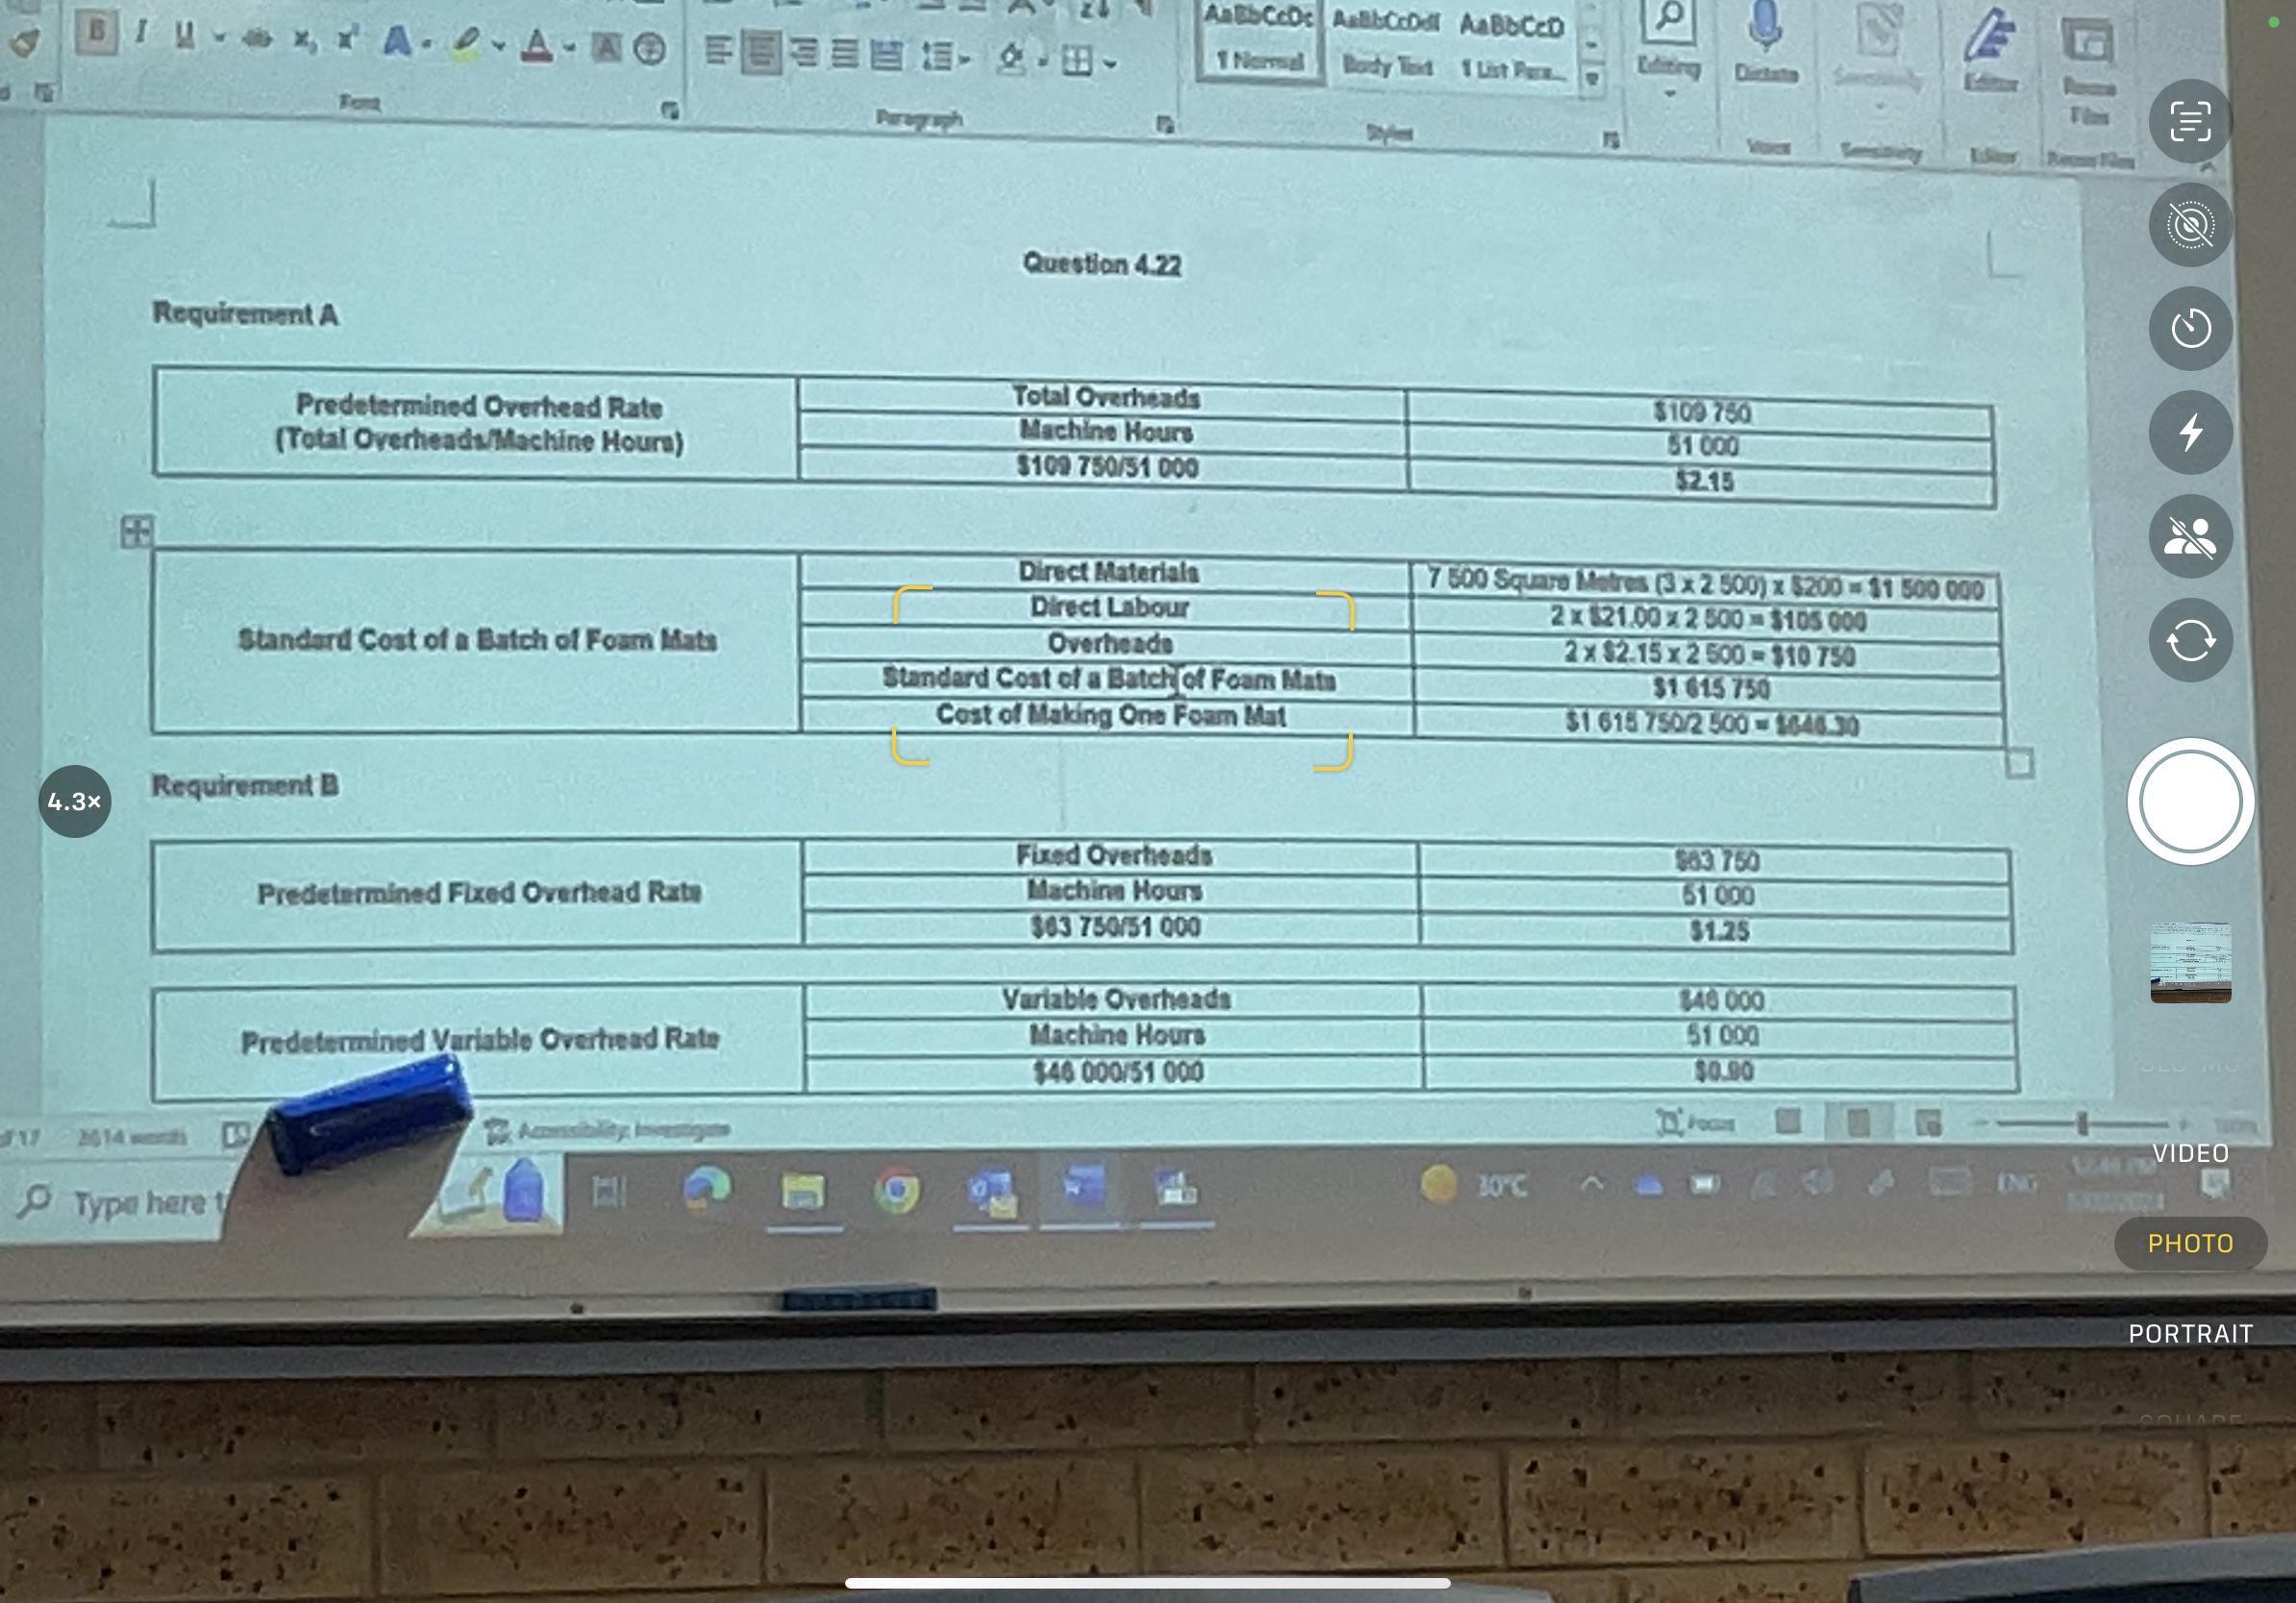

- Predetermined standard fixed overhead rate: 63750/51000 = $1.25
Predetermined variable overhead rate: 46000/51000 = $0.90

- Calculate the following variances
- DMPV: (210-200) * 7200 = $72000 U
- DMQV: [[2500*3) - (2300*3)]*200 = $60000 U
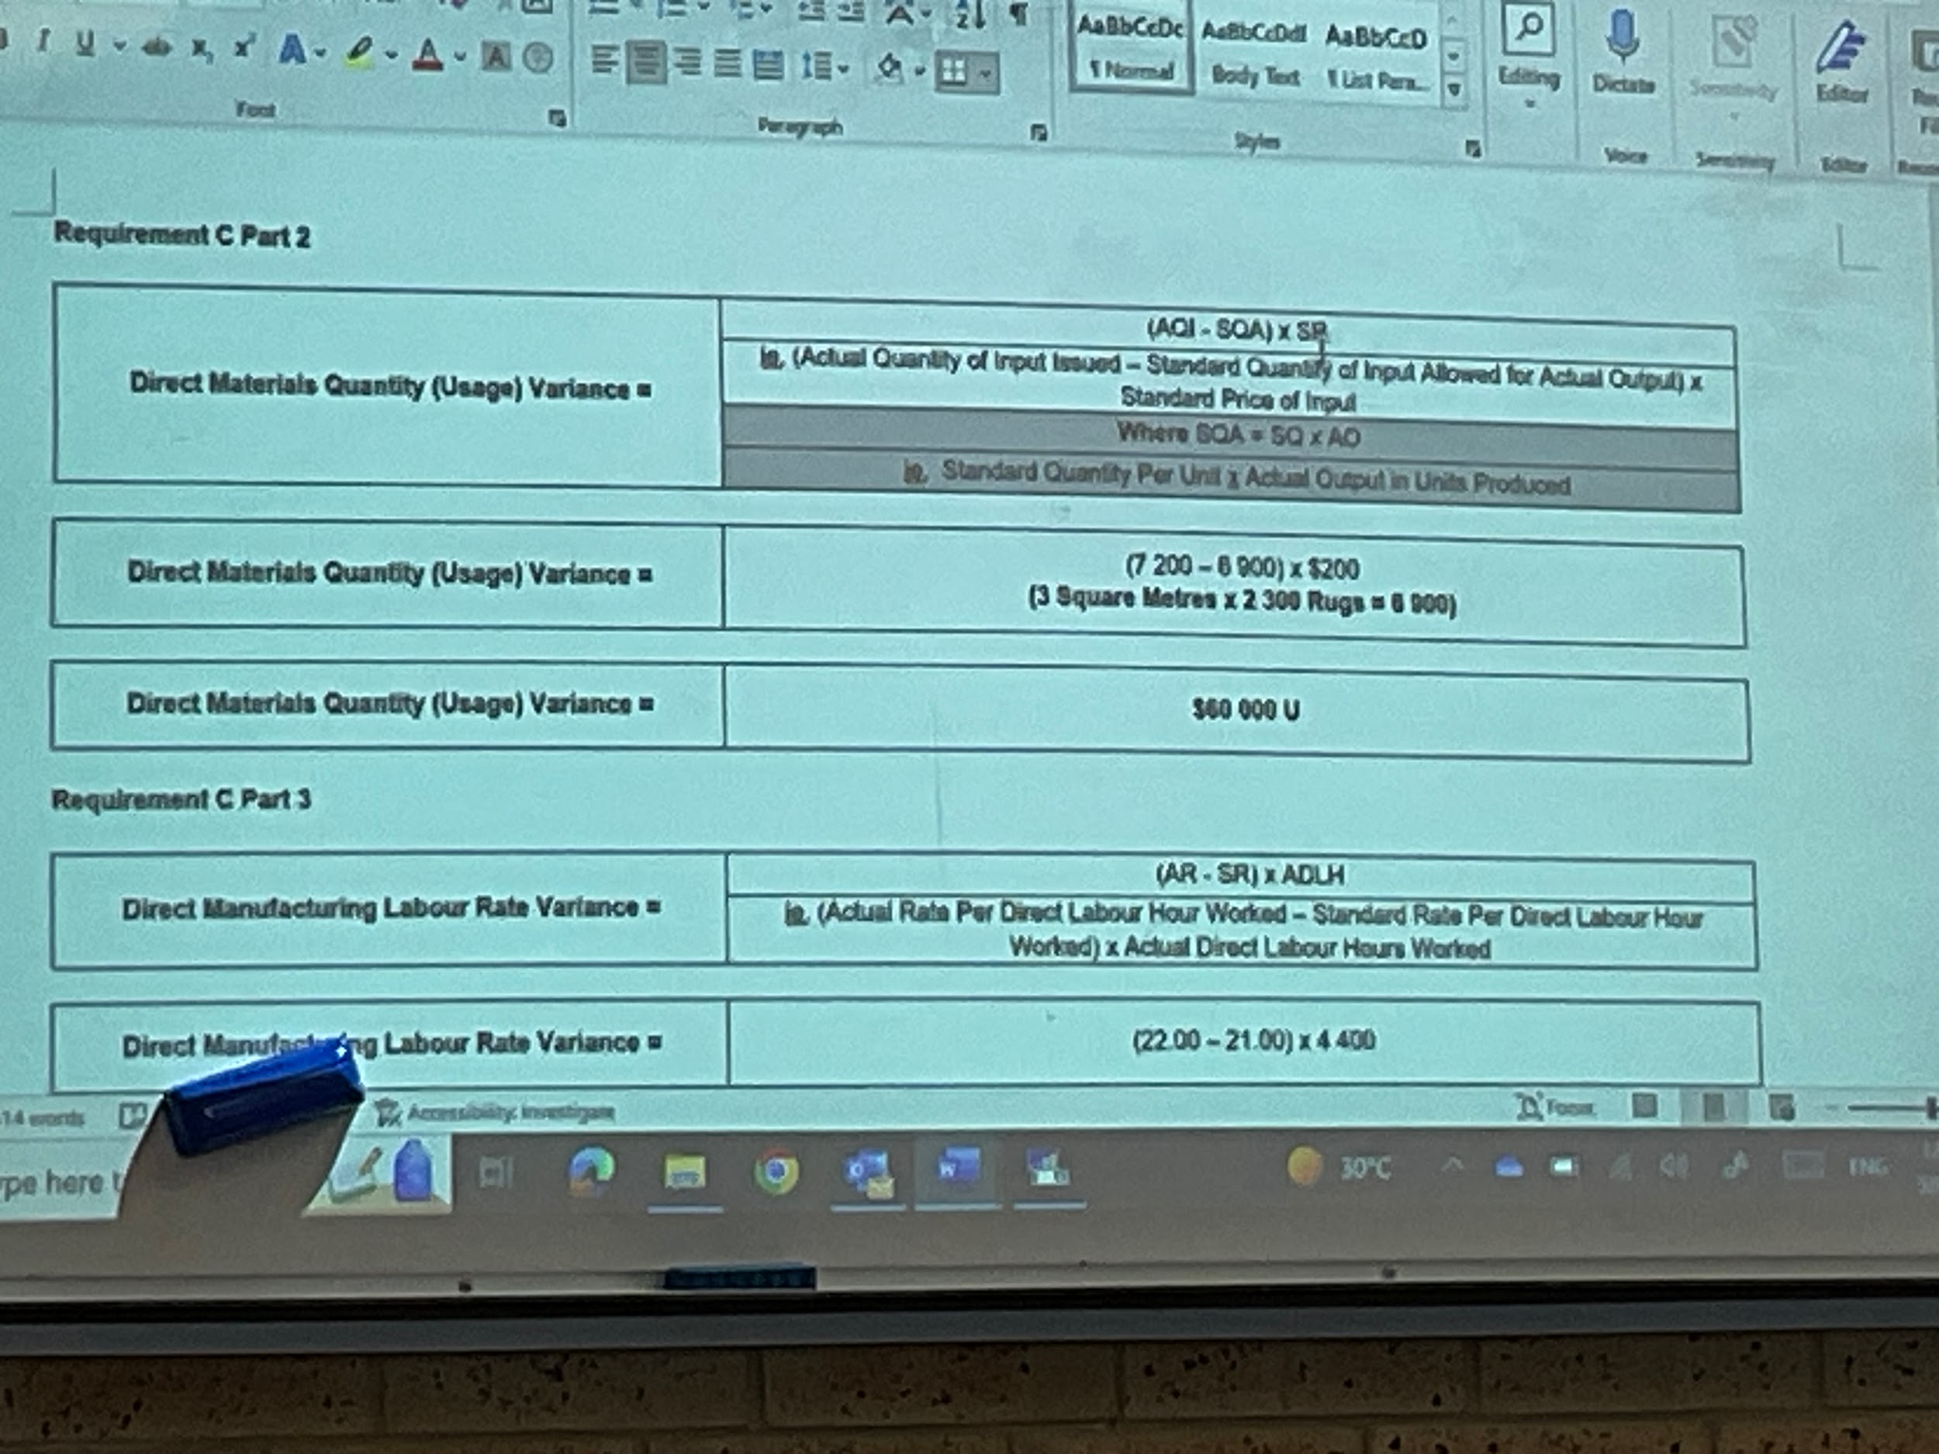

- DMLRV: (22-21)*4400 = 4400 U
- DMLEV: [4400 - 2(2300)]* 21 = (4200) F
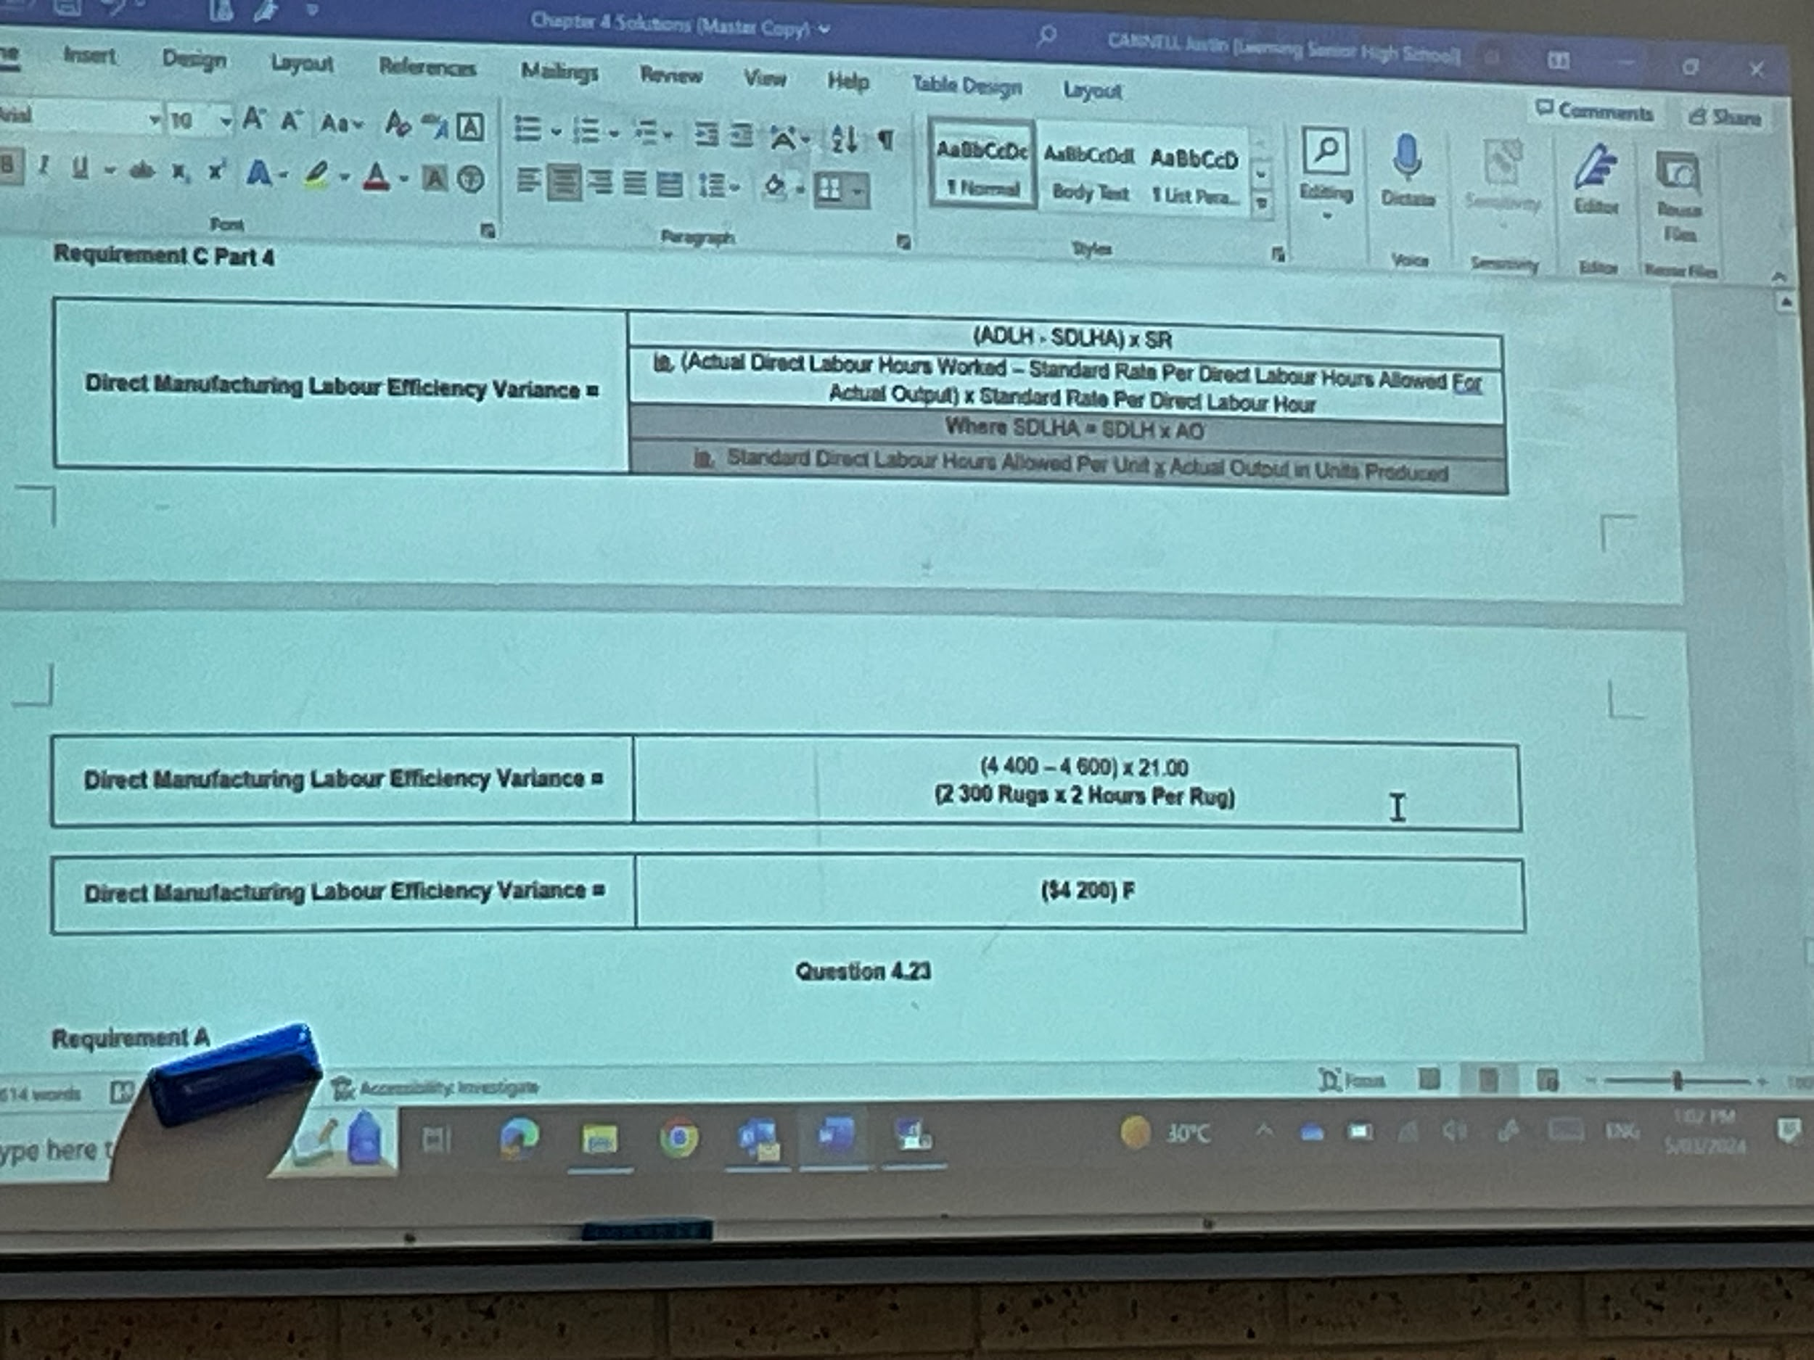

4.23
- POR: 430000/4570 = $94.09 per hour
- Cost of one tent: (463000 + 23560)/500 + (94.09*160)/500 = $1003.23
- With mark-up: $1003.23*1.35 = $1354.36

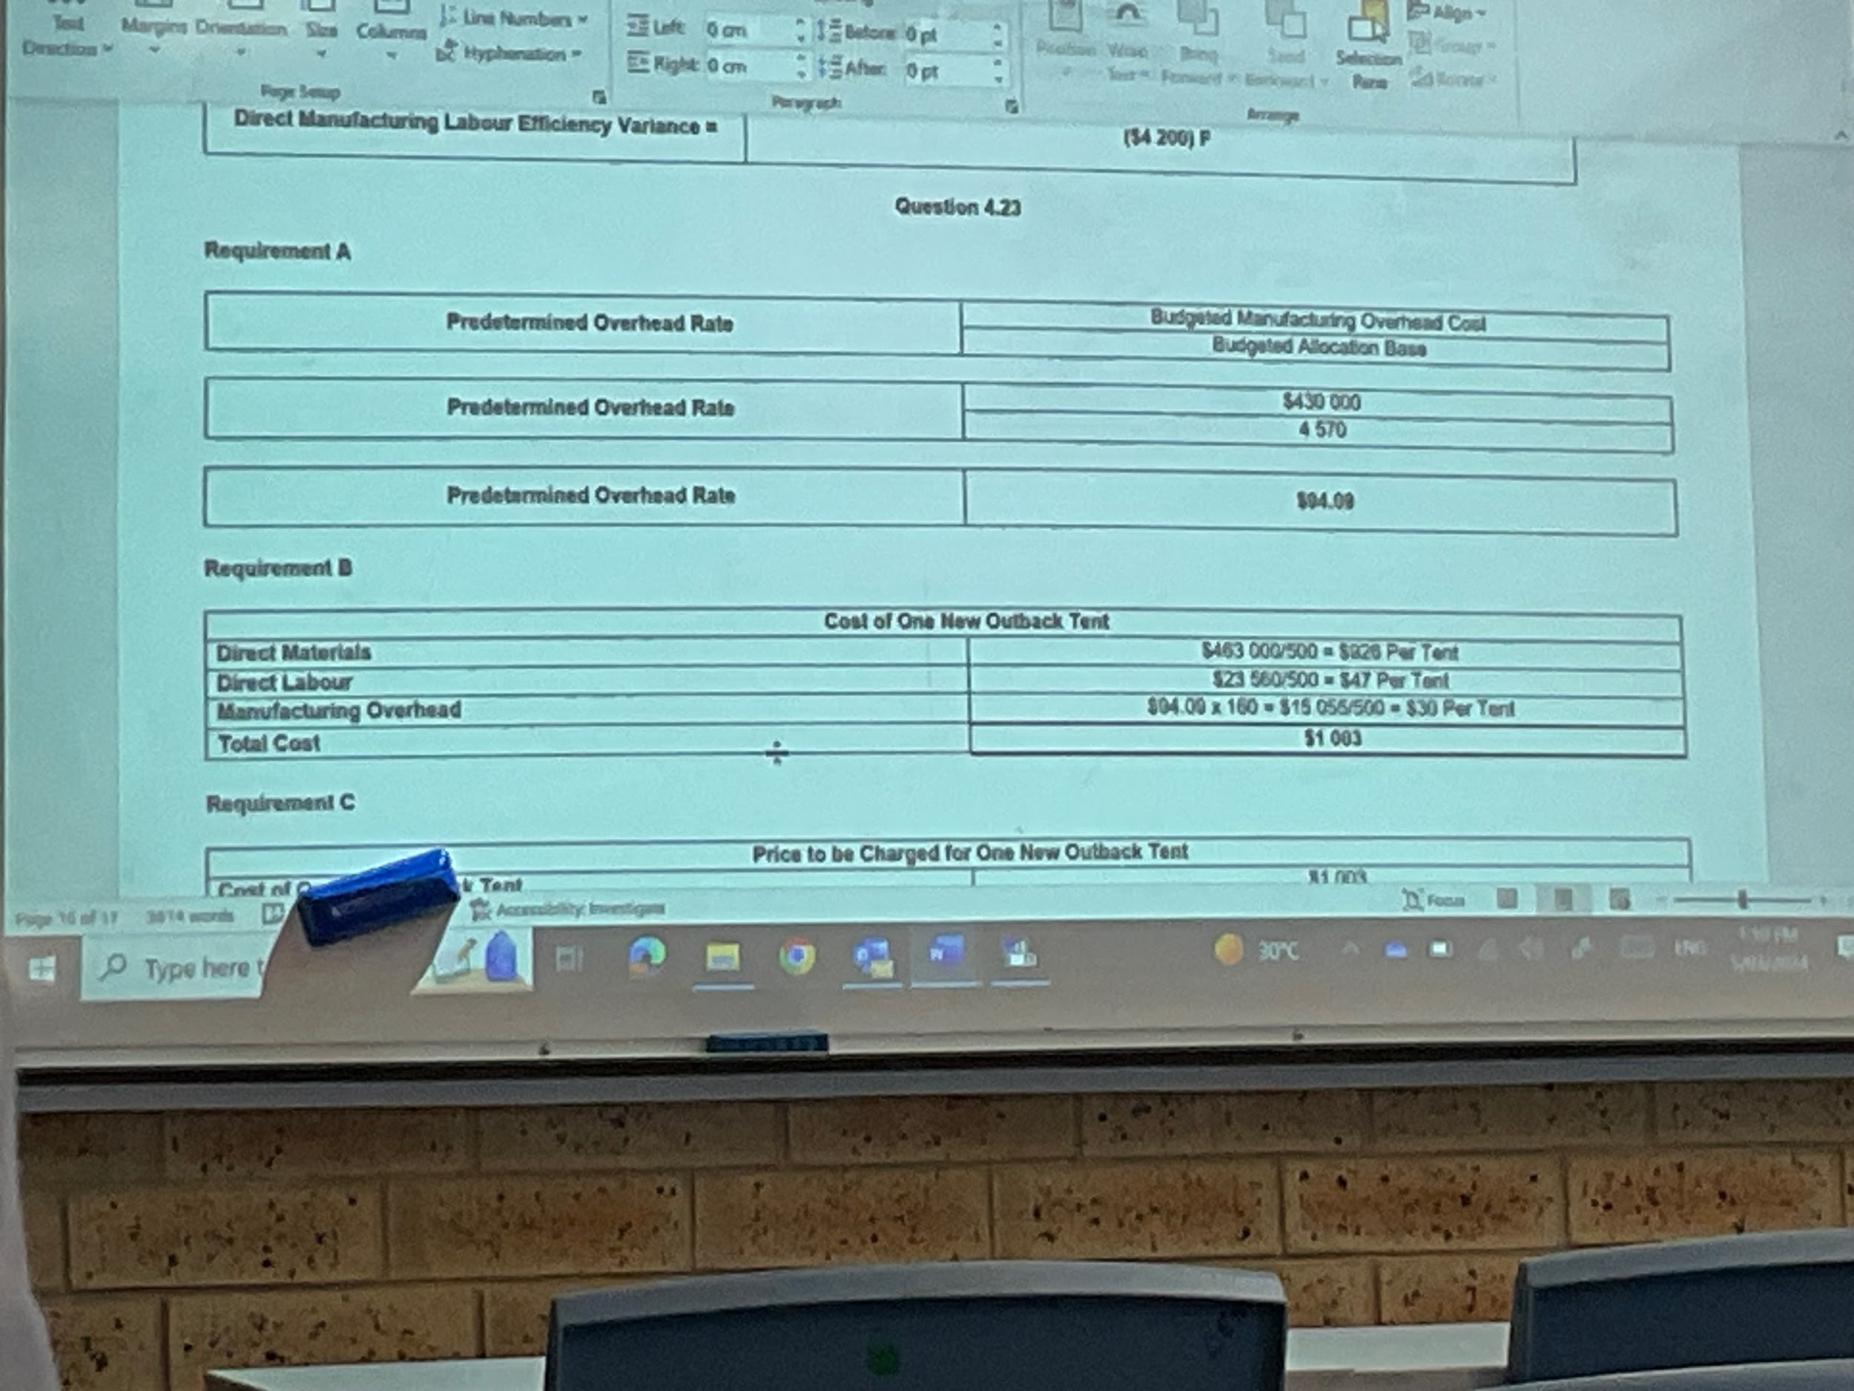
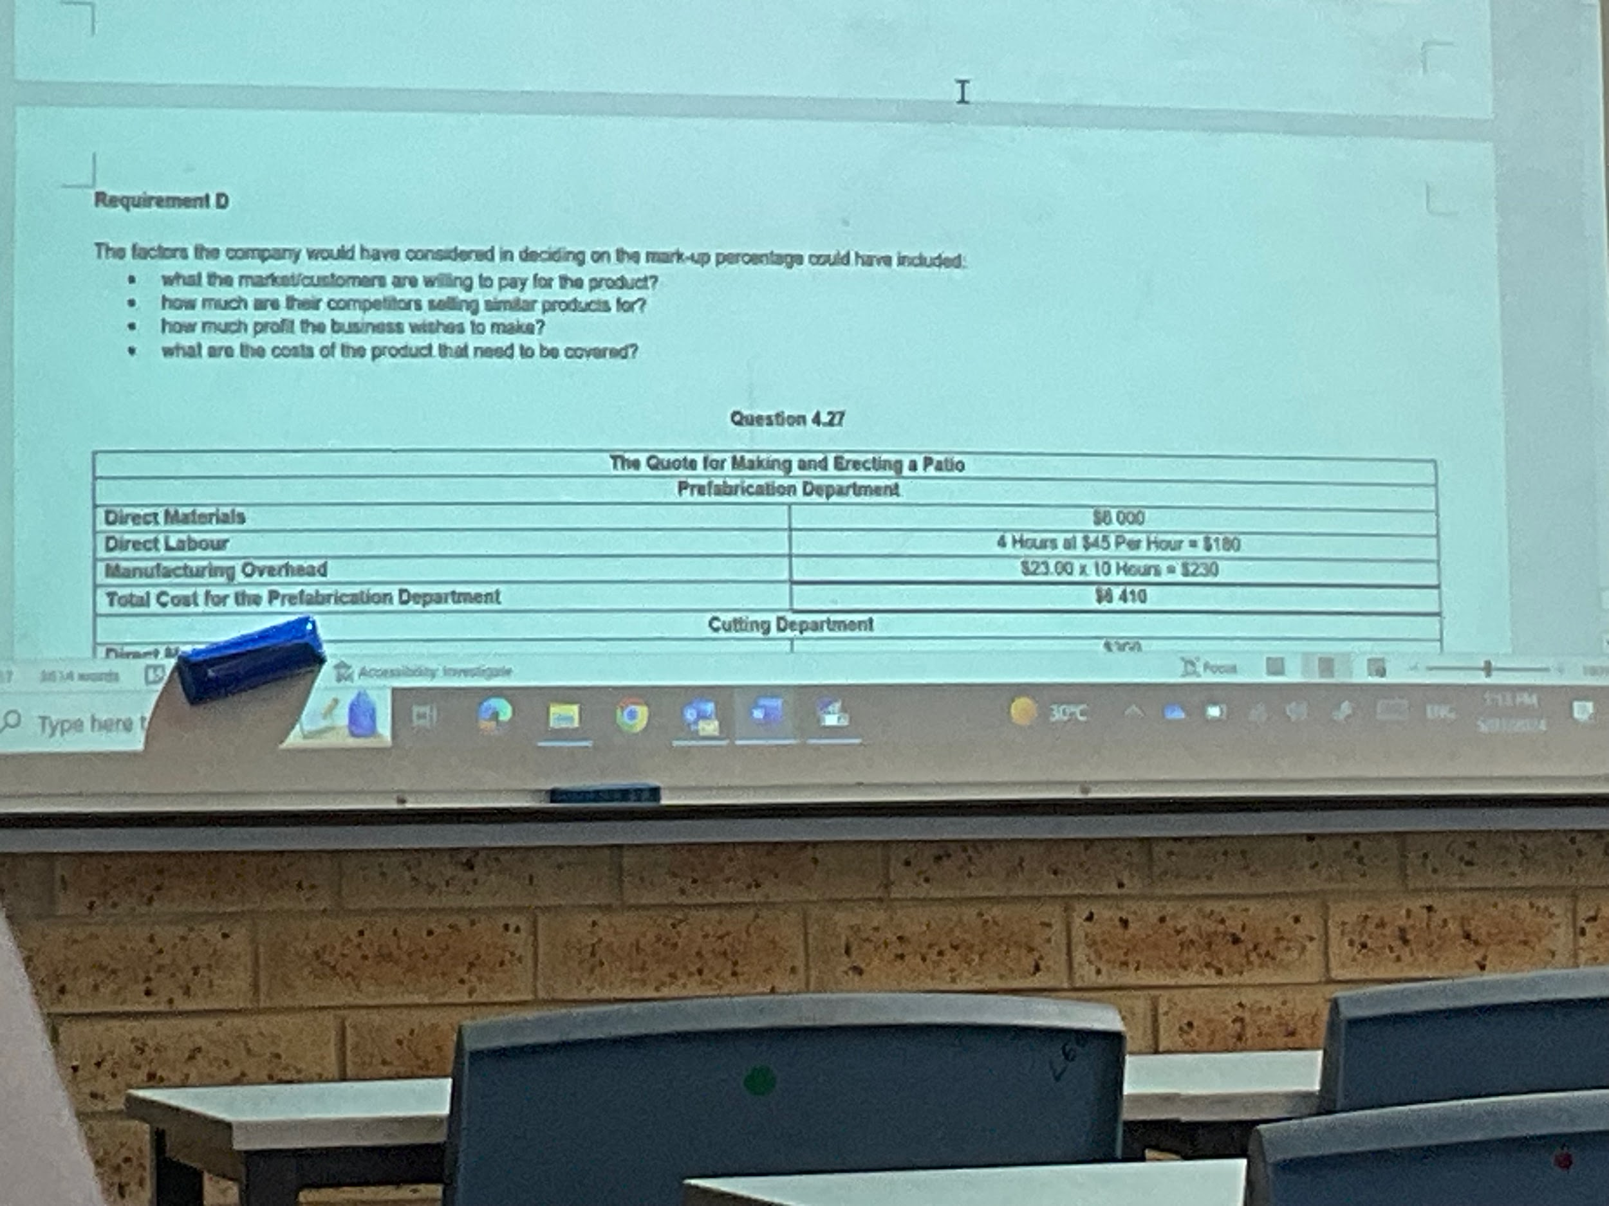
Prefab dept.
Direct materials: 6000
Direct labour: 4(45) = 180
Manufacturing overhead: 23(10) = 230
Total cost: $6410

Cutting dept.
Direct materials: 300
Direct labour: 8(55) = 440
Manufacturing overhead: 8(18) = 144
Total cost: $884

On-site cons. Dept.
Direct materials: 500
Direct labour: 30(61) = 1830
Manufacturing overhead: 30(3) = 90
Total cost: $2420

Total cost of all three depts. = $8762
w/ markup = 9714(1.28) = $12434

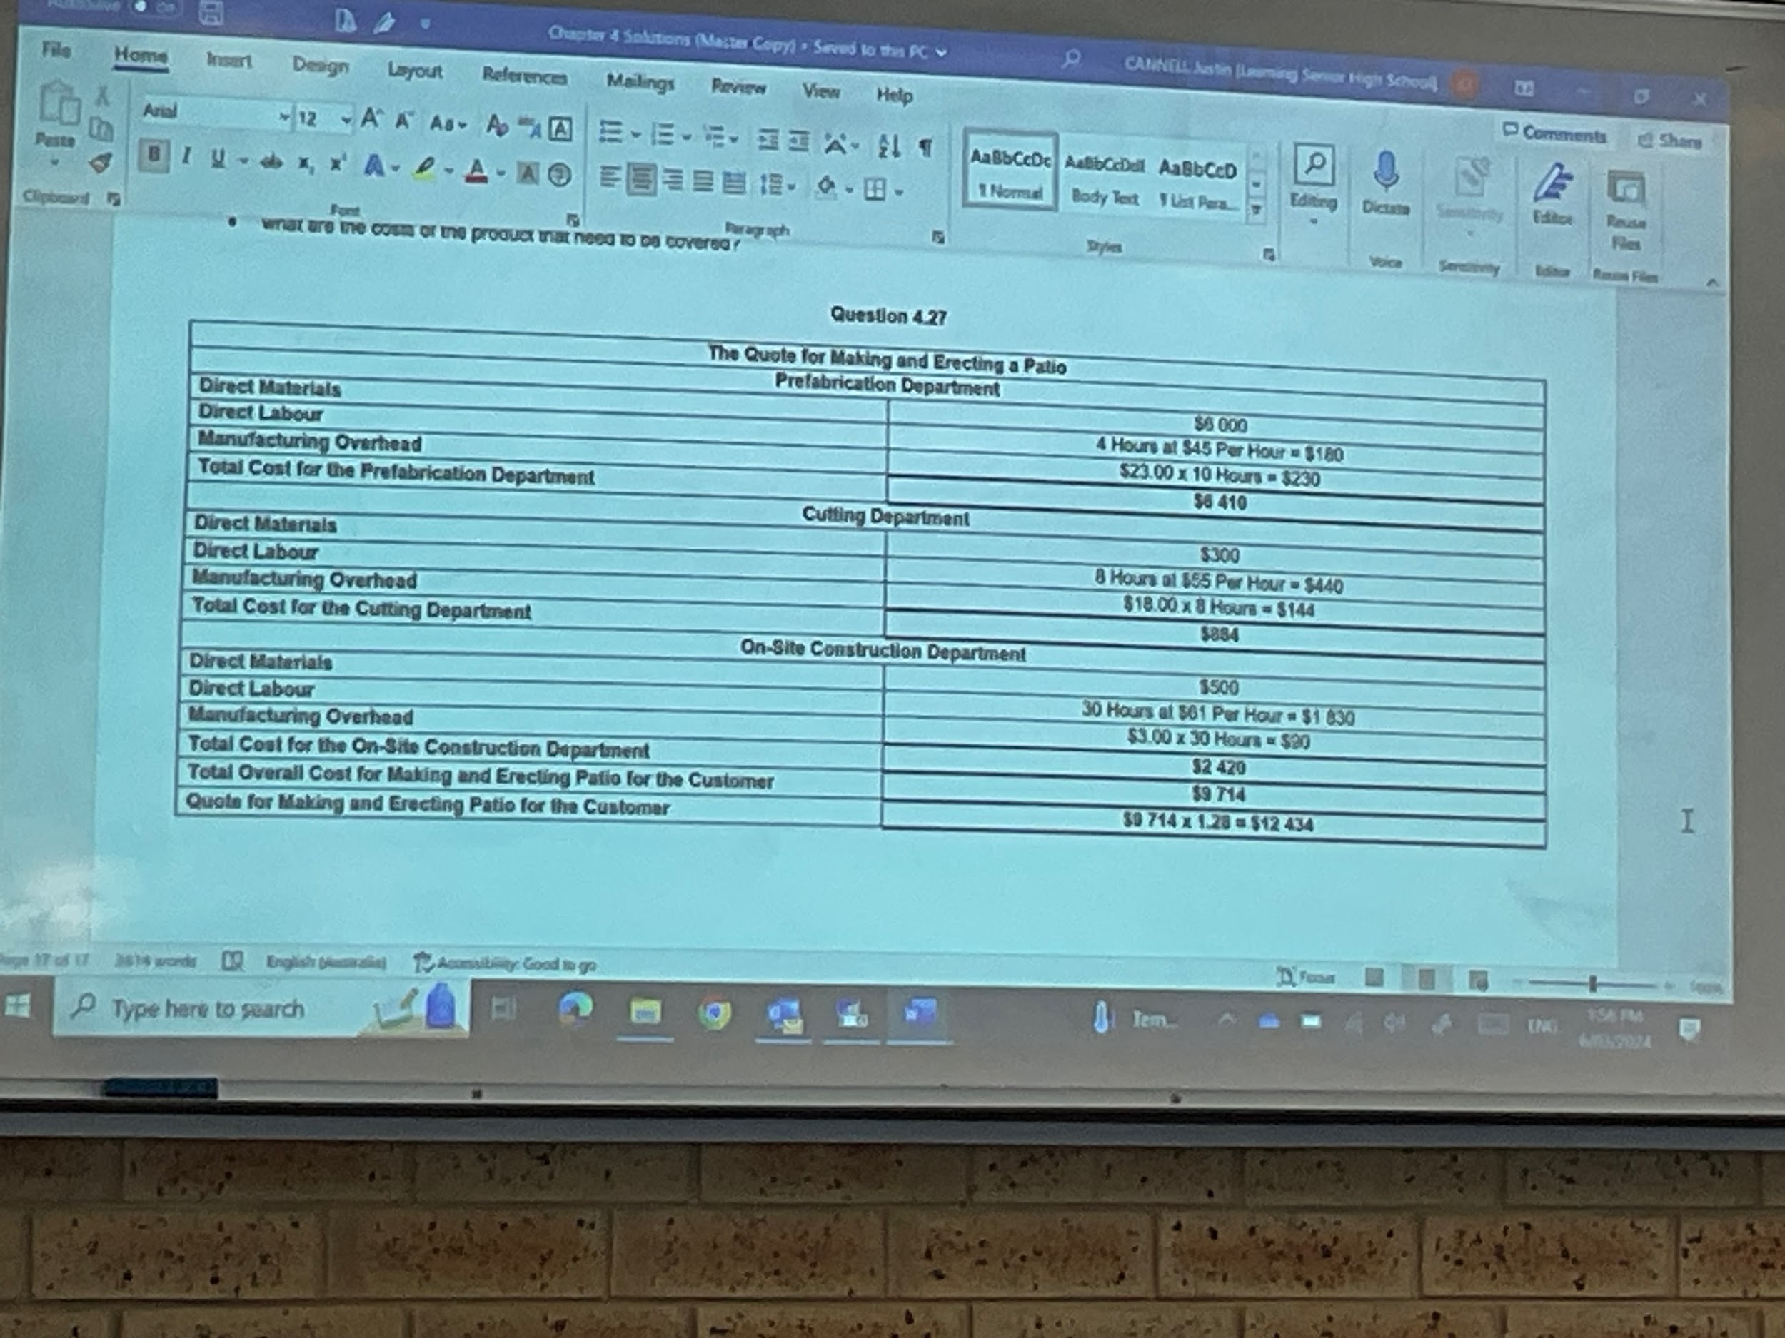

7/3/24

Define each of the following terms and provide examples of the types of costs that would be included:
- Fixed costs
Costs that do not change with the level of business activity.
In a manufacturing business: cost of depreciation is calculated based on the expected life of the machine, not on its use.
Other examples include insurance, licences on vehicles, wages of supervisory staff.

- Variable costs
Costs that change in proportion to the level of production. Includes cost of materials used in the manufacturing process to make each unit, the wages of factory workers per unit and the amount of energy used in production (oil, gas, electricity, etc.)

- Mixed costs
Some costs are a mixture of both fixed and variable costs and the cost accountant will need to apportion them between the two types of costs. This will involve estimation, meaning that CVP analysis is not an exact calculation.
Mixed costs can include wages where the fixed element is the normal weekly wages of production staff and the variable component is any overtime required.
Electricity to light and air-condition the business premises is relatively fixed, but increased production would increase electricity used by production machines, which is a variable cost.

Fred runs a fast food shop making hamburgers. Identify whether the following expenses are fixed or variable costs.

Type of costs | Variable costs | Fixed costs | Mixed costs
Electricity |  |  | X
Packaging | X
Wages - full time |  | X
Wages - casual | X
Water | X
Materials purchased | X
Depreciation on equipment |  | X
Depreciation on office furniture |  | X

How is the break-even point calculated and why is it necessary for it to be calculated?

The break-even point for a product is the volume of production at which the income from the number of units produced and sold (i.e. total sales) is equal to the total costs. This will not produce a profit or a loss but ‘break-even’.

To calculate the break-even point, the profit is set to zero and we calculate the number of units required.
(S*X) = P + FC + (VC*X) where profit = 0
- S = Selling price per unit
- X = number of units produced and sold
- VC = variable costs per product
- FC = total fixed costs

8/3/24

5.5
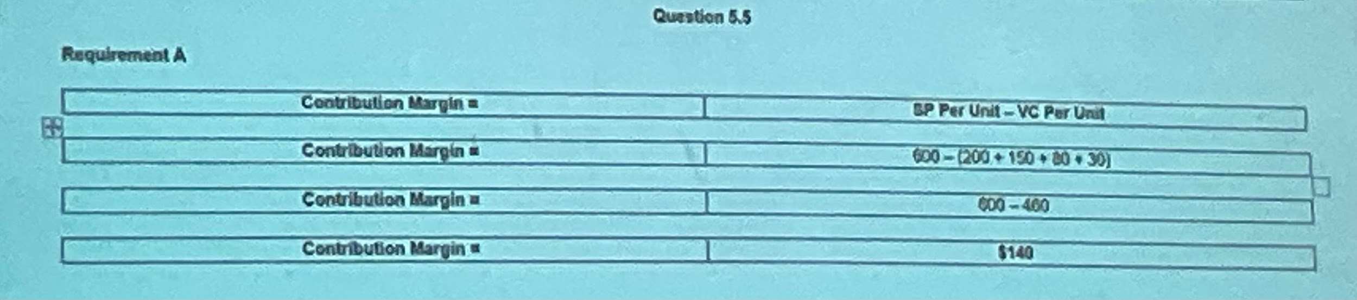
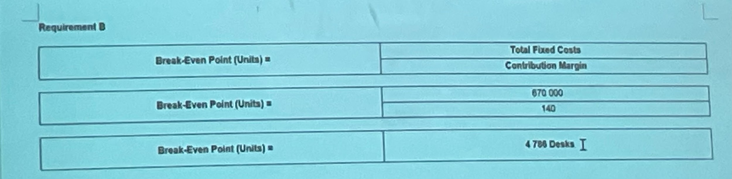
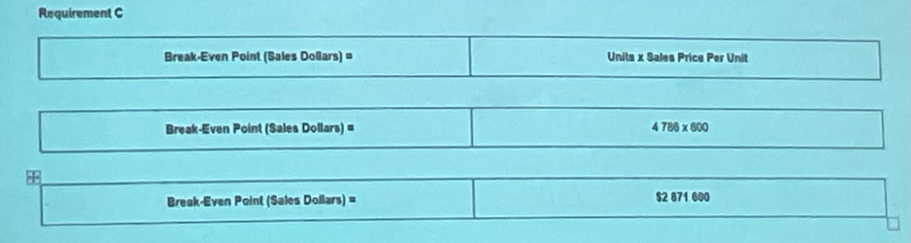
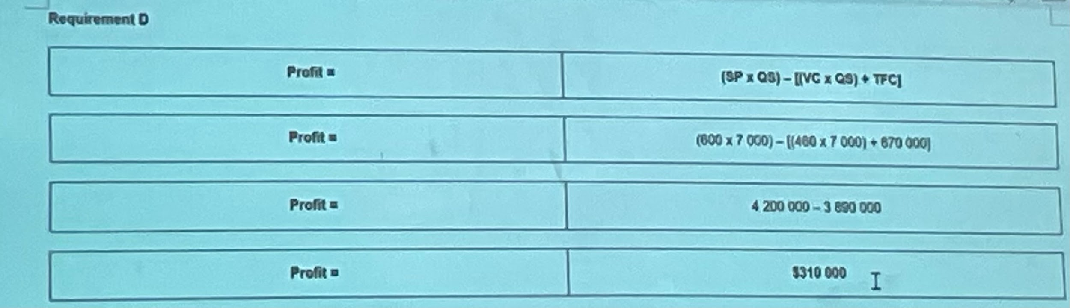
Test 2 notes:
Nature of costs
- A cost object is any object for which we require a value or any object for which costs are measured and assigned. Examples of cost objects are a product, a service, a process, an activity, and a customer.

Cost behaviours:
- Fixed costs
Costs that do not change with the level of business activity.
In a manufacturing business: cost of depreciation is calculated based on the expected life of the machine, not on its use.
Other examples include insurance, licences on vehicles, wages of supervisory staff.

- Variable costs
Costs that change in proportion to the level of production. Includes cost of materials used in the manufacturing process to make each unit, the wages of factory workers per unit and the amount of energy used in production (oil, gas, electricity, etc.)

- Mixed costs
Some costs are a mixture of both fixed and variable costs and the cost accountant will need to apportion them between the two types of costs. This will involve estimation, meaning that CVP analysis is not an exact calculation.
Mixed costs can include wages where the fixed element is the normal weekly wages of production staff and the variable component is any overtime required.
Electricity to light and air-condition the business premises is relatively fixed, but increased production would increase electricity used by production machines, which is a variable cost.

Relationships to cost objects:
- Direct costs
A cost easily able to be traced to a product or service with a high level of accuracy. This cost is physically and easily (economically and conveniently) traced to the finished product.
Examples: wages of a mechanic in a car repair business, cost of bottles in wine production, cost of metals in building a car.

- Indirect costs
Costs that are not so easily traced to a product or service. These are items not incorporated into the product or are too insignificant to make it worth tracing the cost to the finished product.
Examples: salary of a factory manager, local government rates and taxes, and business insurance of premises.

Treatment of costs:
- Product costs
Includes all costs attributable to a product and are recorded as an expense in the period in which the product is sold and this will be recorded as the cost of goods.
Examples: computers sold by a computer shop and commercial loans from banks

- Period costs
Any costs that aren’t product costs. They are an expense and therefore are shown in the business’s Income statement in the period in which they are incurred.
Examples: advertising, office rent, wages paid to sales personnel.

Time orientation of costs:
- Standard cost: a predetermined cost and based on some preconceived benchmark of what is considered appropriate to the making of a product.
  - This benchmark of quantity of input -> standard input
  - Benchmark price -> standard price
  - Total standard cost = standard price * standard quantity
- Standard costing is a system of product costing where the cost of a product is based on standard costs for direct materials, direct labour and manufacturing overheads.

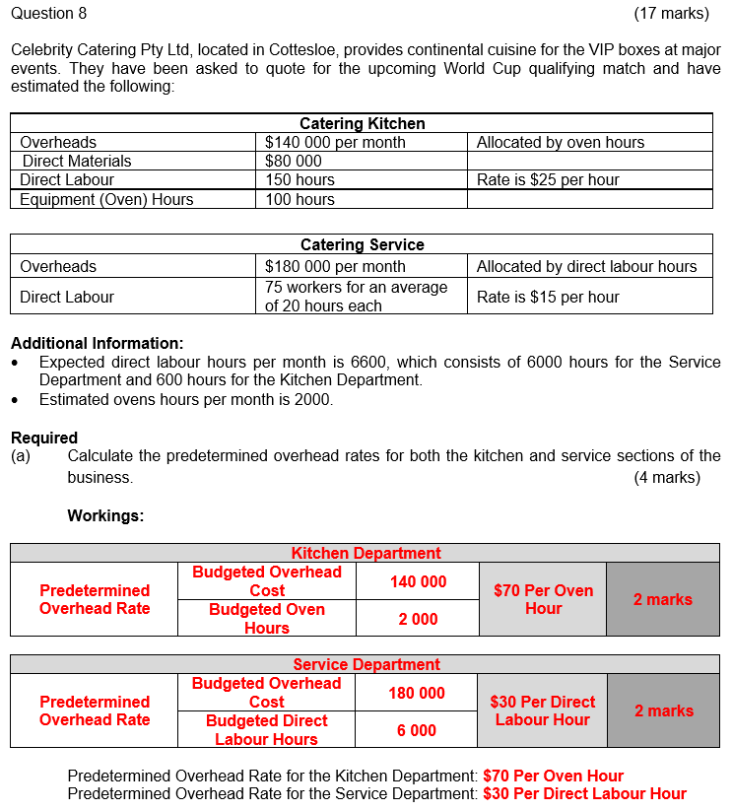
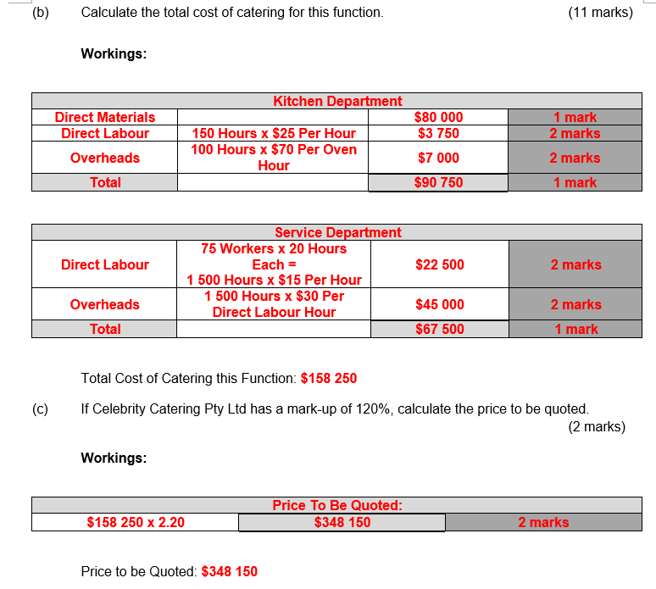
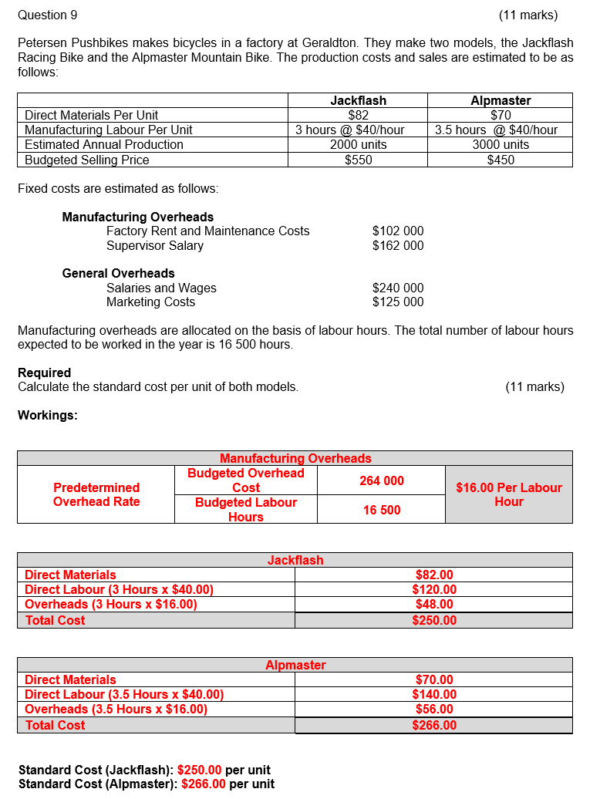

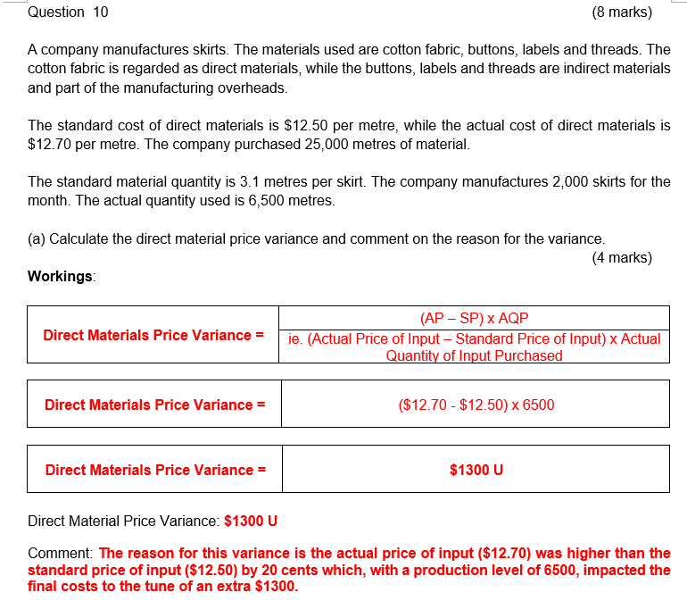

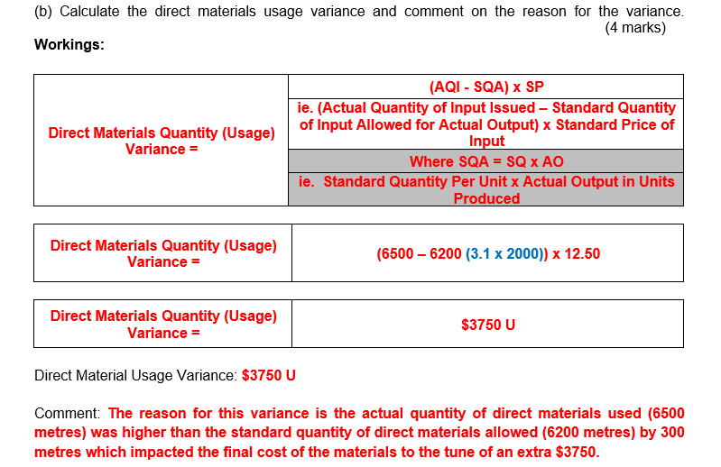
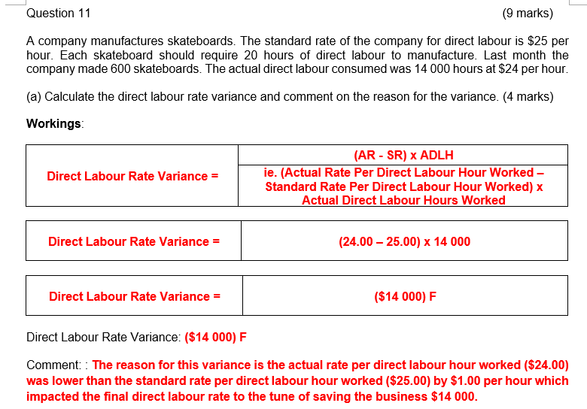
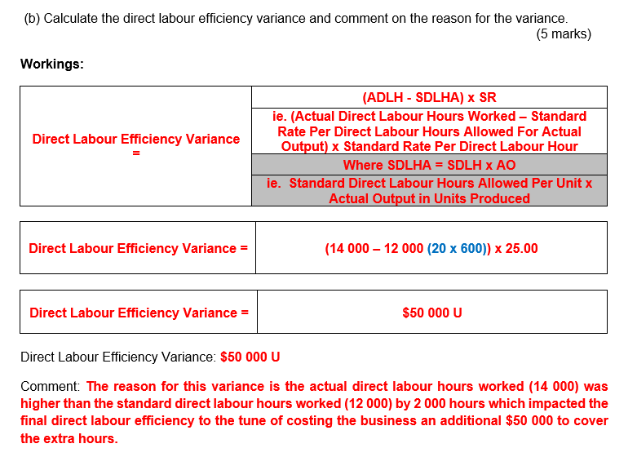

12/3/24

5.7
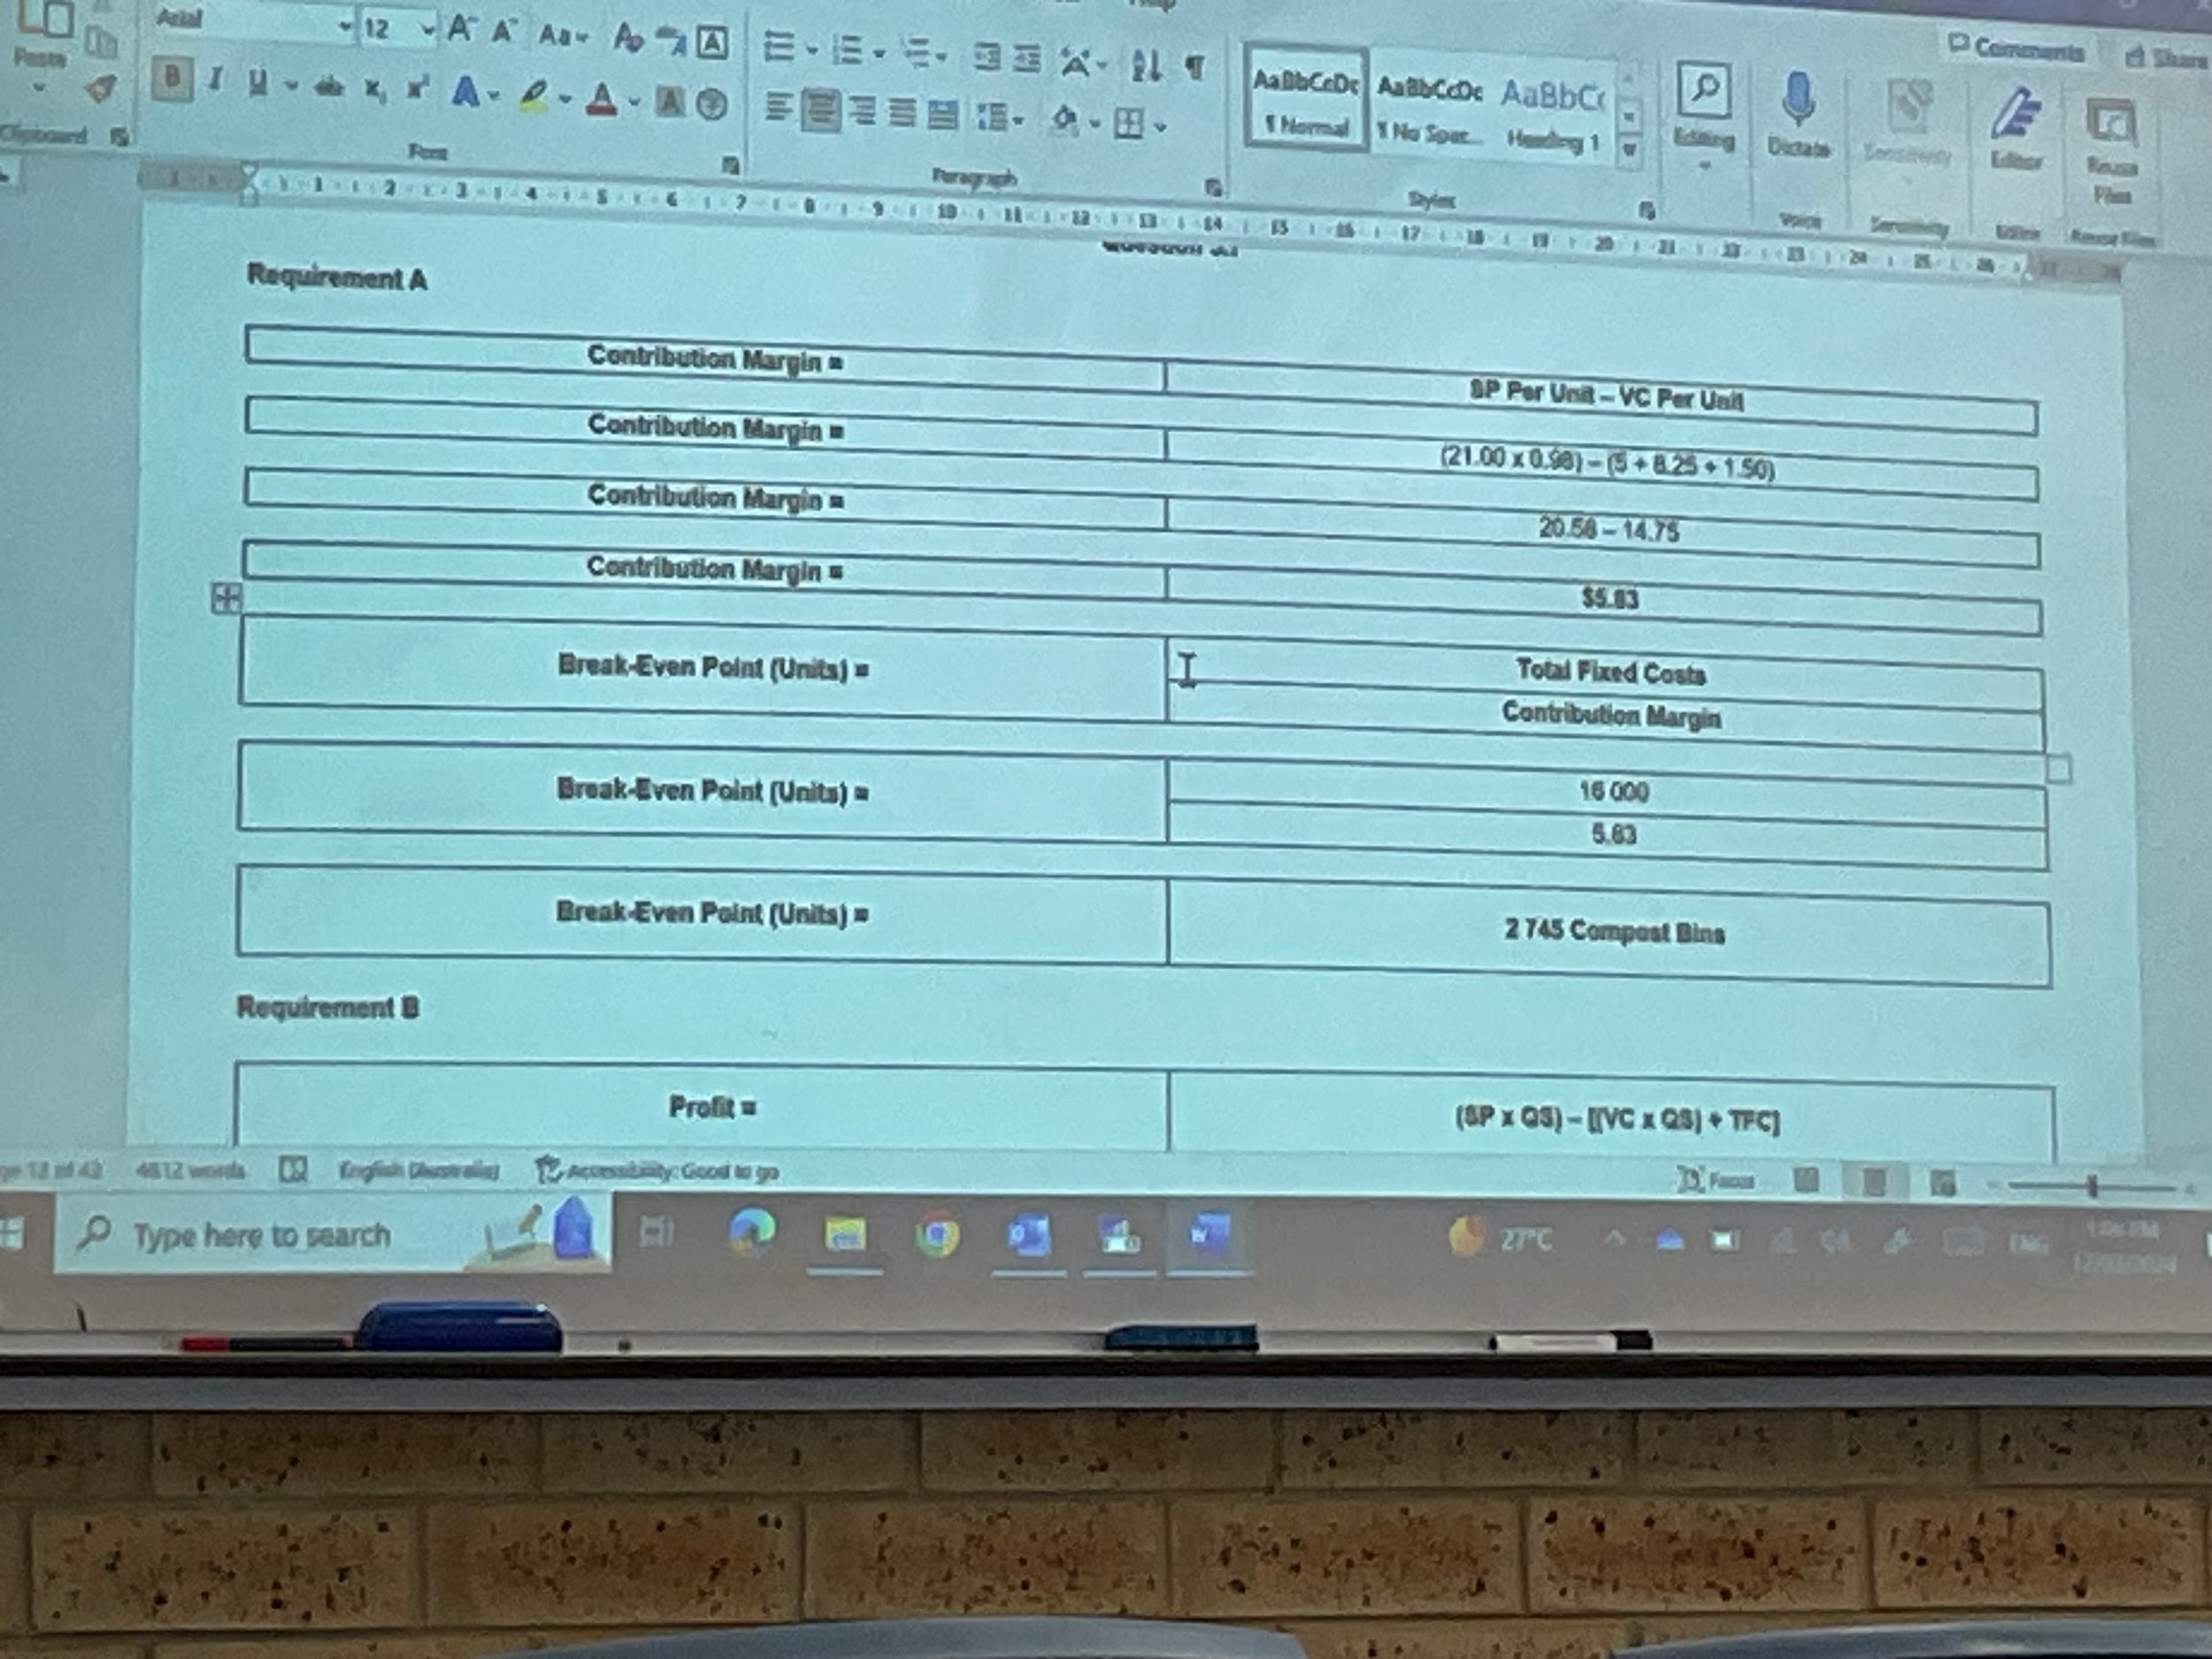
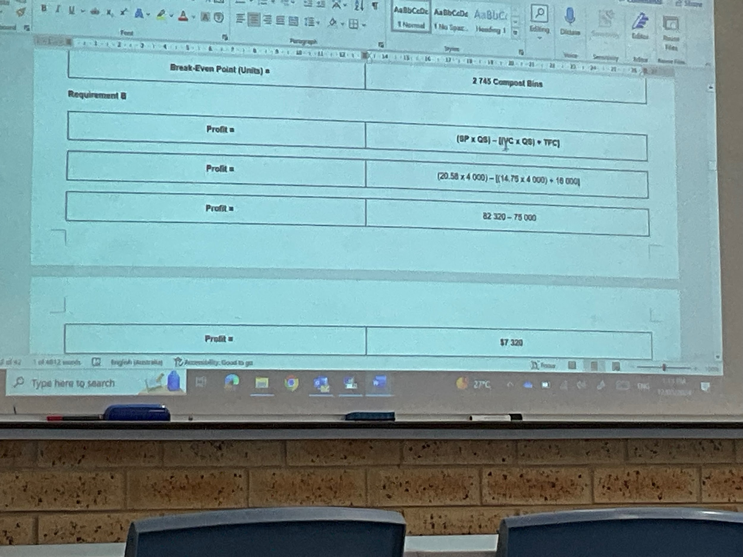
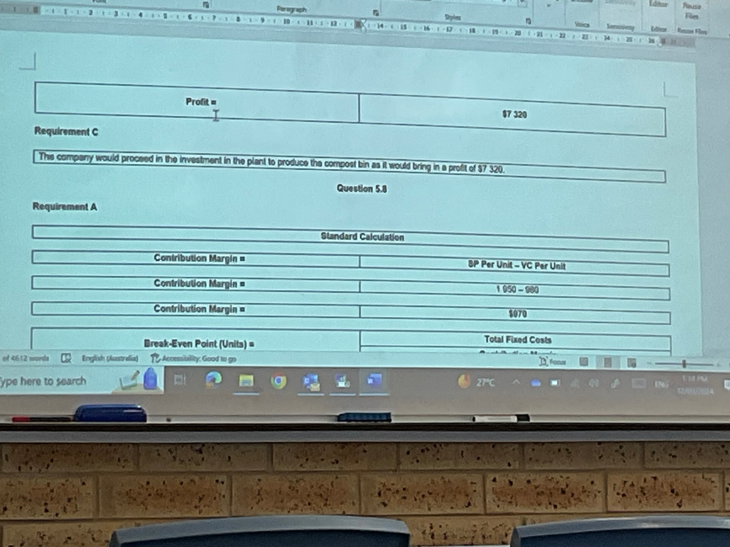

15/3/24
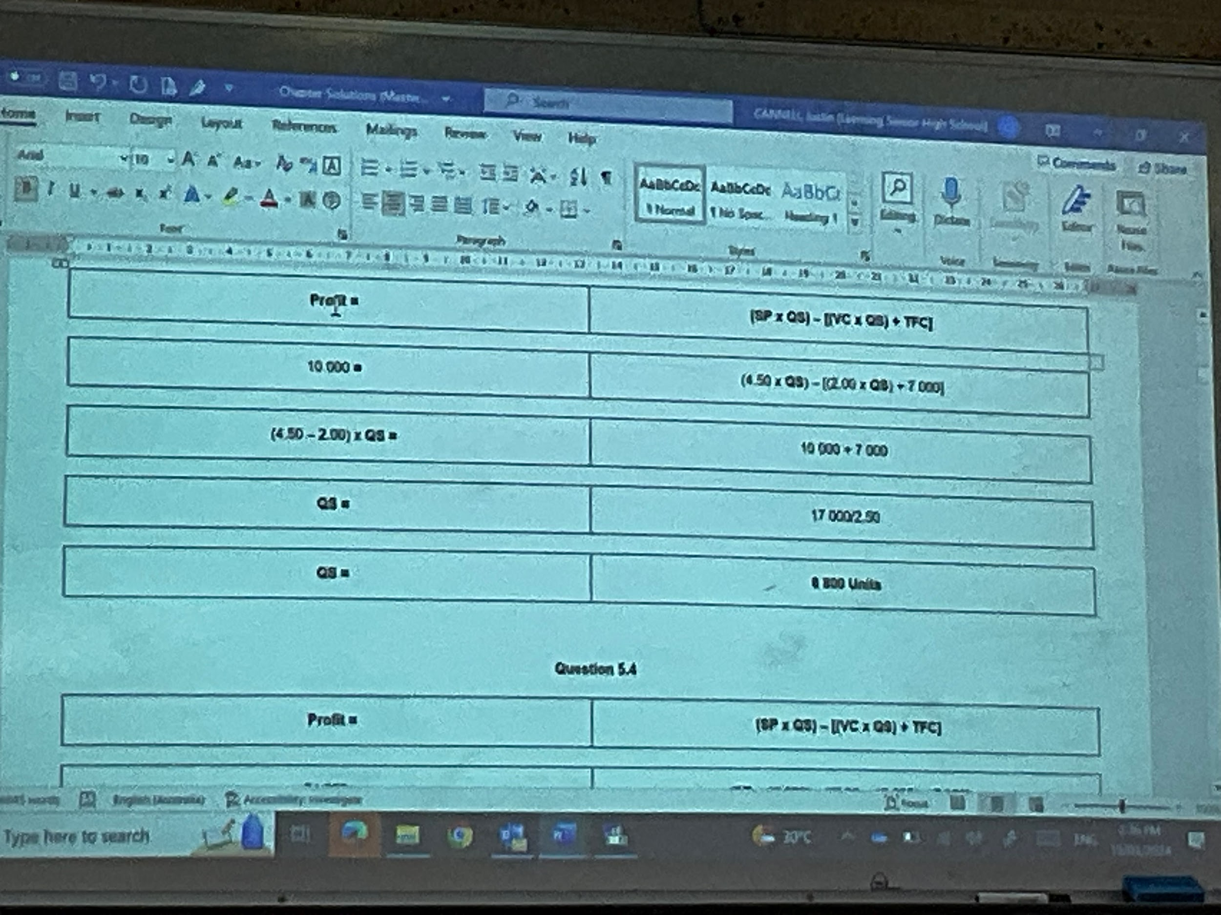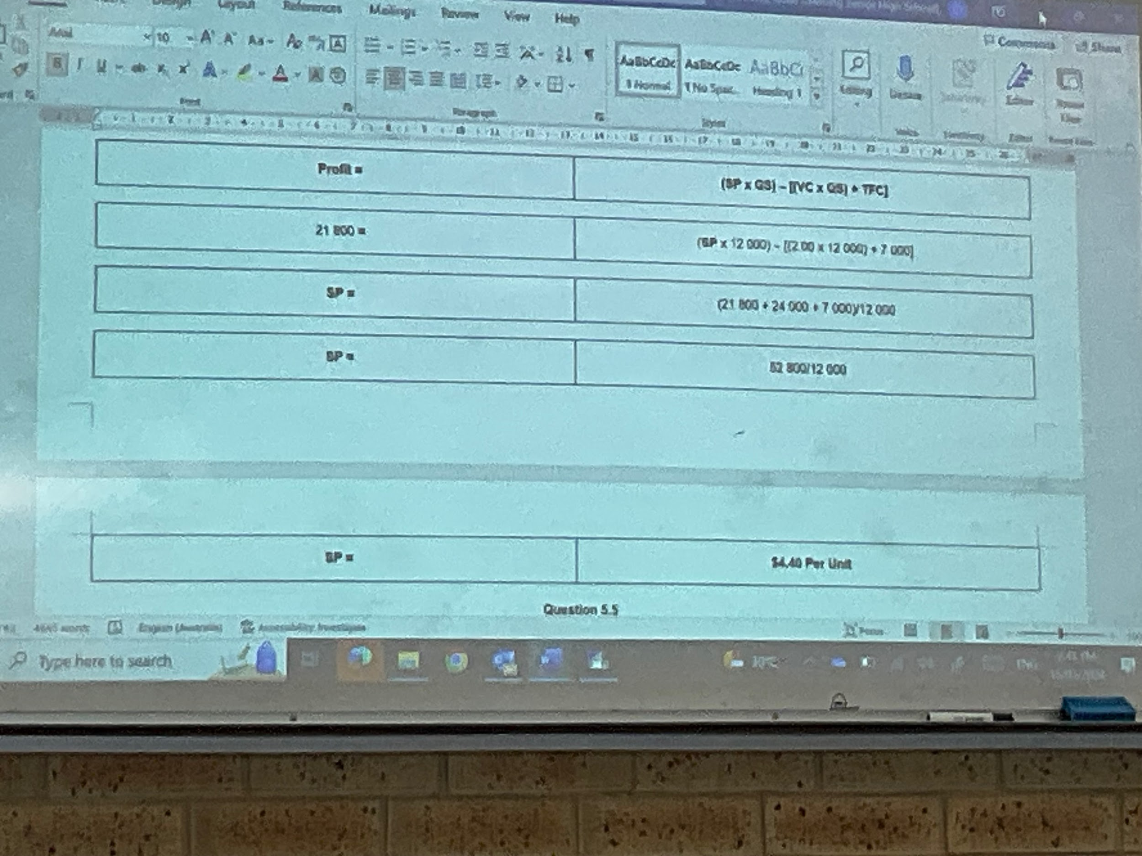

18/3/24
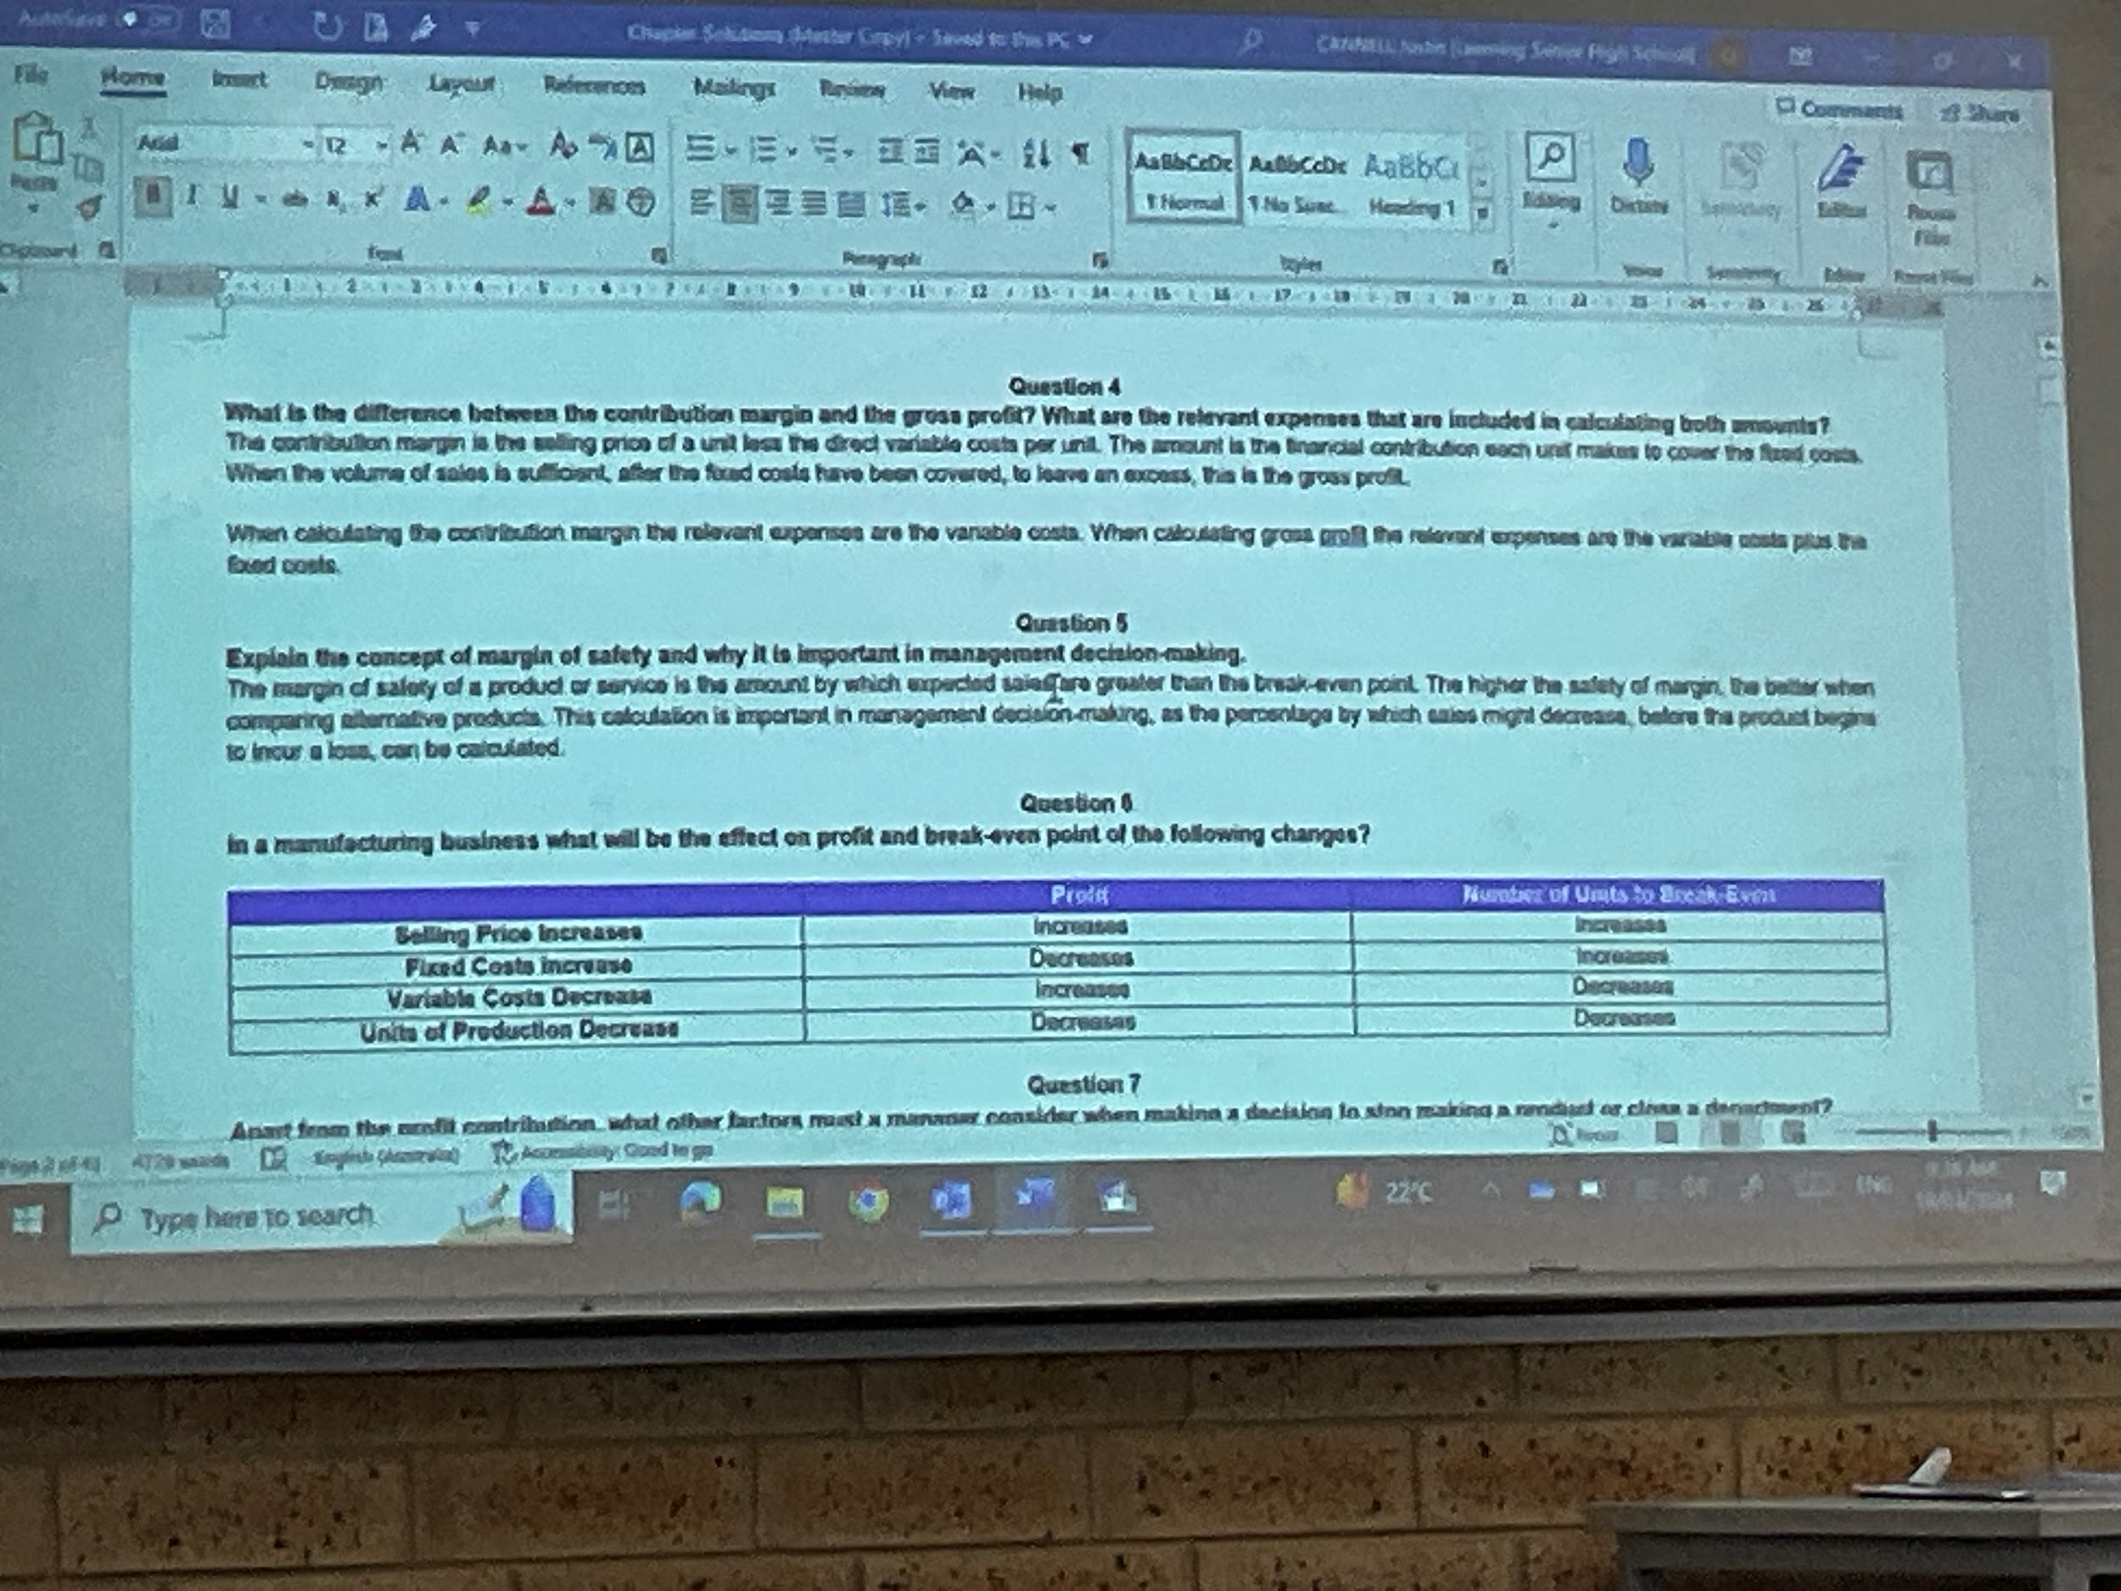
5.5
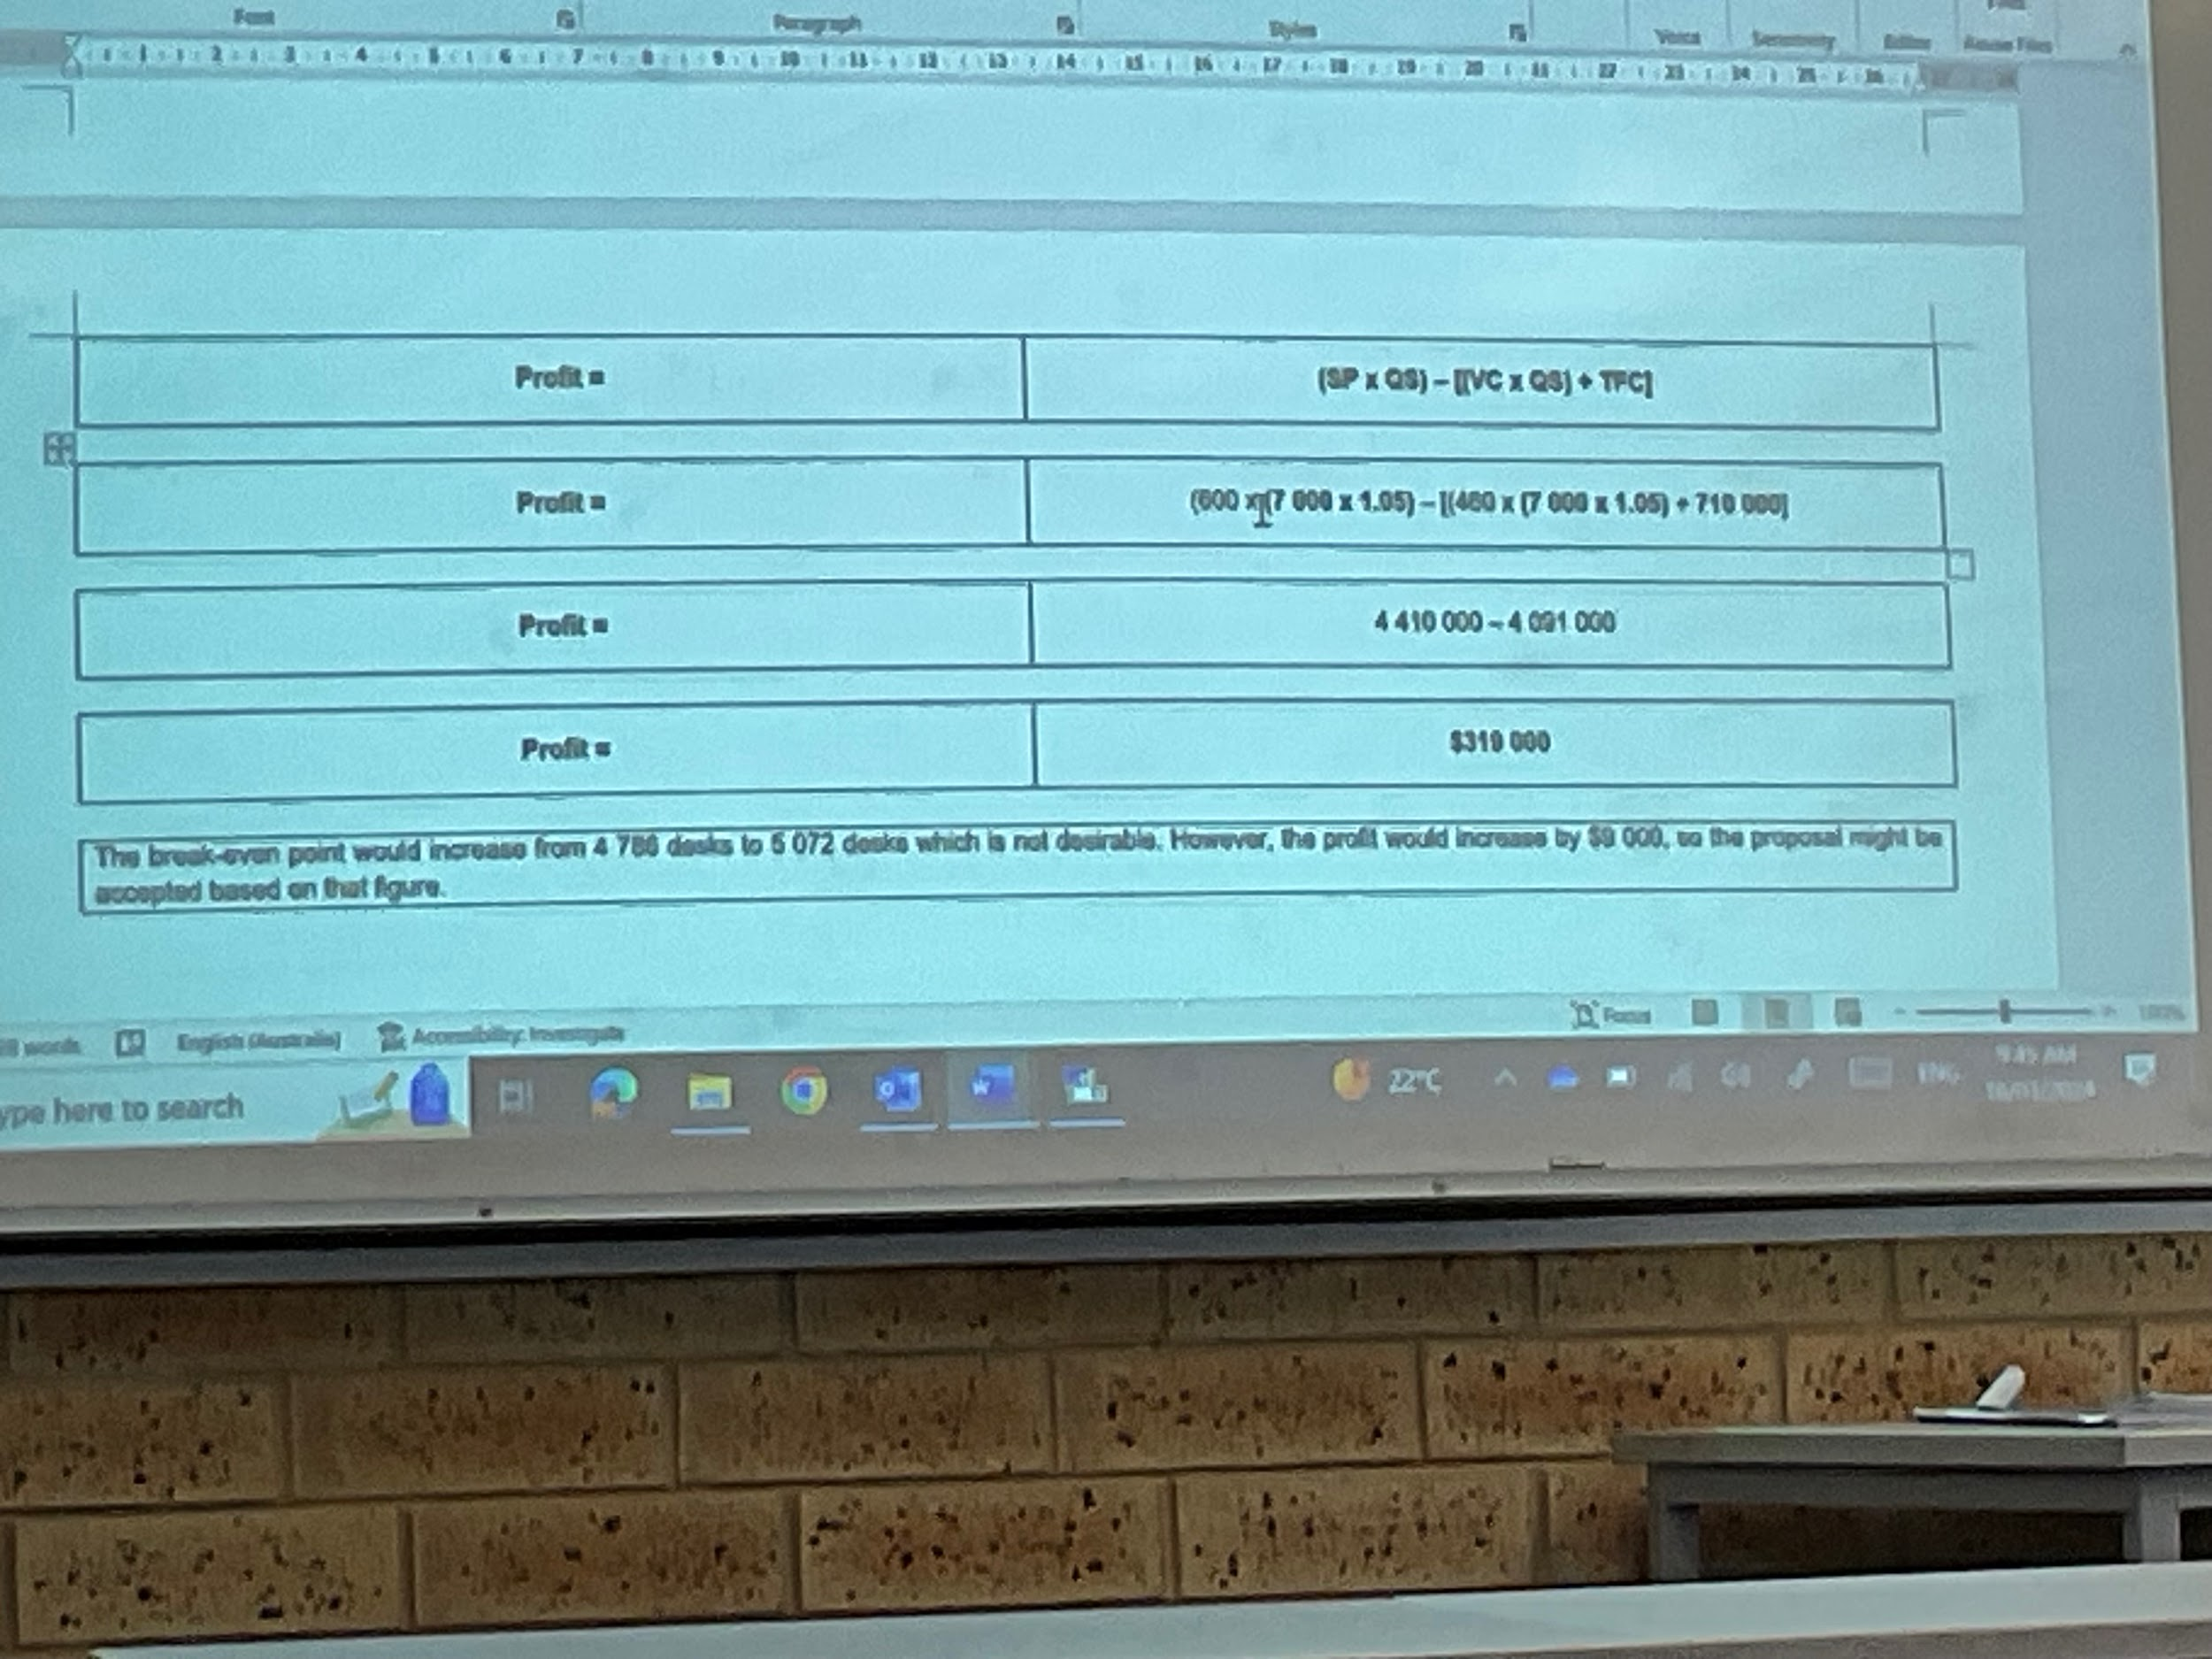
G.
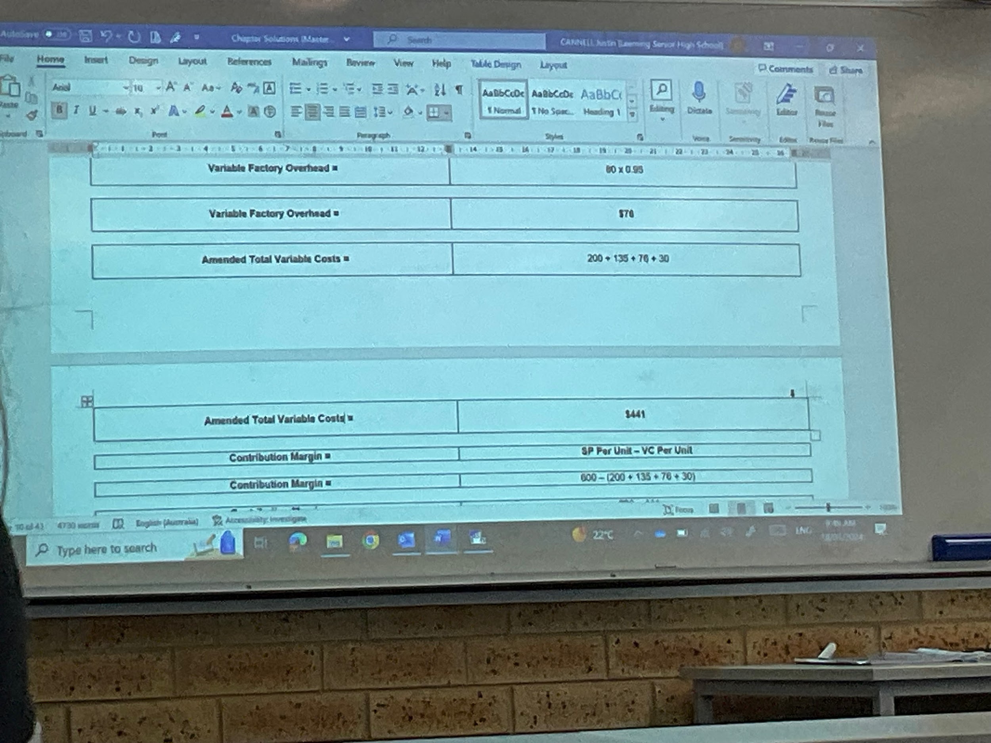
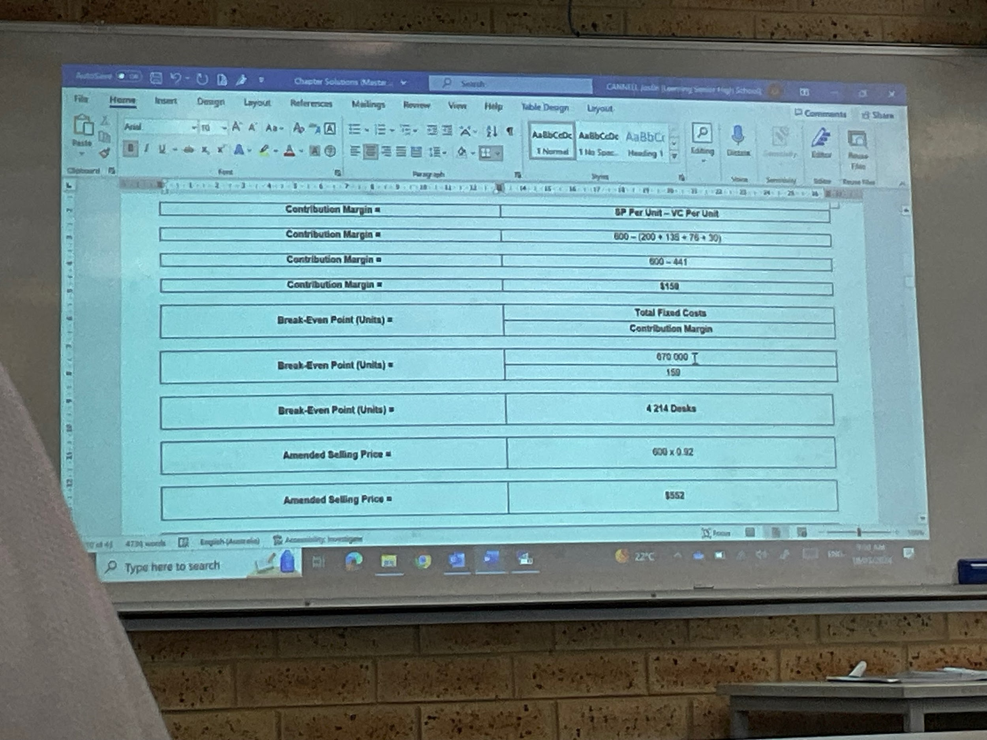
Amended sales volume: 7000*1.07 = 7490 desks

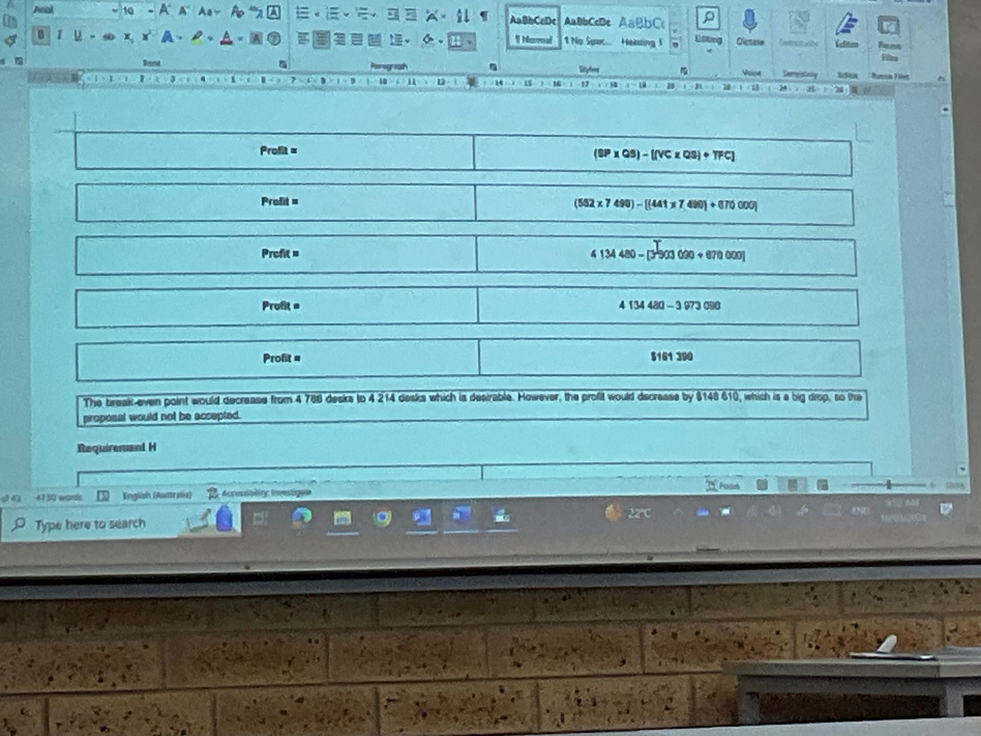

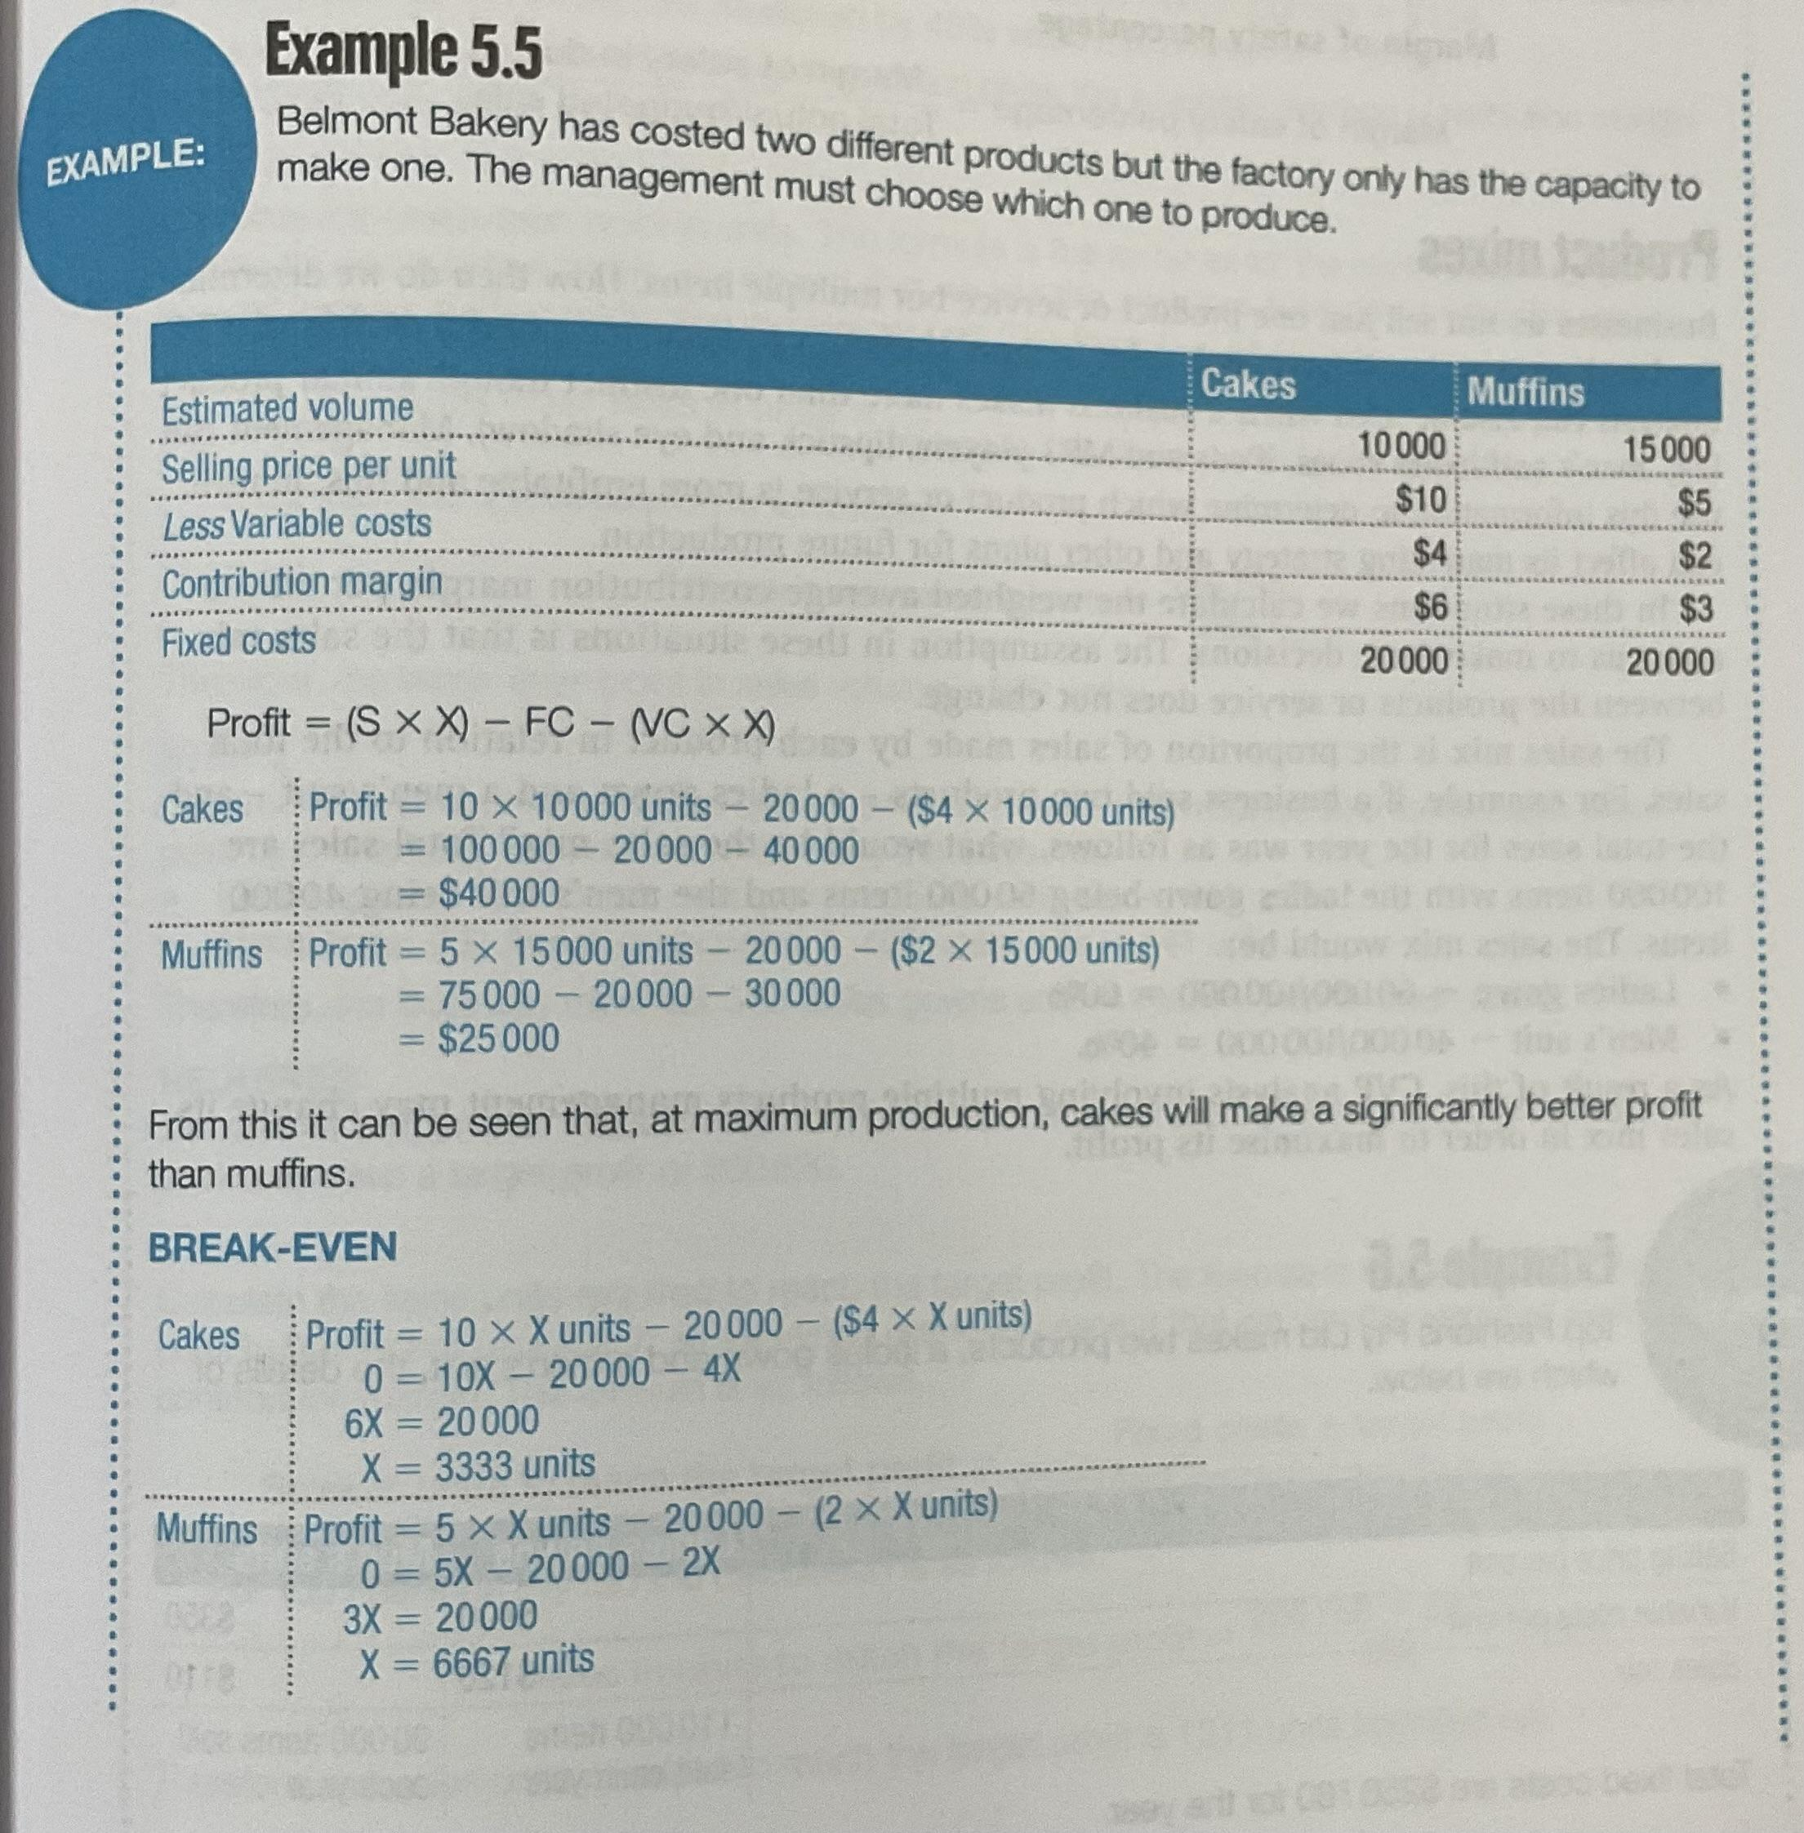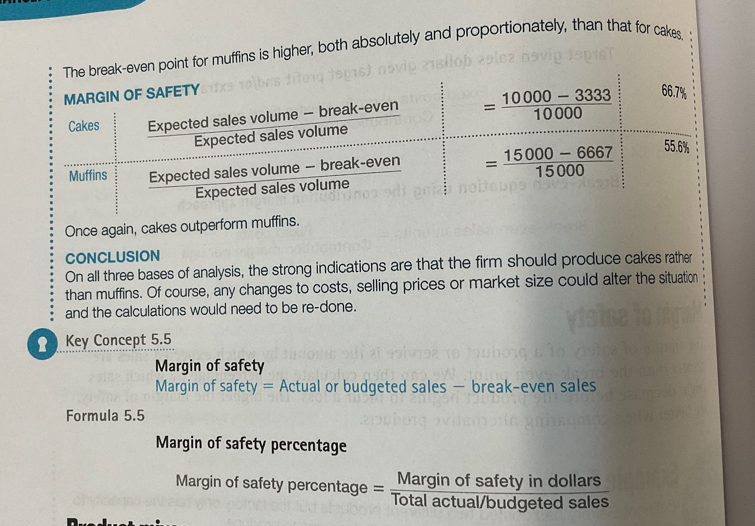

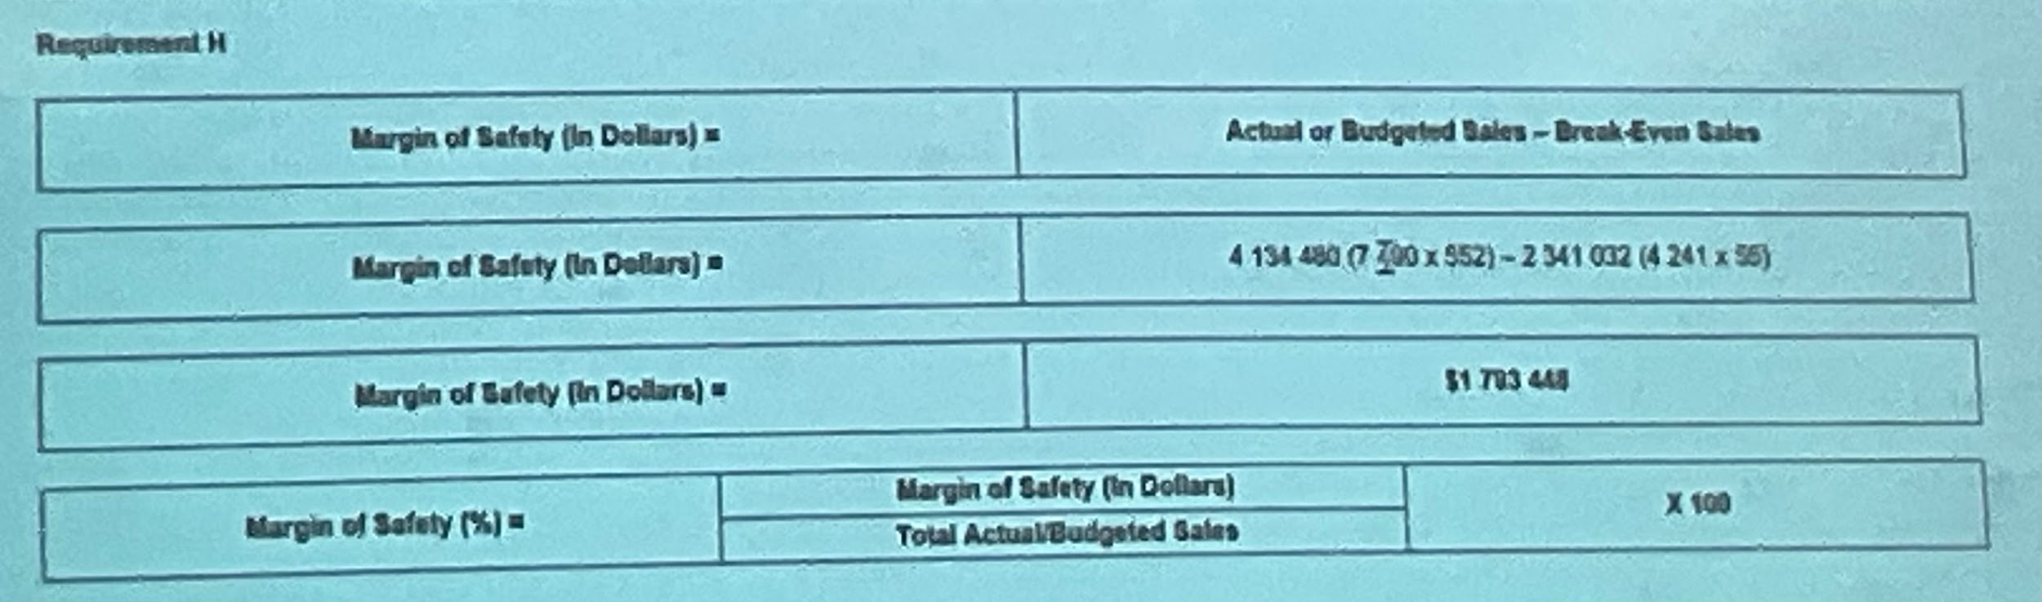
Margin of safety = 1793448/4134480 = 43.4%

5.7
- Contribution margin = 21(0.98) - 14.75 = $5.83
BEP = 160000/5.83 = 16000/5.83 = 2745 bins
- Profit = SP*QS - ((VC*QS) + TFC)
20.58(4000) - (14.75*4000 + 16000) = $7320
- The BEP is quite high, at over half of expected production per year which can be seen as undesirable, however the expected profit is also good, at $7320 so the business should proceed with the investment.

5.8
- Contribution margin = $4 850 000/5000 = $970 per unit
Total fixed costs = $1 860 000
Break even point = 1860000/970 = 1918 computers sold
BEP (sales) = 1950(1918) = $3740100
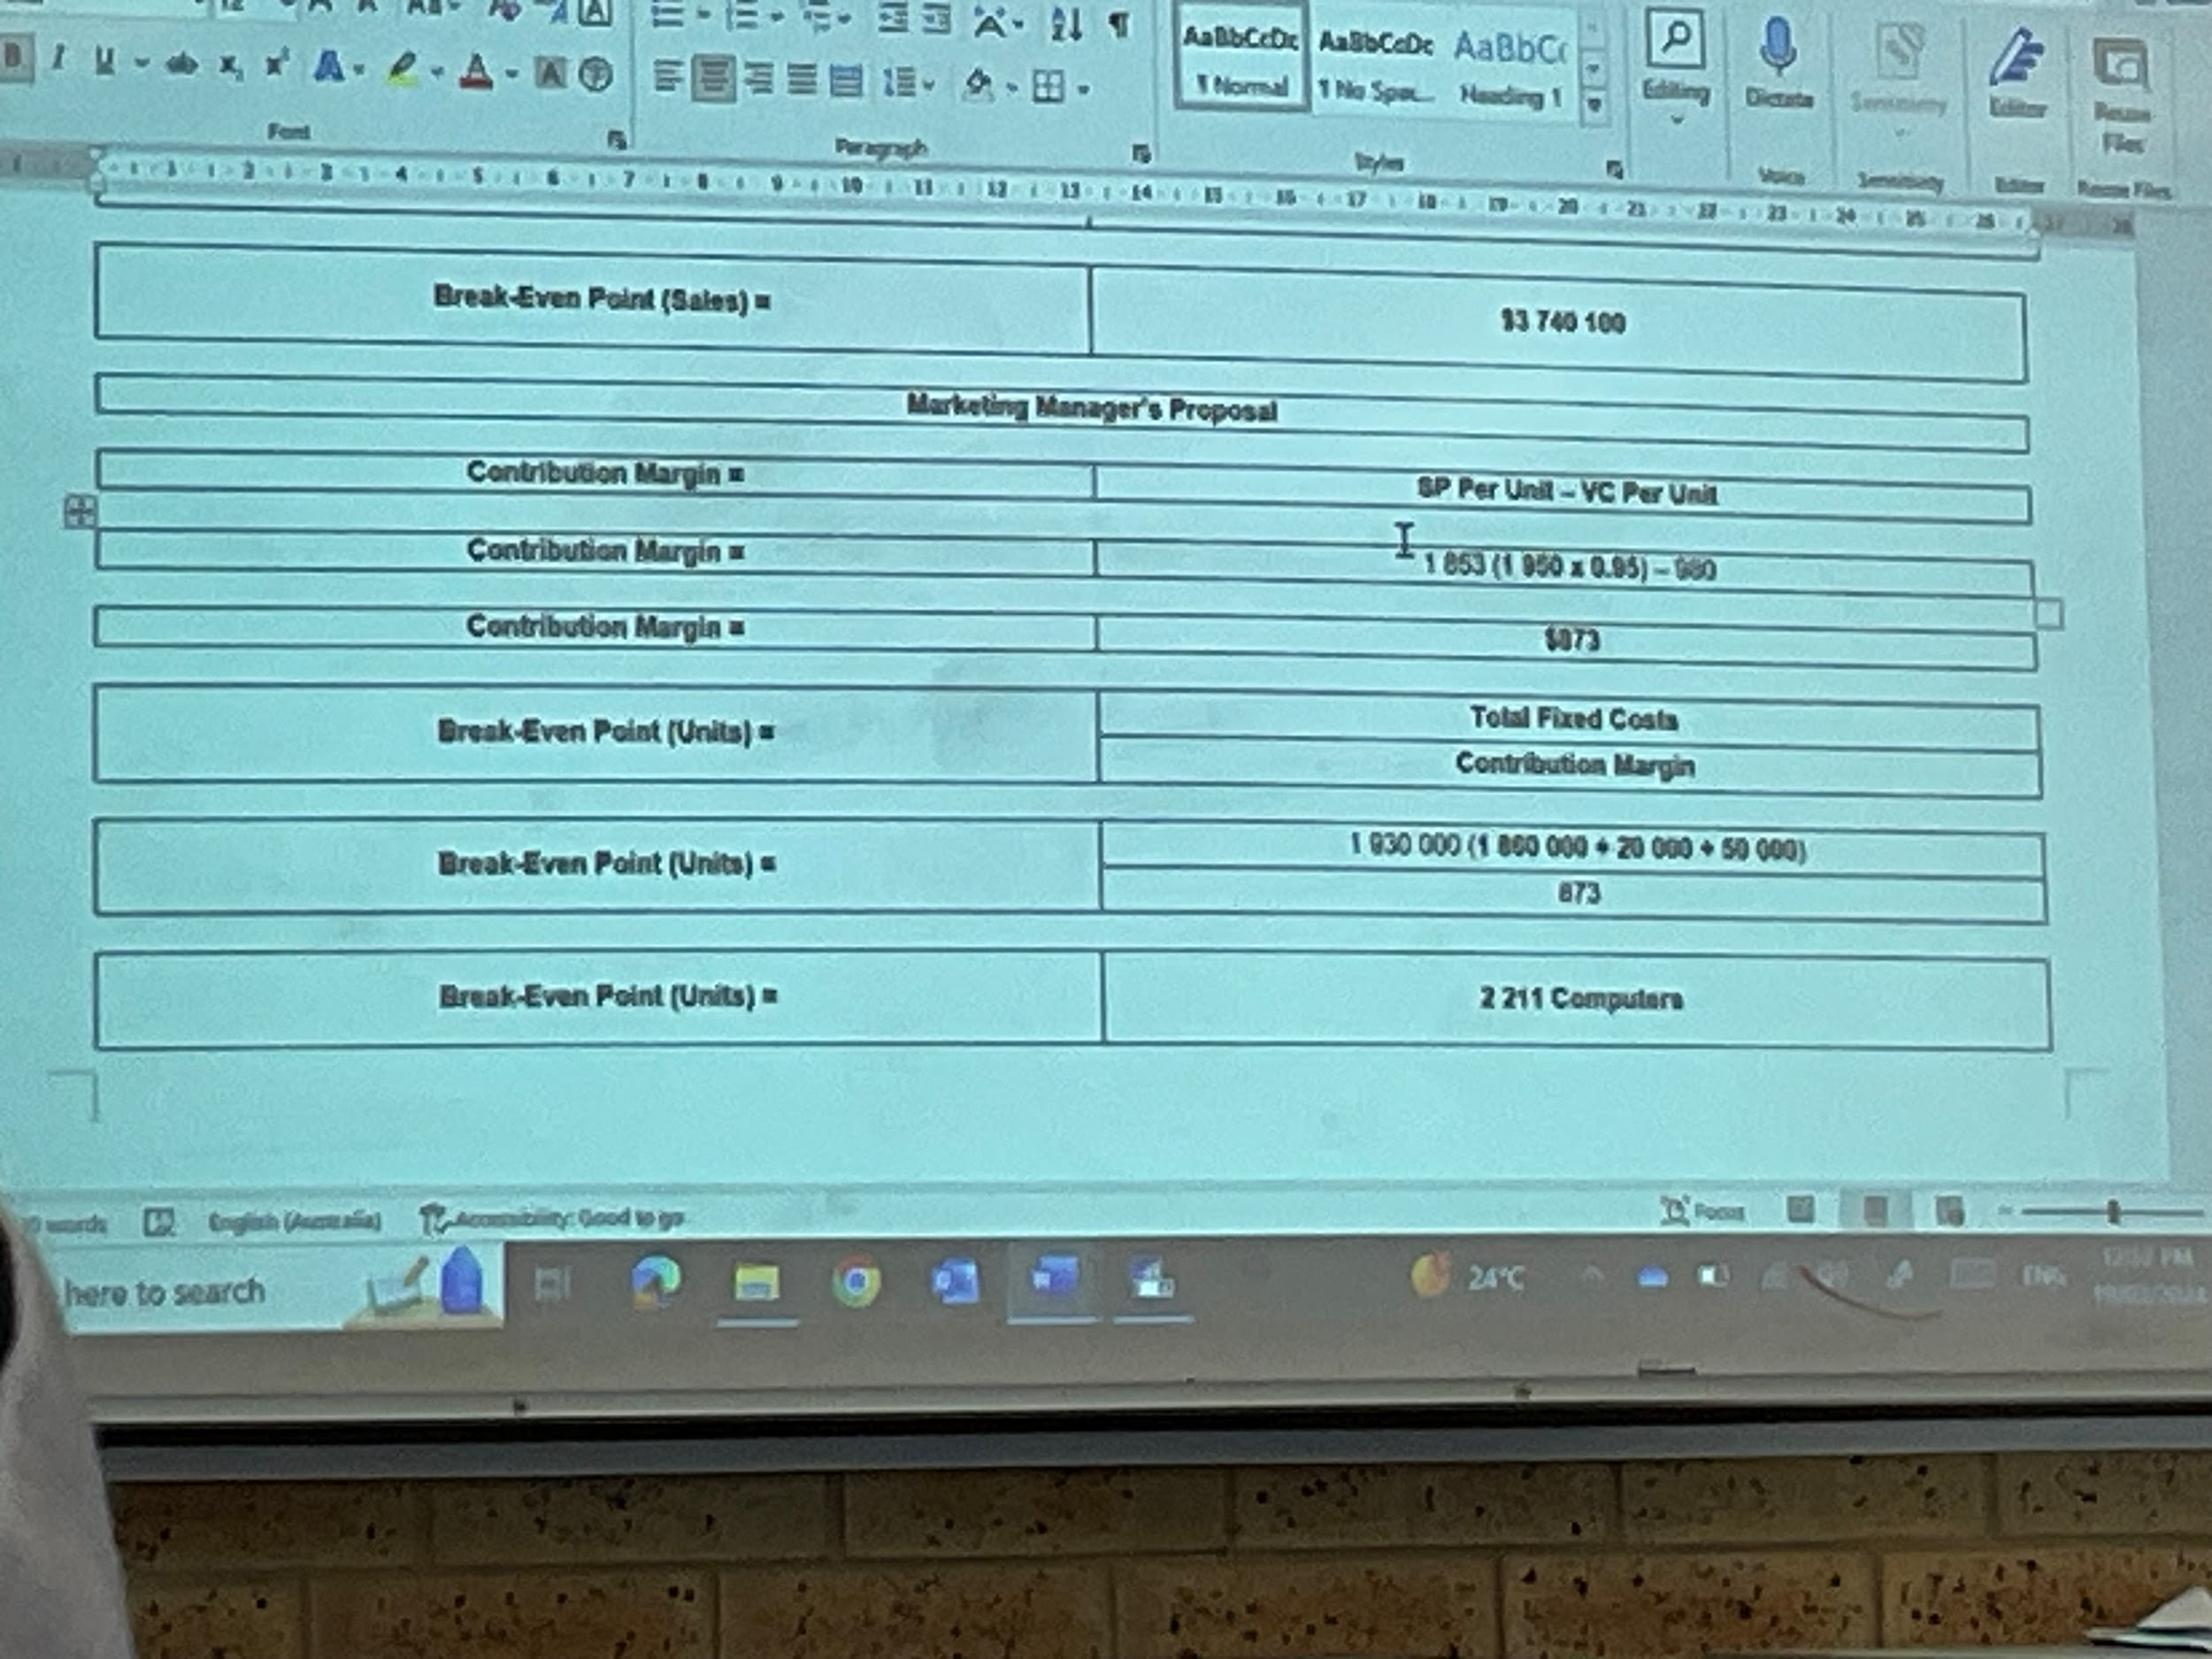
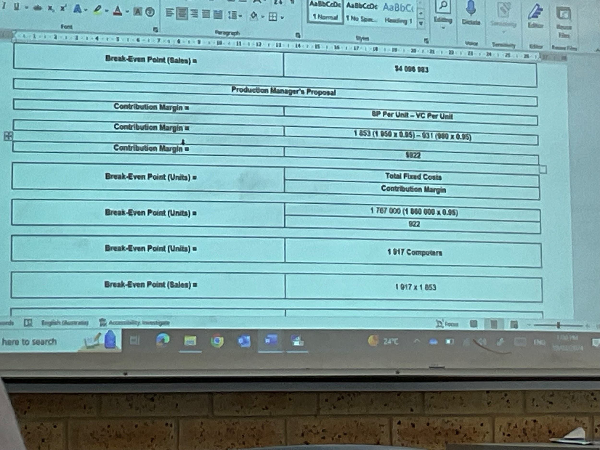Proposal one (marketing manager):
CM = 1950(0.95) - 980 = $873
BEP (units) = (1860000 + 20000 + 50000)/873 = 2211 computers sold
BEP (sales) = 2211 (1853) = $4096983

Proposal two (production manager):
CM = 1950(0.95) - 980(0.95) = $922
BEP (units) = 1860000(0.95) / 922 = 1917 computers
BEP (sales) = 1917 (1853) = $352201

- MOS (Standard calculation):
MOS (dollars) = 9750000 - 3740100 = $6009900
MOS (%) = 6009900 / 9750000 (100) = 61.64%

MOS (Marketing manager):
MOS (dollars) = 9750000(0.95)(1.1) - 4096983 = $6091767
MOS (%) = 6091767 / 10188750 (100) = 59.79%

MOS (production manager):
MOS (dollars) = 9750000(1.1) - 3552201 = $7172799
MOS (%) = 7172799 / 1072500 (100) = 66.9%

- Standard calculation
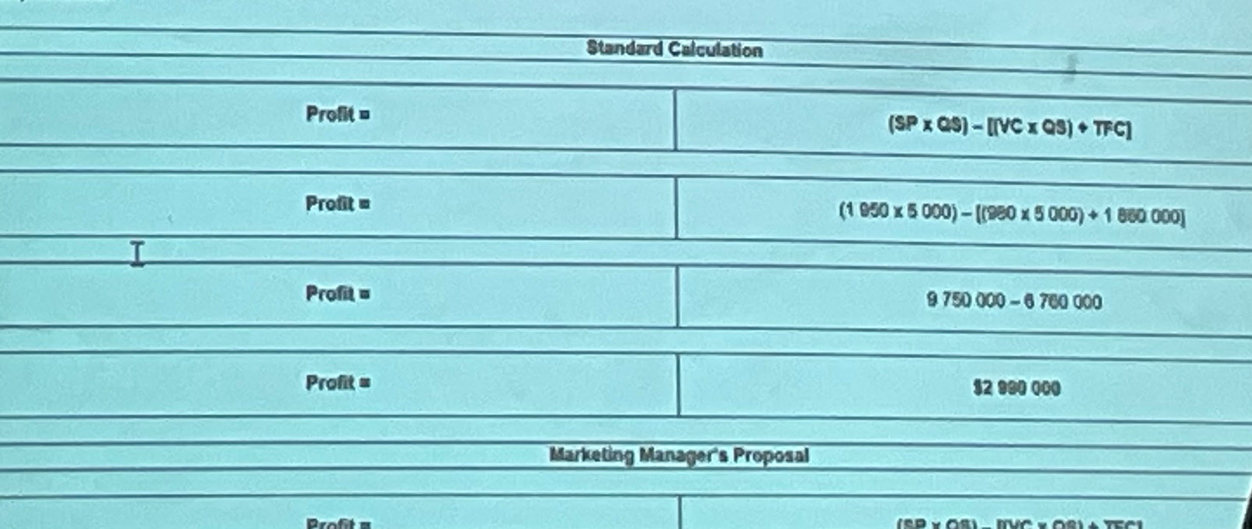

Marketing manager calculation
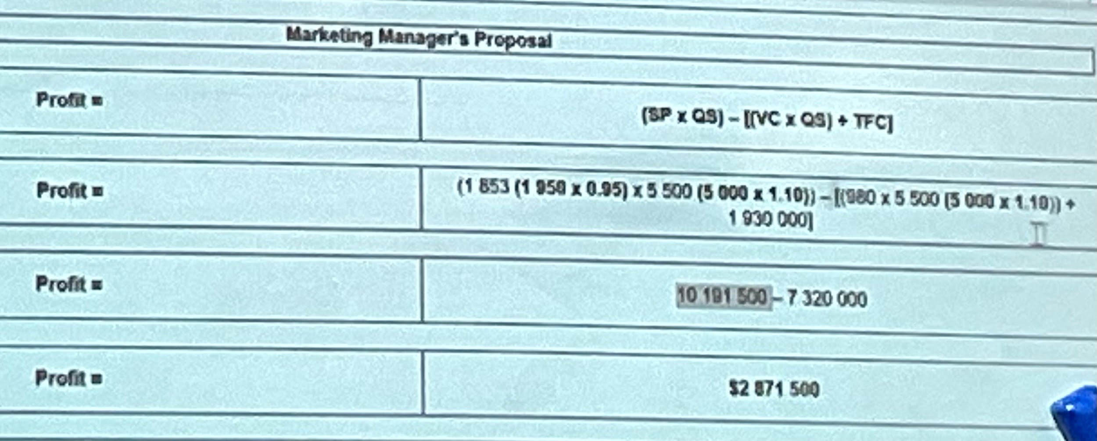

Production manager calculation
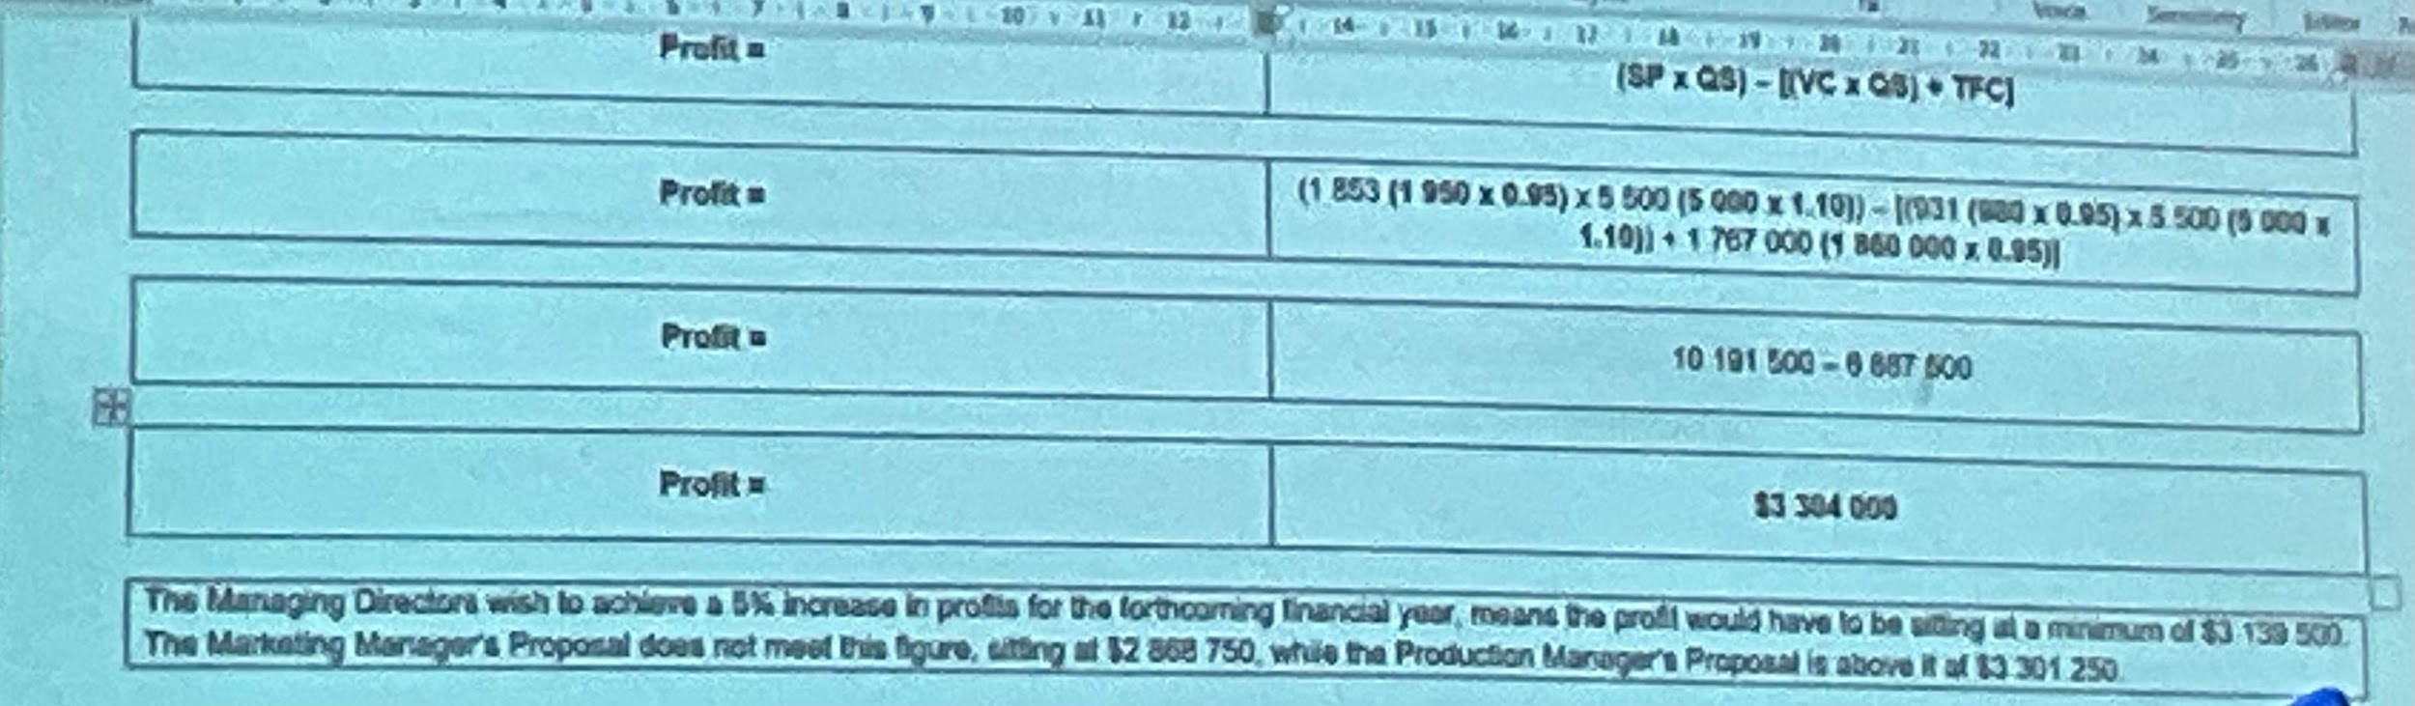

22/3/24

5.9
- BEP = TFC / CM
0 = 200000 / CM
CM = 200000 - 0
CM = $200000

- 200000 = selling price / 6
CM = TC - VC
200000 = 500000 - VC
VC = 300000
Number of units produced = total VC / VC per unit
= 300000 / 6
= 50000
Selling price per unit = 500000 / 50000
= $10

- 55000*10 = $550000 revenue
Total VC = 6*55000 = $330000
TFC = $200000
Profit = 550000 - 330000 - 200000
= $20000

5.11
- CM = SP - VC
= 2000 - (40 + 500 + 200 + 400)
= $860

Total CM = 860(600)
= $516000

- BEP (units) = TFC / CM
= 200000 / 860
= 233 units
BEP (sales) = 233(2000)
= $466000

- Profit = 860(600) - 200000
= $316000

- CMR = CM per unit / SP
= 860 / 2000
= 0.43 or 43%

- 1400000 / 2000 = 700 sold
New profit = 700(860) - 200000
= $402000
Profit difference = 402000 - 316000
= $86000
Increase of 27.2% in profit

- New fee = 2000(0.9)
= $1800
Advertising = $50000

CM = 860 - 200
= $660

BEP = 250000 / 660
= 379 units

Sales = (316000 + 250000) / 660
= 858 units
Therefore not a good proposal, and significantly increases BEP point as sales price reduces and increase in fixed costs.

- Profit: 316000 = Selling price*600(1.1) - [(400(0.95) + 40 + 500 + 200)660 + 200000(0.9)
= SP*660 - [(1120)660 + 180000)
= SP*660 = 919200
SP = 1235200 / 660
SP = $1920

- MOS = Actual/budgeted sales - break even sales
= 2000(660) - 466000
= 734000

MOS% = MOS / Actual/budgeted sales
= 734000/1200000
= 61.2%

5.13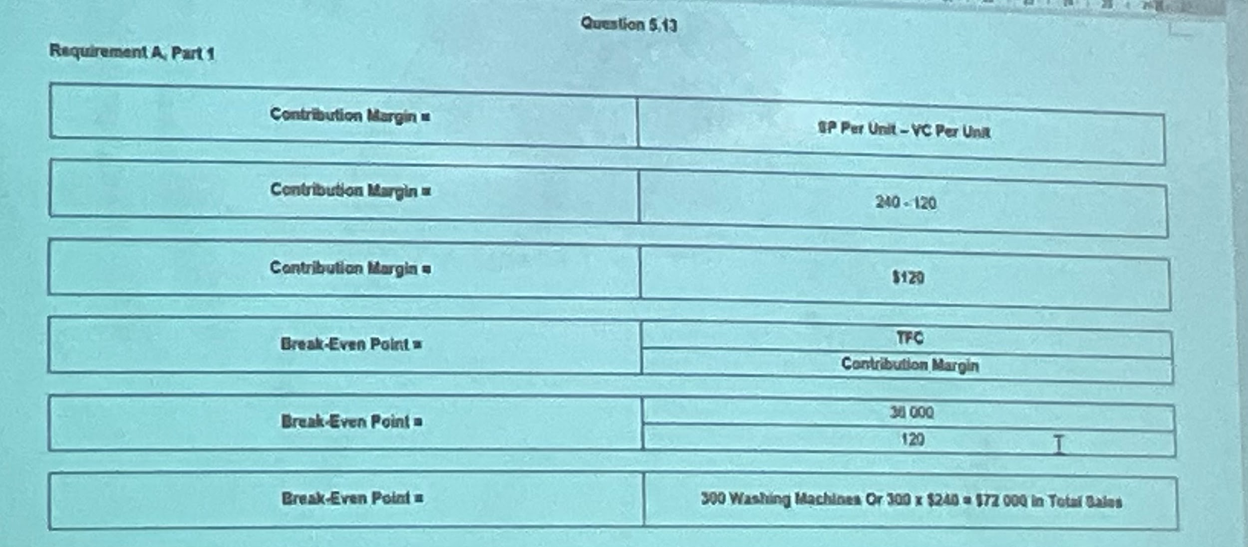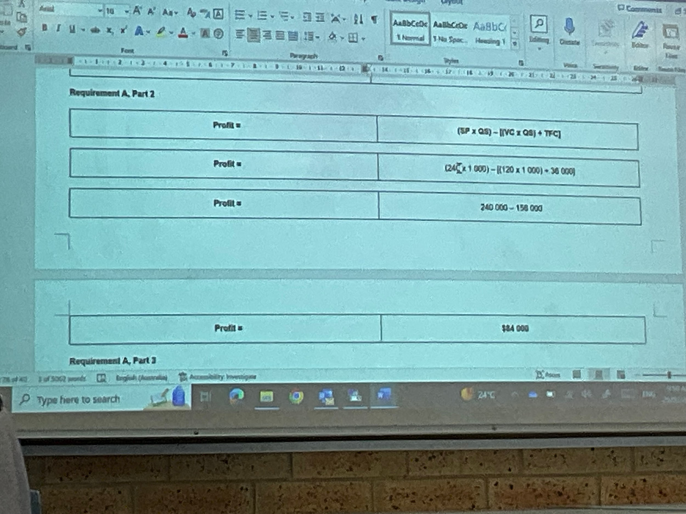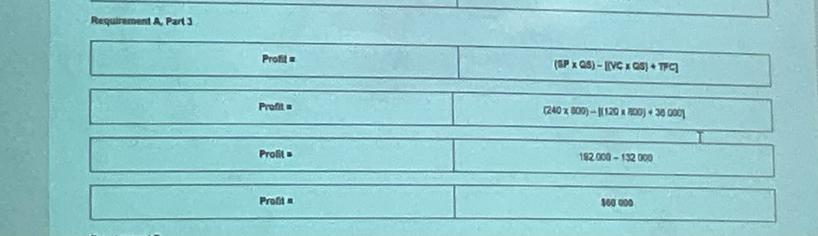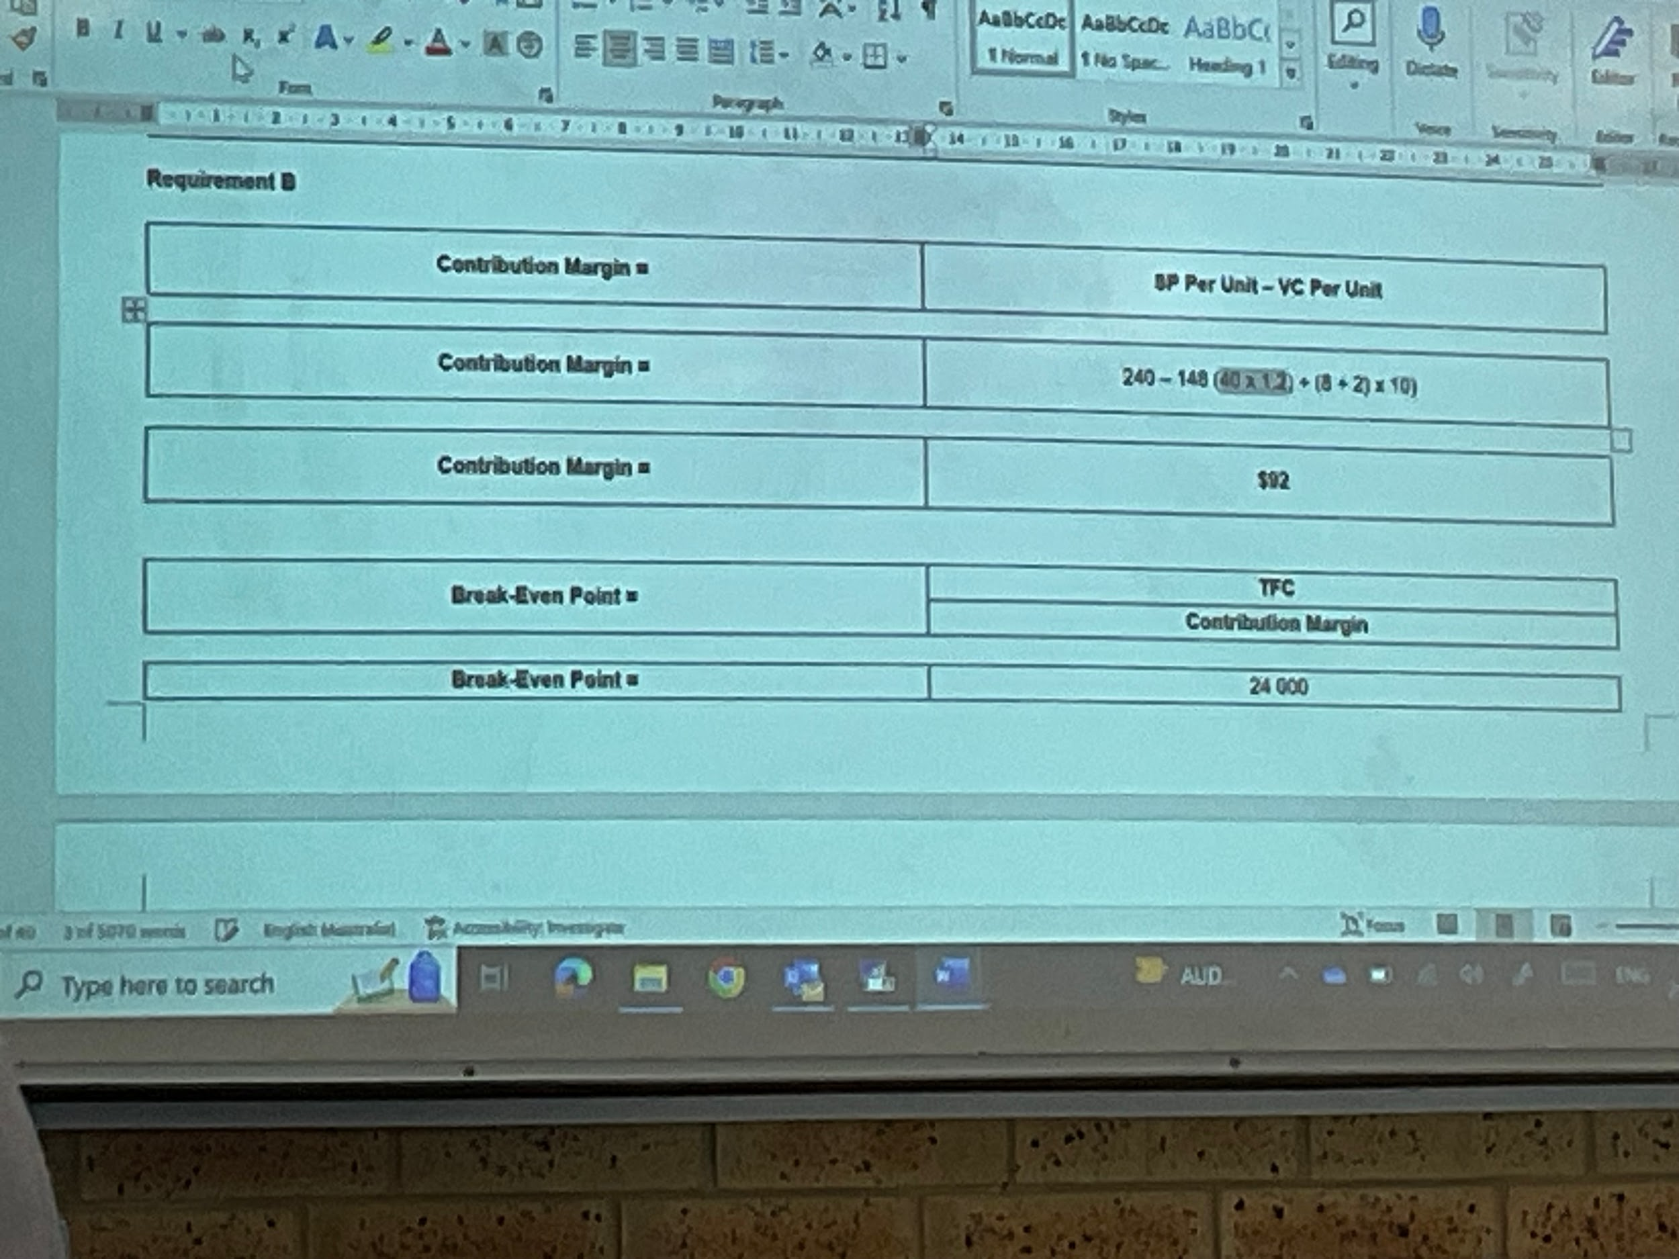
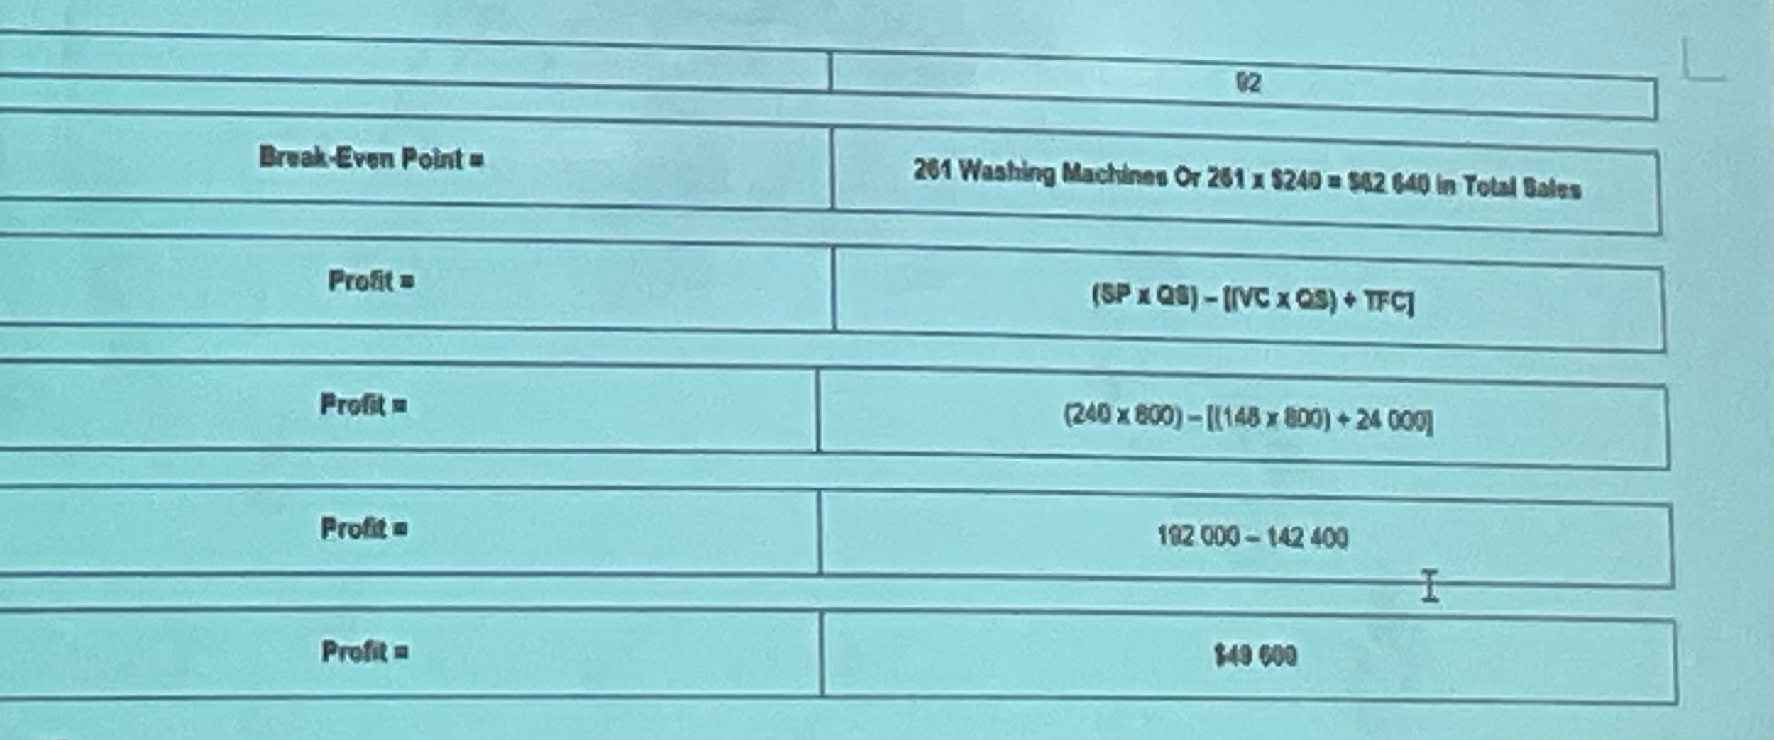
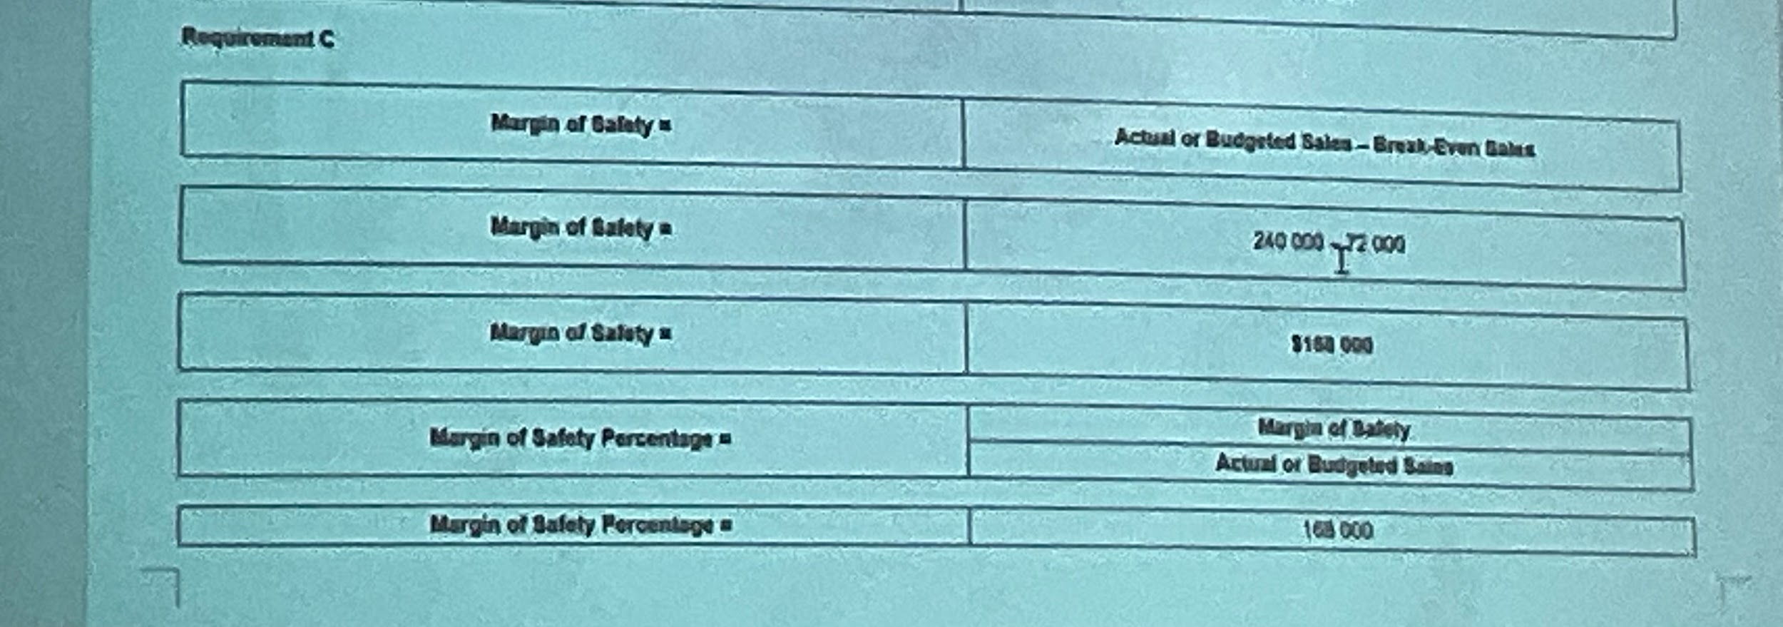
MOS% = 168000/240000
= 70%

25/3/24

5.17
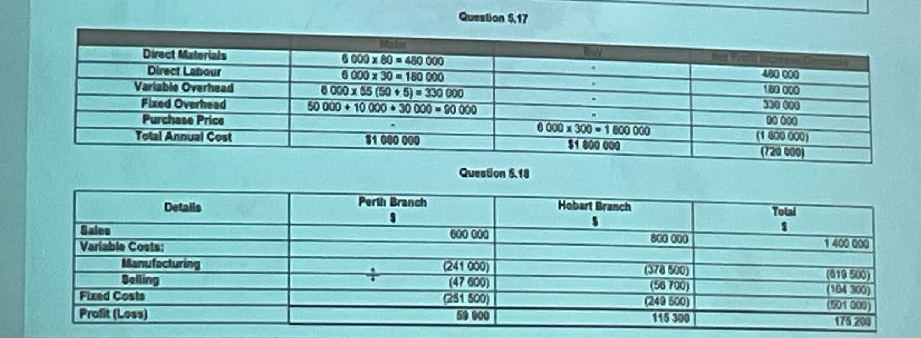

5.18
Perth branch
Sales: 600000
Variable costs (manufacturing): (241000)
(Selling): (47600)
Fixed costs: (185000) + 190000(0.7)(0.5) = (251500)
Profit(loss) = 59900

Hobart branch:
Sales: 800000
Variable costs (manufacturing): (378500)
(Selling): (56700)
Fixed costs: (183000) + 190000(0.7)(0.5) = (249500)
Profit(loss) = 115300

Total profit = $175200

5.19
- SM% for bedside lamp = 4000 / (4000 + 3000)
= 57%
SM% for room lamp = 3000 / 7000
= 43%

- WACM (per unit) = sum of [CM (per unit) * sales mix%]
CM (bedside lamp) = 90 - (30 + 10 + 20)
= $30

CM (room lamp) = 120 - (40 + 15 + 30)
= $35

WACM (per unit) = 30(0.57) + 35(0.43)
= $32

- BEP (units) = TFC / WACM
= (120000 + 85000) / 32
= 6406 units

- Bedside lamp: CM per unit = 30
Hours to produce per unit = 1
CM per machine hour = $30

Lounge lamp: CM per unit = 35
Hours to produce = 1.5
CM per machine hour = $24

- 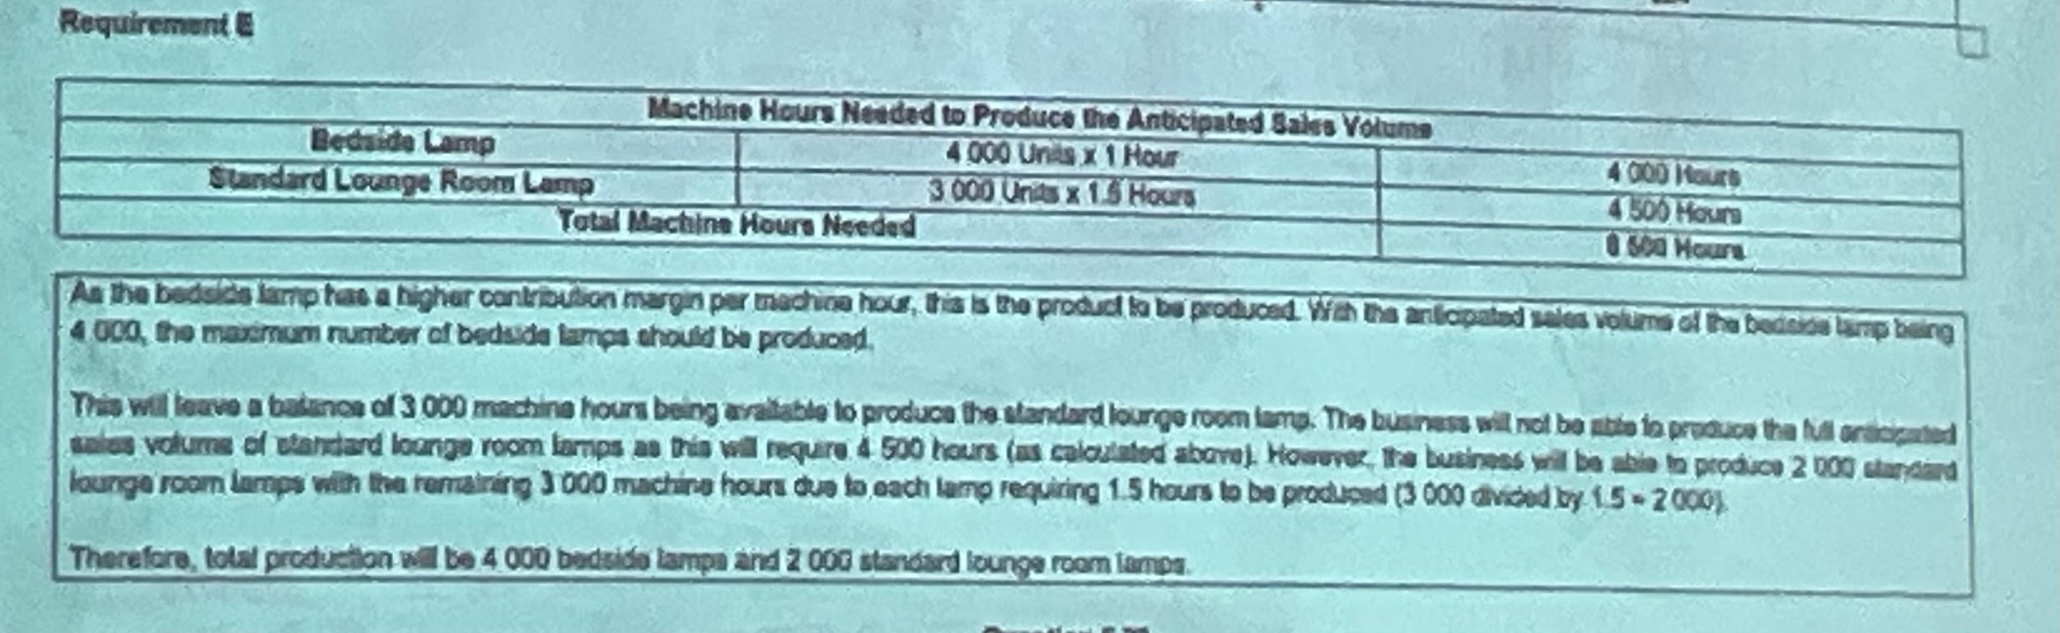

5.23
- Total capacity = 5000
Current production capacity = 6000

CM (normal production) = 450 - 210
= $240

Profit (normal production) = 450*5000 - 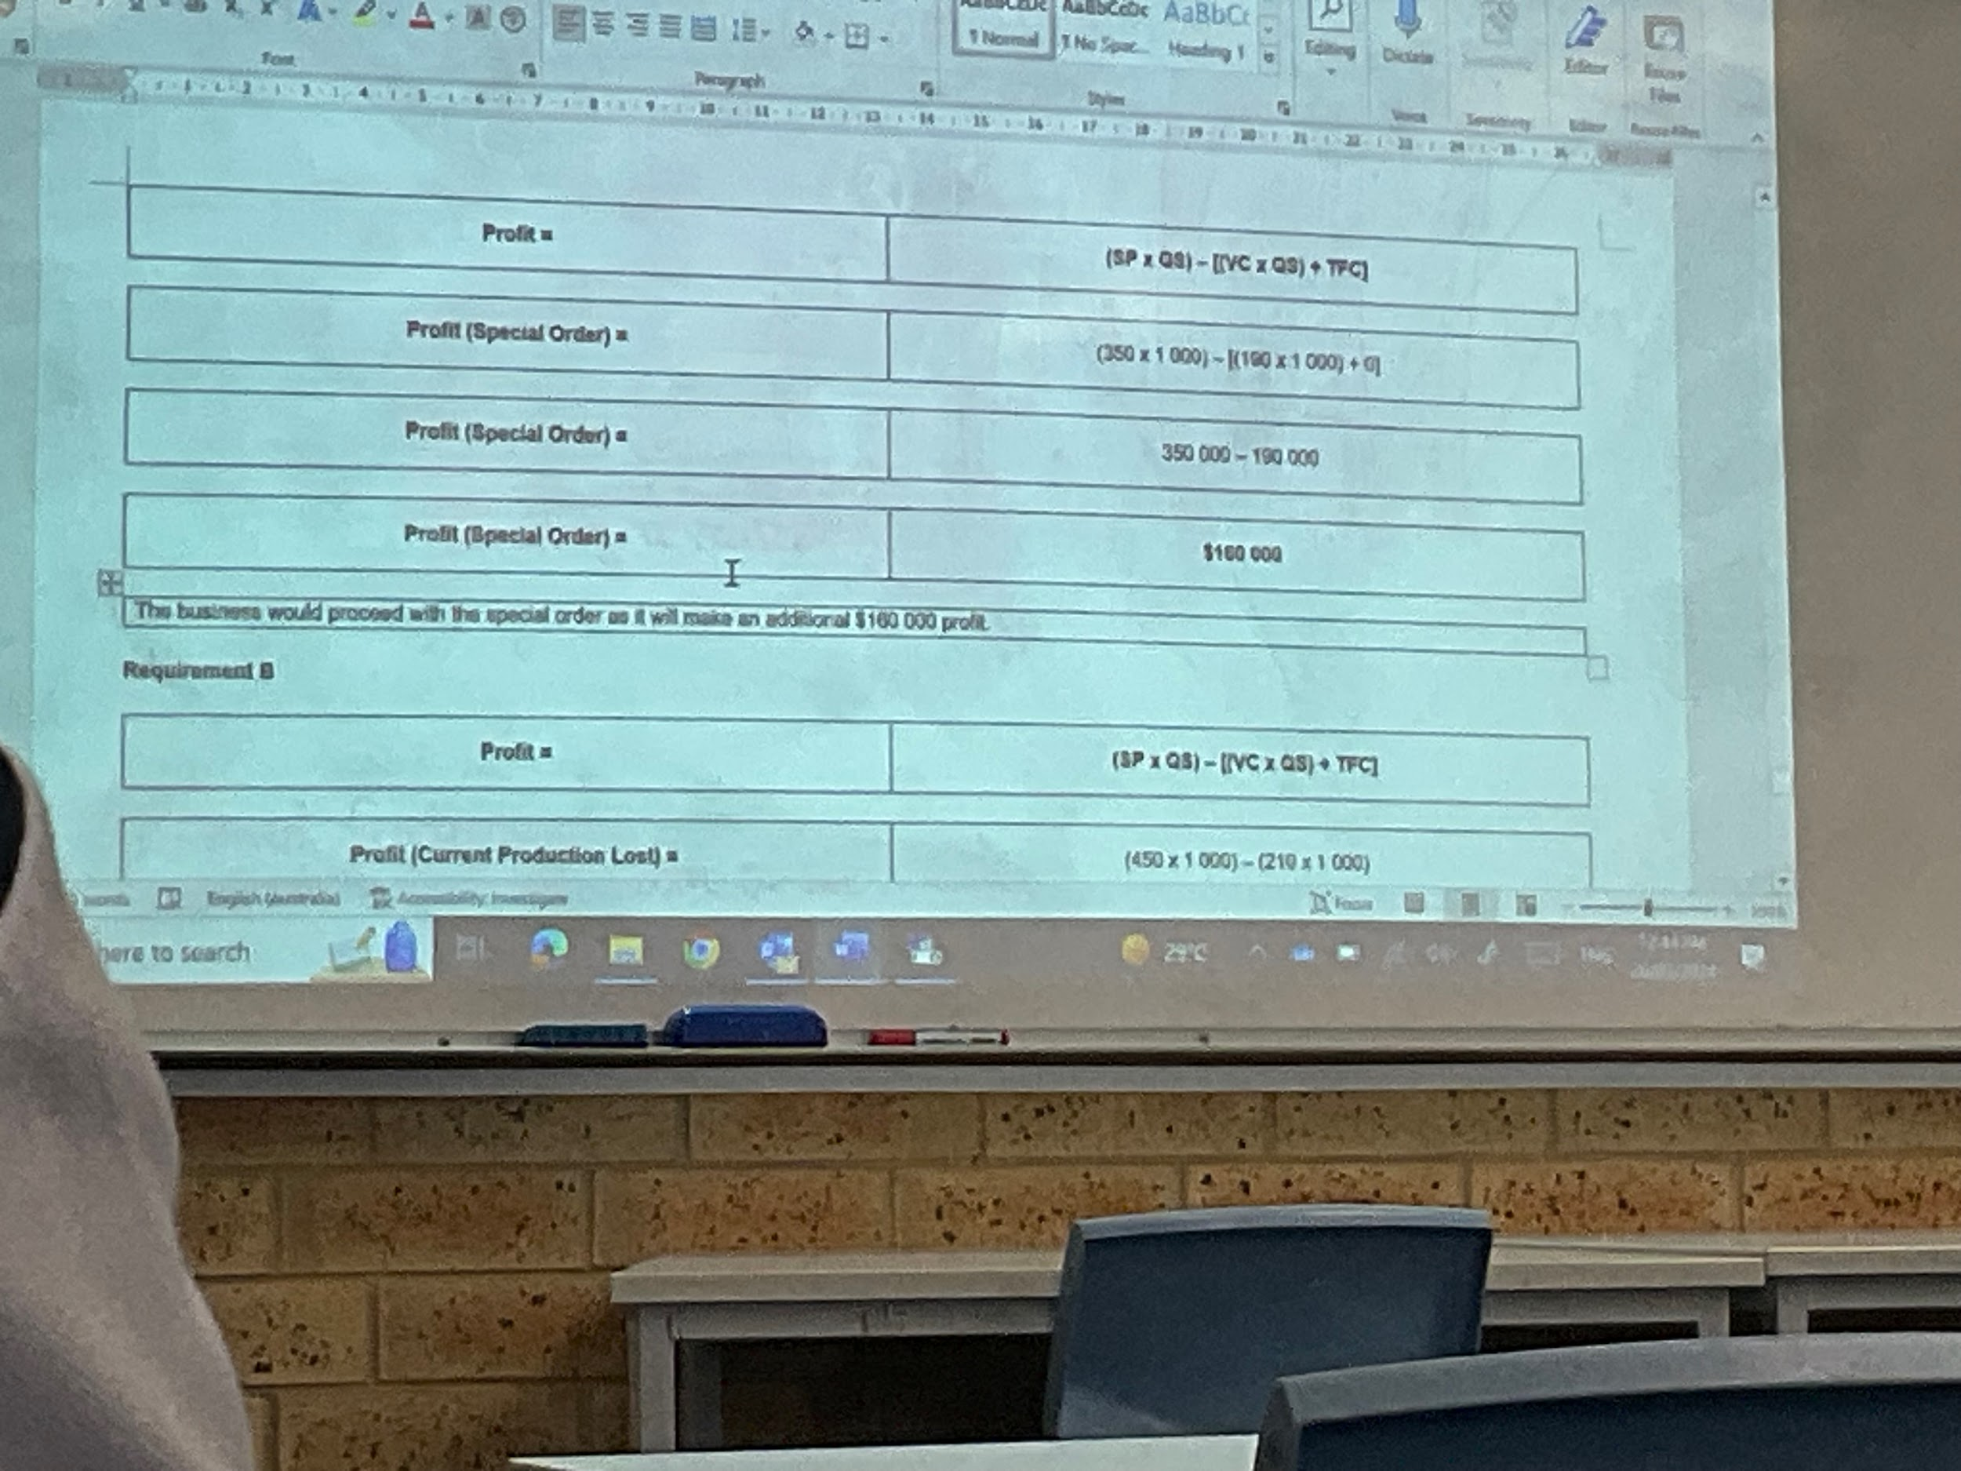

- 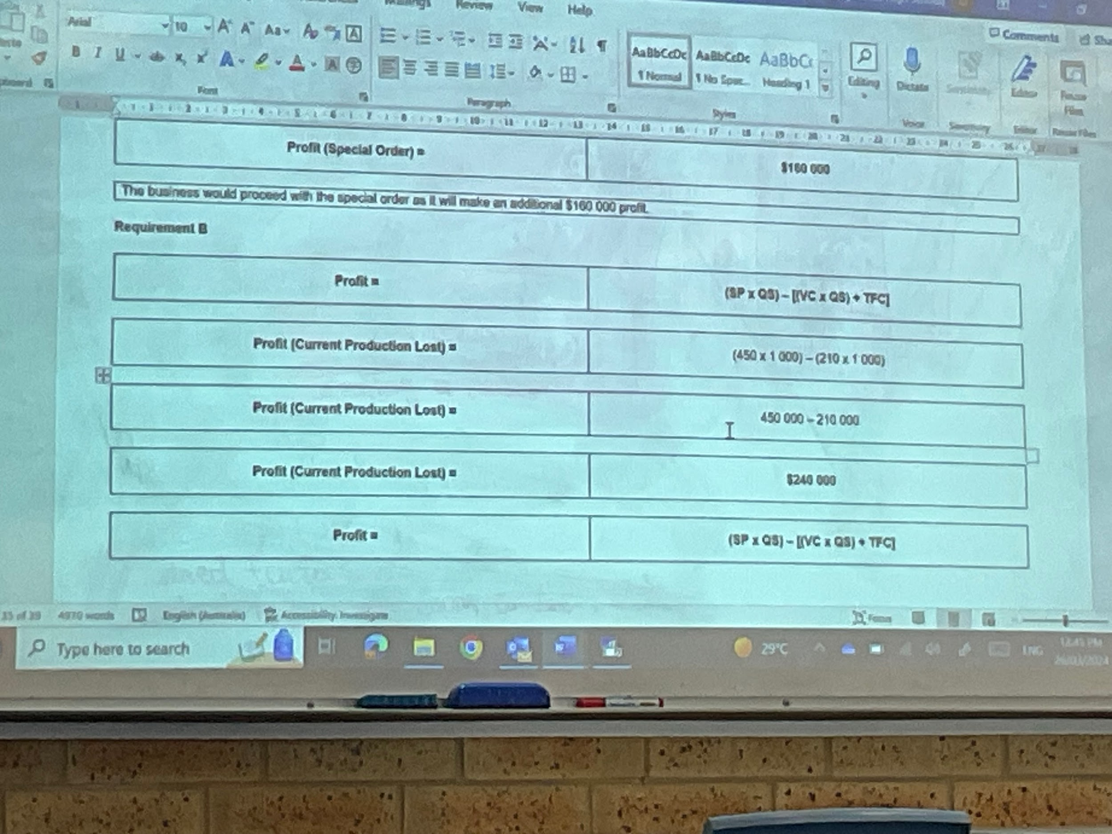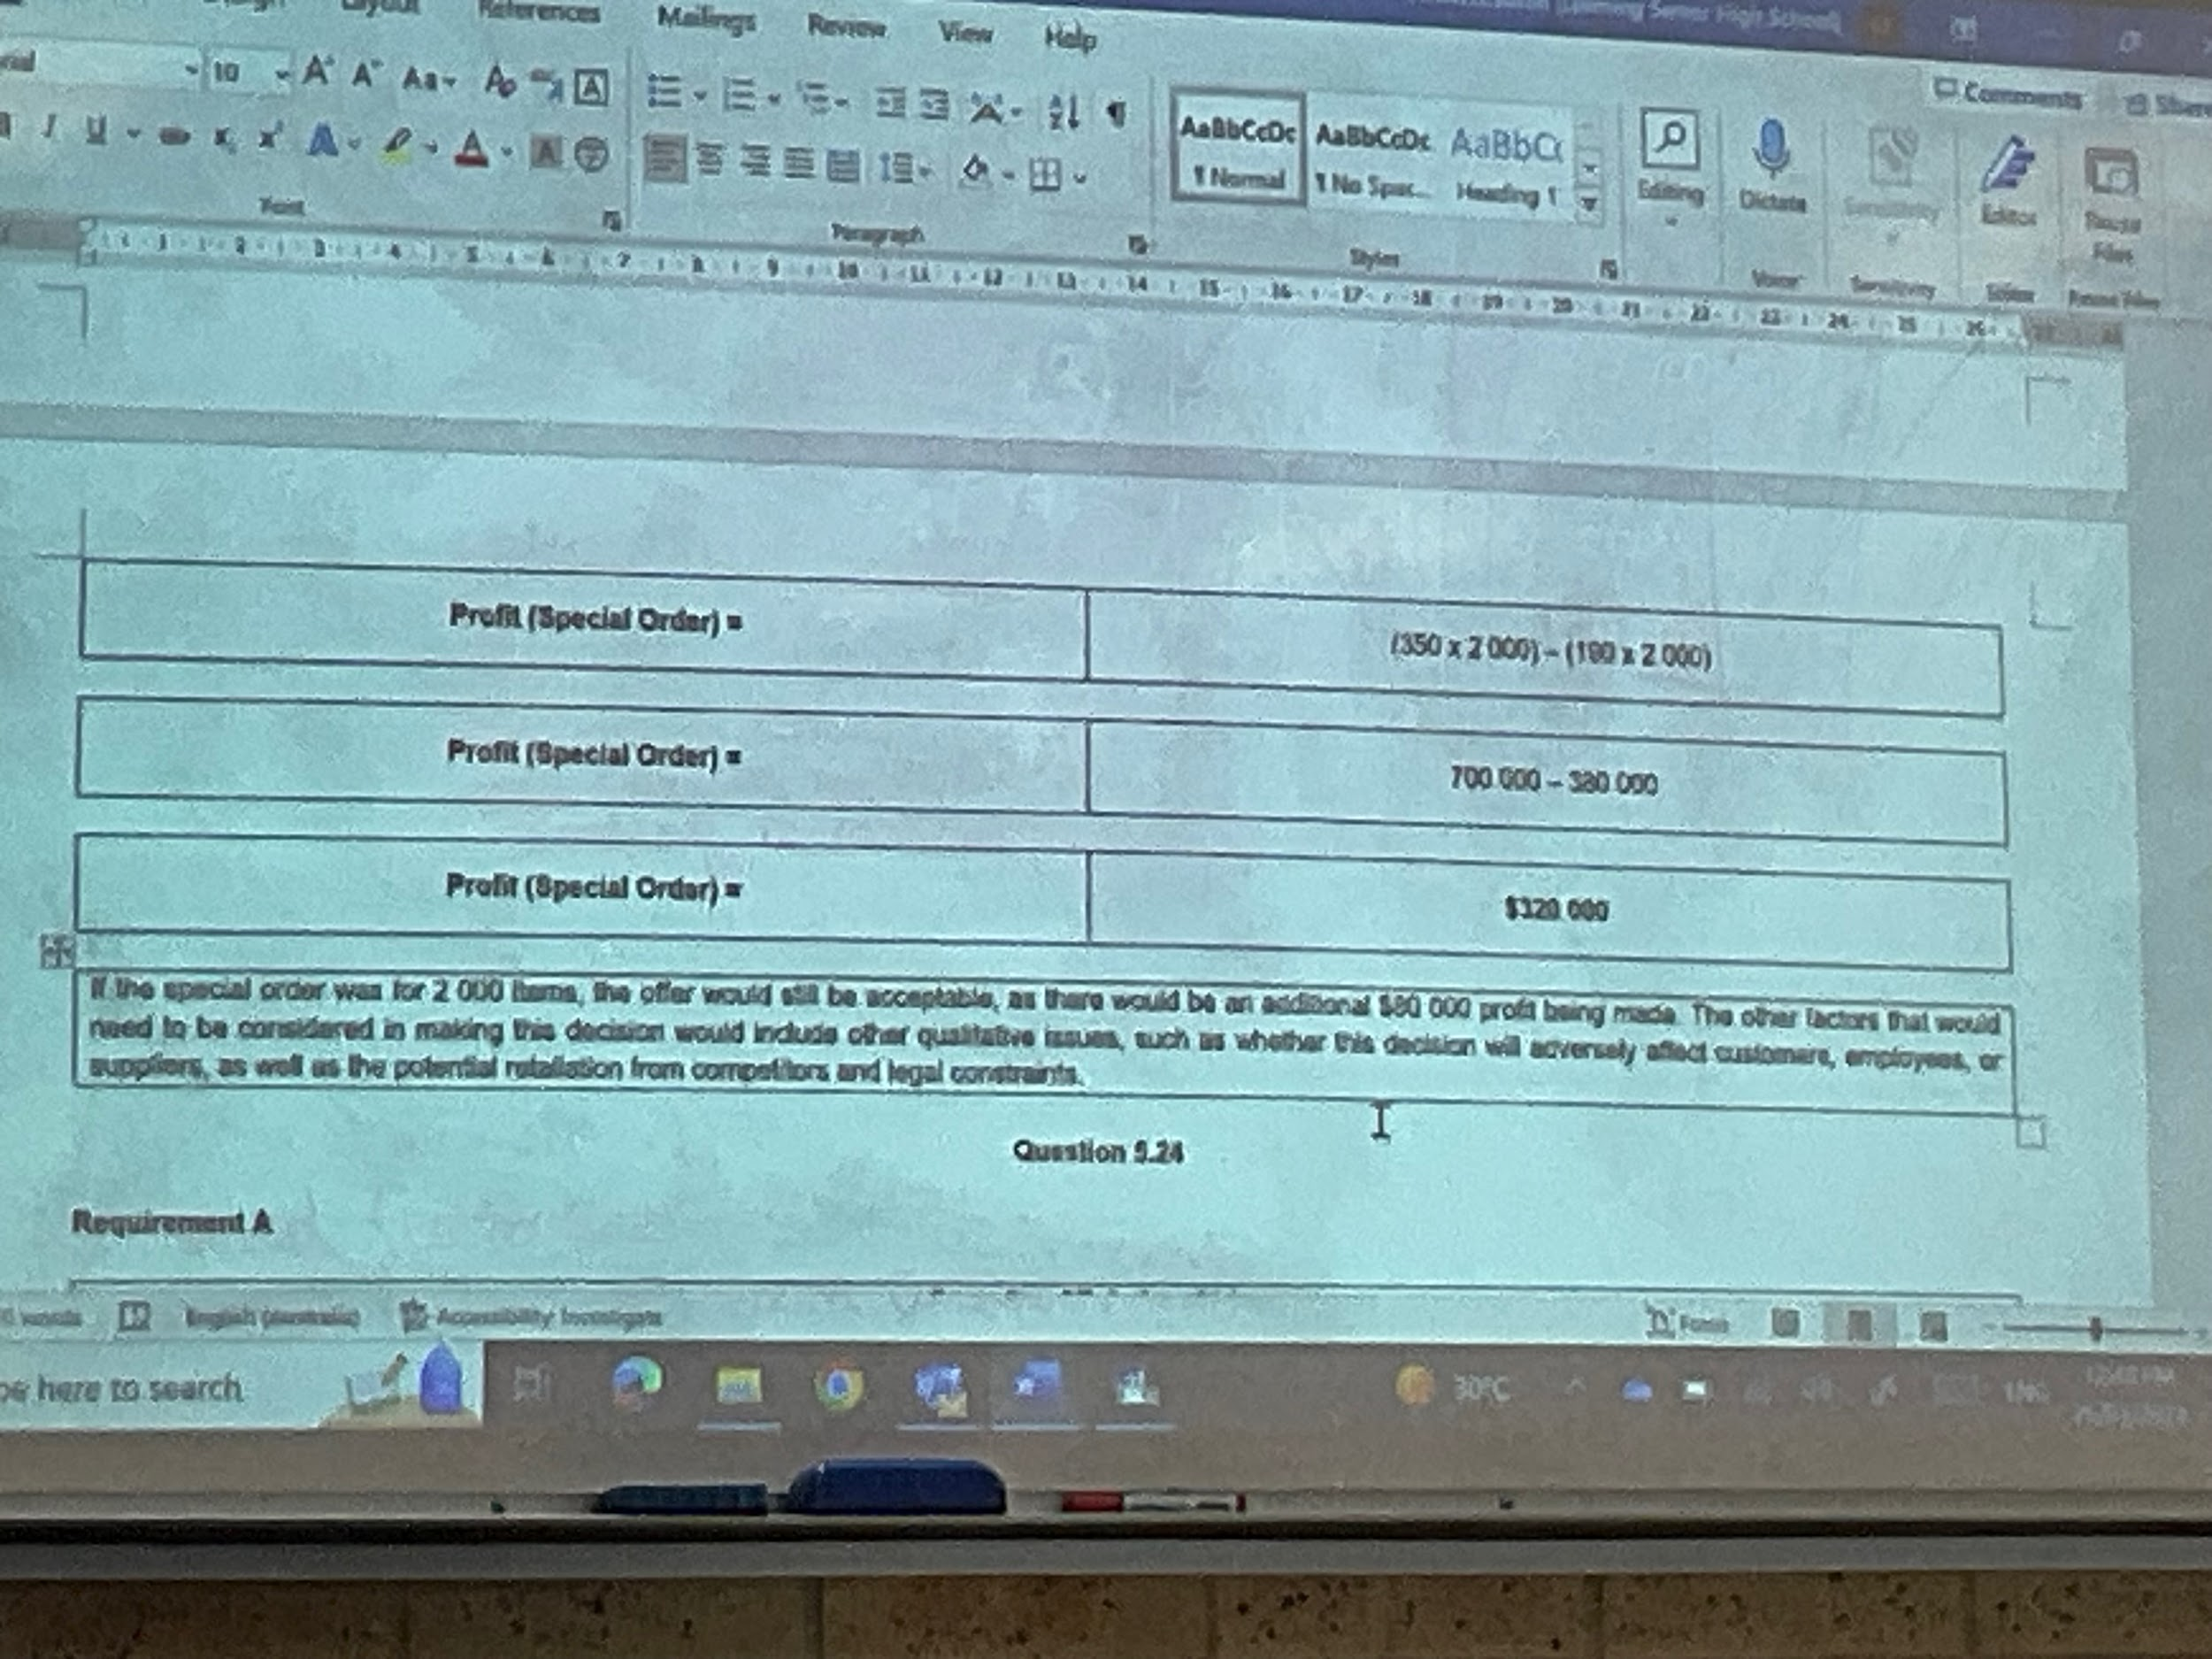

5.24
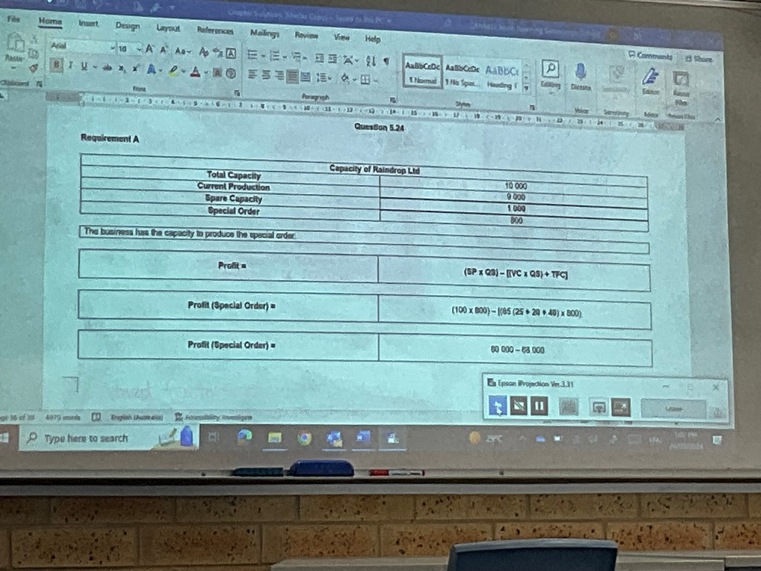

15/4/24

14. List budgets that would possibly contribute to a master budget for:
- A manufacturer: operating budgets such as the sale plan which will link to the level of production and all related aspects of required materials, labour and overhead costs.
- A retailer: operating budgets such as budgets for costs of sales, cost of goods, purchases and inventory, marketing, advertising
- A service business:
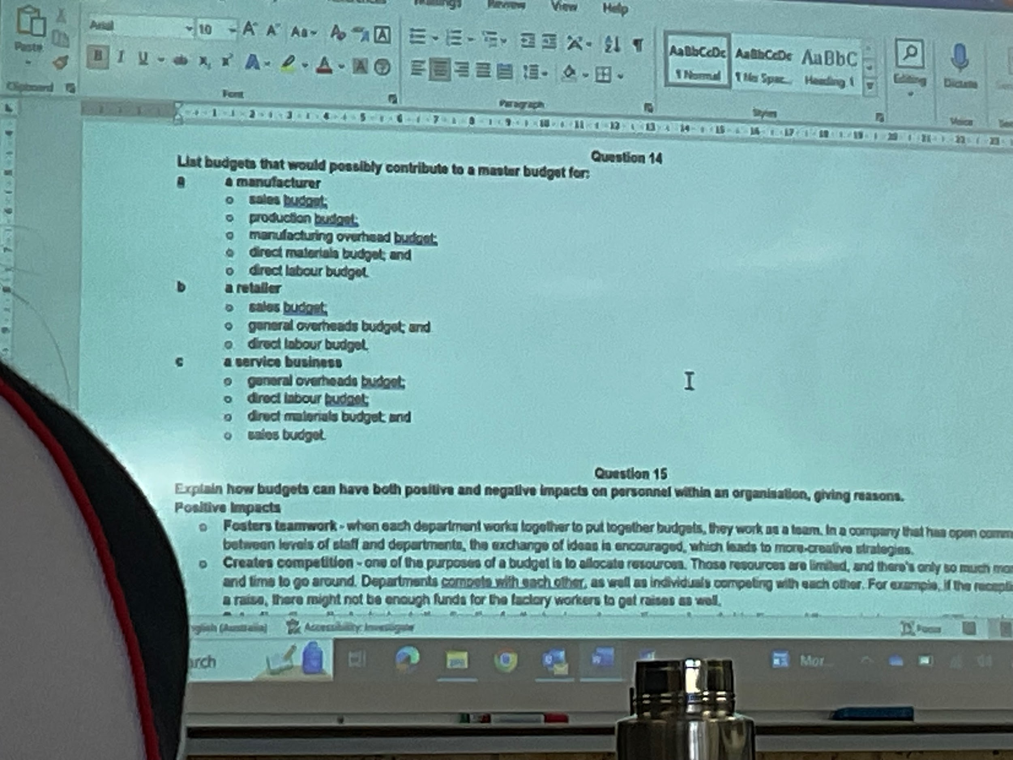

19/4/24

2.3
July: $115500
Credit: $46200
Cash: $69300

August: $119900
Credit: $47960
Cash: $71940

September: $123200
Credit: $49280
Cash: $73920

October: $132000
Credit: $52800
Cash: $79200

November: $165000
Credit: $66000
Cash: $99000

December: $193600
Credit: $77440
Cash: $116160

Months | total sales | credit sales (40%) | October | November | December
July | 115500 | 46200 | 13860
August | 119900 | 47960 | 14388 | 14388
September | 123200 | 49280 | 19121* | 14784 | 14784
October | 132000 | 52800 |  | 20486* | 15840
November  December | 165000  193000 | 66000  77440 |  |  | 25608
Total |  |  | $47369 | $49658 | $56232
discount given |  |  | $591 | $634 | $792

*3% discount deducted for prompt payment

2.4
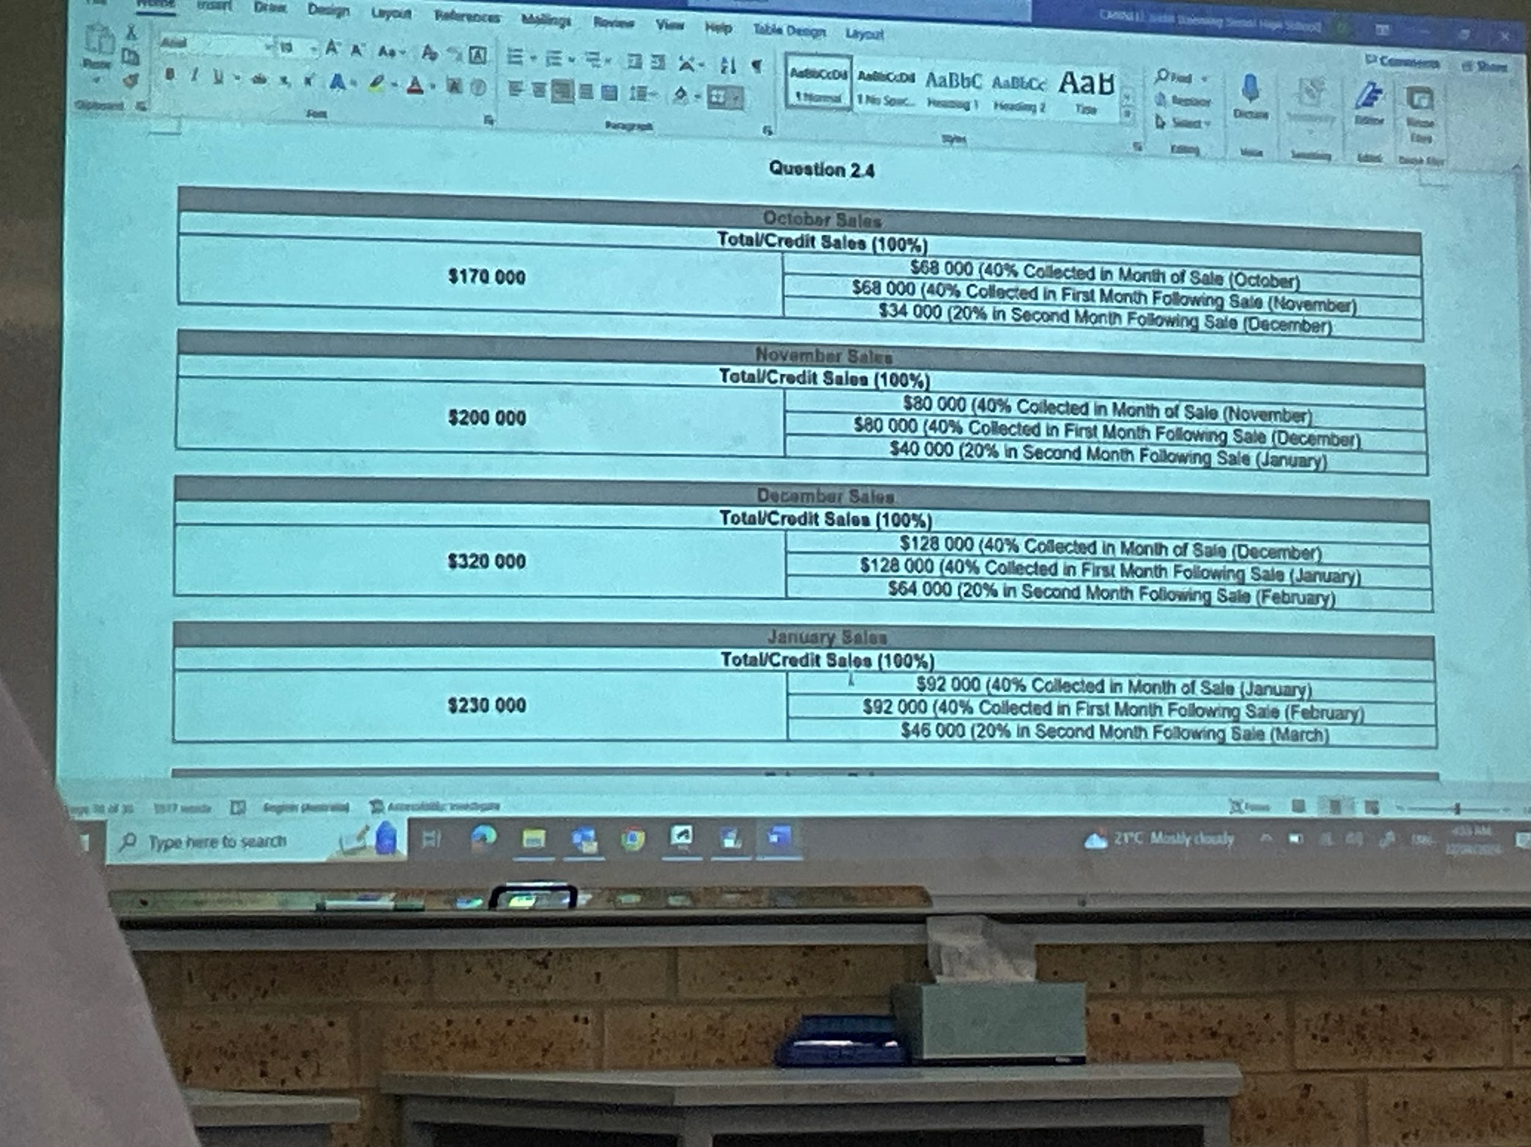

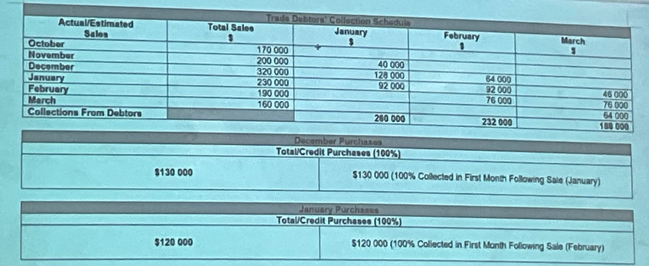
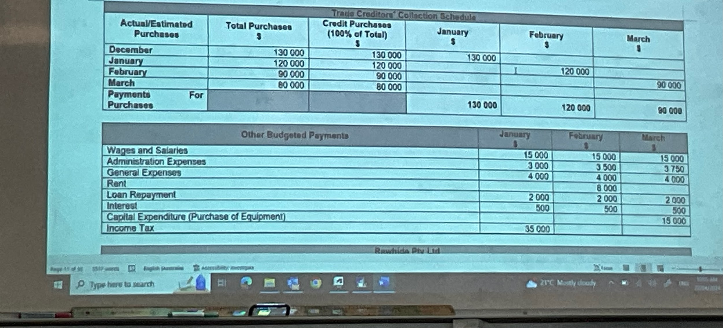
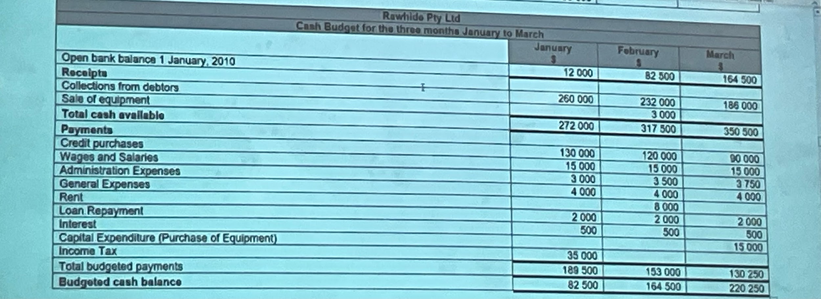

28/4/24

Credit sales
July: 53460
August: 53988
September: $59400
October: $52800
November: 46200

Debtors receivable Collection Schedule
Actual/Estimated  Purchases | Credit Purchases  (60% of Total)  $ | October  $ | November  $
July | 53460 | 5346
August | 53988 | 10798 | 5399
September | 59400 | 41580 | 11880
October | 52800 |  | 36960
November | 46200
Collections from debtors |  | 57724 | 56969
cash sales (40% of total) |  | 35200 | 30800
Budgeted cash. 929924. 85039

Cheung Pty Ltd
Cash Budget for the two months October and November
 | October  $ | November  $
Open Bank Balance 1 October 2010 | 16900 | 4944
Receipts
Collections from Debtors  Cash sales | 57724  35200 | 54229  30800
Equipment sale | 4400
Bank Loan |  | 20000
Total cash available | 114224 | 109963
Payments
Credit Purchases | 43120* | 32340*
Salaries and Wages | 12400 | 12500
Electricity | 5610 | 4202
Advertising | 8200 | 7600
Office Admin Expenses | 15400 | 14500
Loan Repayment | 3000
Interest Expense | 500
Equipment Maintenance | 2100 | 1730
Annual Copier Service | 360
Entertainment and Hospitality | 600
Dividends | 17000
Travel |  | 725
Cleaning  Capital expenditure (eq) | 990 | 990  25080
Total Budgeted Payments | 109280 | 99667
Budgeted Cash Balance | 4944 | 10316
*Discount received of 2%

Cheung Pty Ltd
Budgeted Income Statement for the two months ending 30 November 2010
 | $
Sales | 165000
Less Cost of Sales | (90750)
Gross Profit  add other operating income  Discount revenue  Total income | 74250  1540  75790
Expenses
Advertising | 15800
Salaries and wages | 25000
Equipment Depreciation | 1600
Insurance  Office admin | 1100  29000
Total Expenses | 43500
Budgeted Profit (Before Taxation)
Income Taxation
Budgeted Profit (After Taxation)

Tiggy WInkle Pty Ltd
Budgeted Income Statement for April - June 2024
 | $
Sales | 950250
Less Cost of Sales | (403590)
Gross profit | 546560
Total income
Operating Expenses
EFTPOS Fees | 1996
Depreciation on plant and equipment | 9000
Interest | 180
Rent | 5500
Advertising | 4800
General running costs | 15600
Administration costs | 12600
Salary | 11800
Insurance | 625
Total expenses | 62101
Budgeted Profit (Before Taxation) | 484559
Income Taxation | 145368
Budgeted Profit (After Taxation) | $339191

Badawi Suppliers
cash performance report for the month of December 2011
 |  |  | $
Sales |  |  | 950250
Less Cost of Sales |  |  | (403590)
Gross profit |  |  | 546560
Total income
Operating Expenses
EFTPOS Fees |  |  | 1996
Depreciation on plant and equipment |  |  | 9000
Interest |  |  | 180
Rent |  |  | 5500
Advertising |  |  | 4800
General running costs |  |  | 15600
Administration costs |  |  | 12600
Salary |  |  | 11800
Insurance |  |  | 625
Total expenses |  |  | 62101
Budgeted Profit (Before Taxation) |  |  | 484559
Income Taxation |  |  | 145368
Budgeted Profit (After Taxation) |  |  | $339191

8/5/23
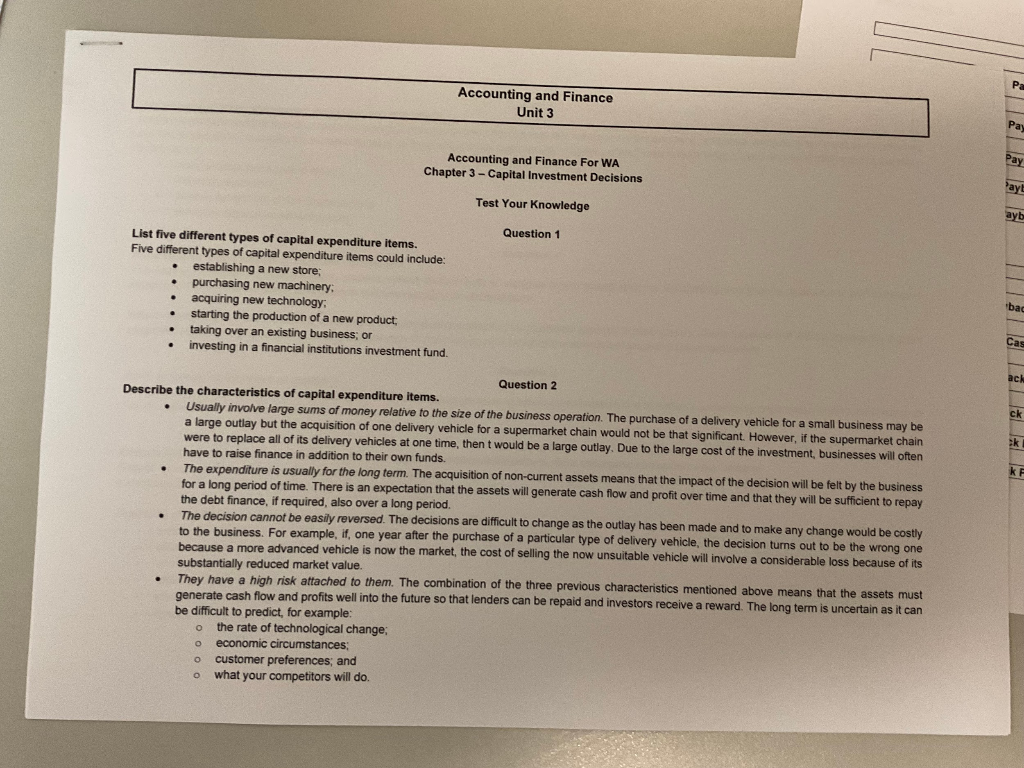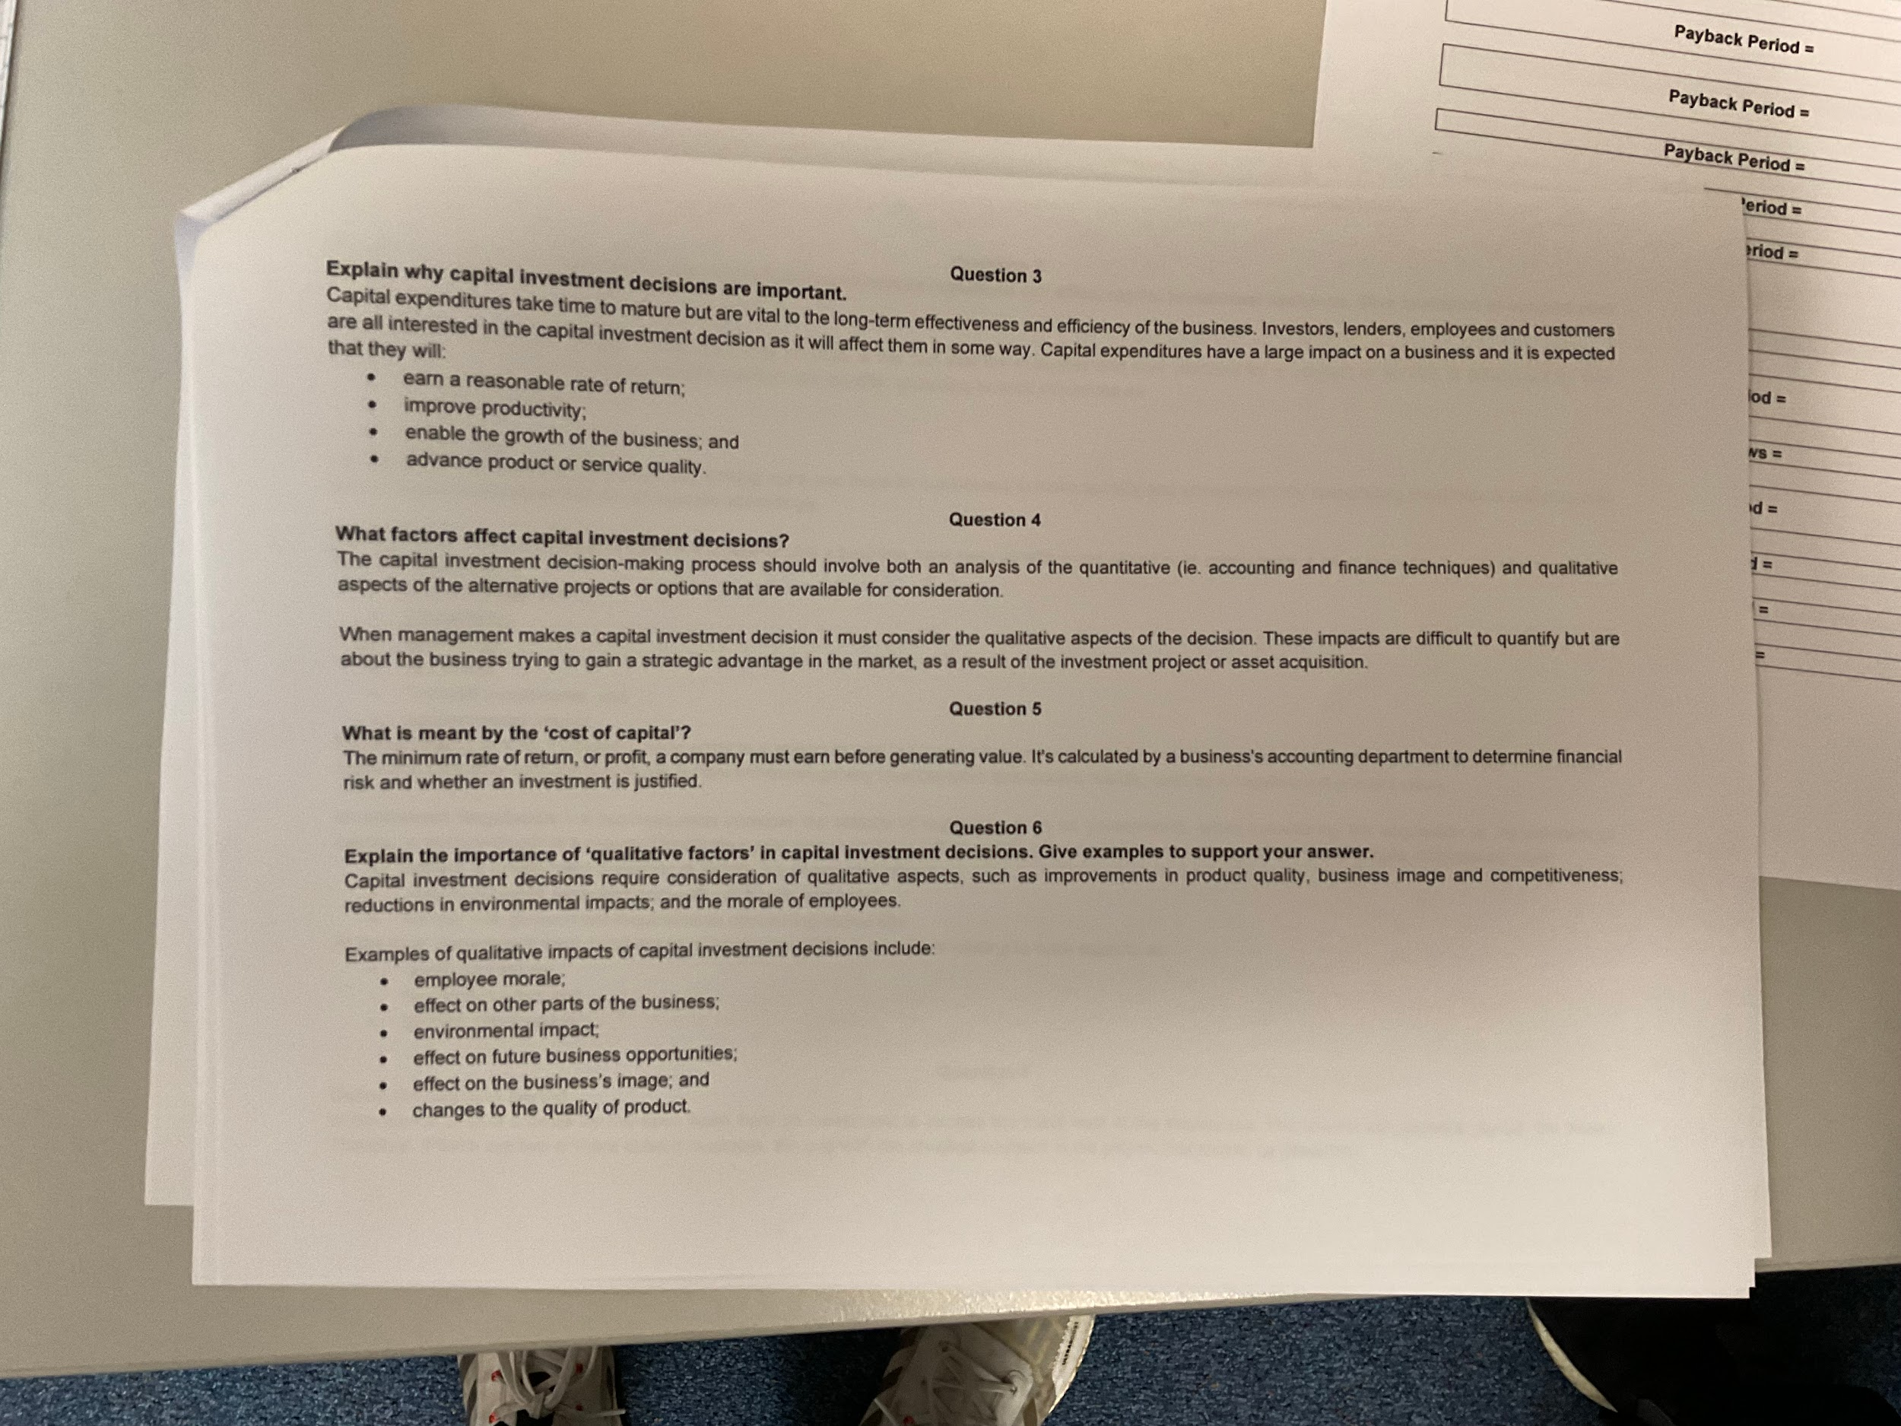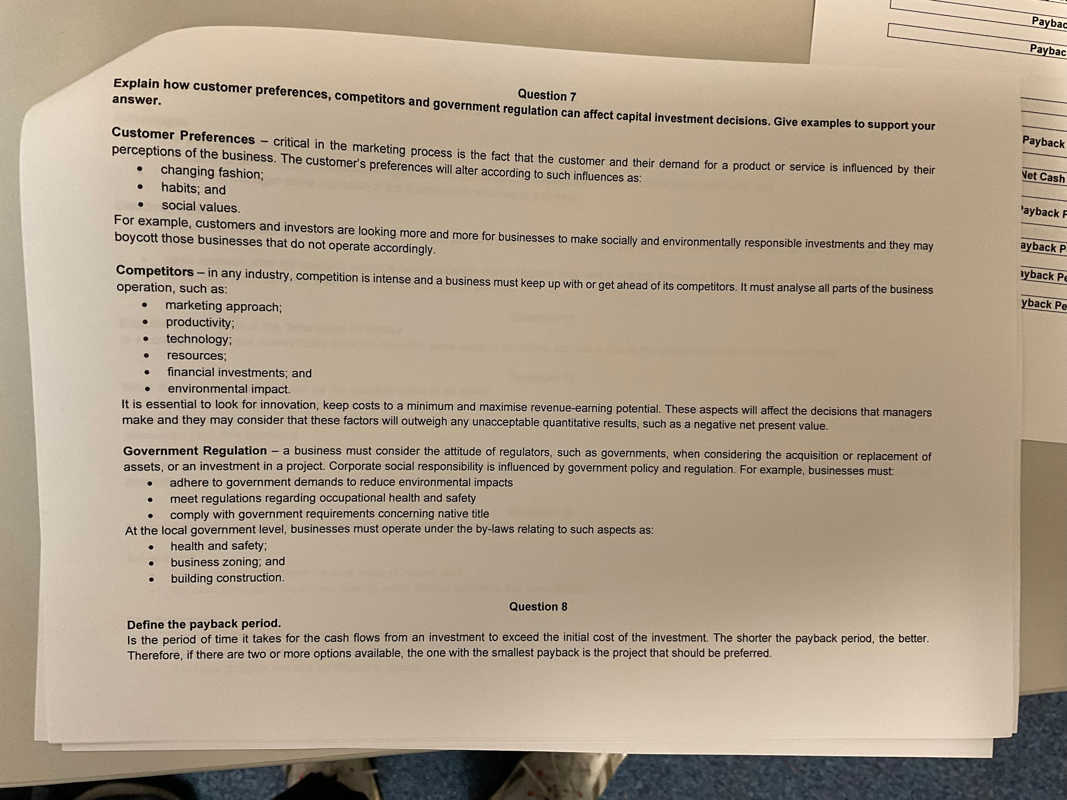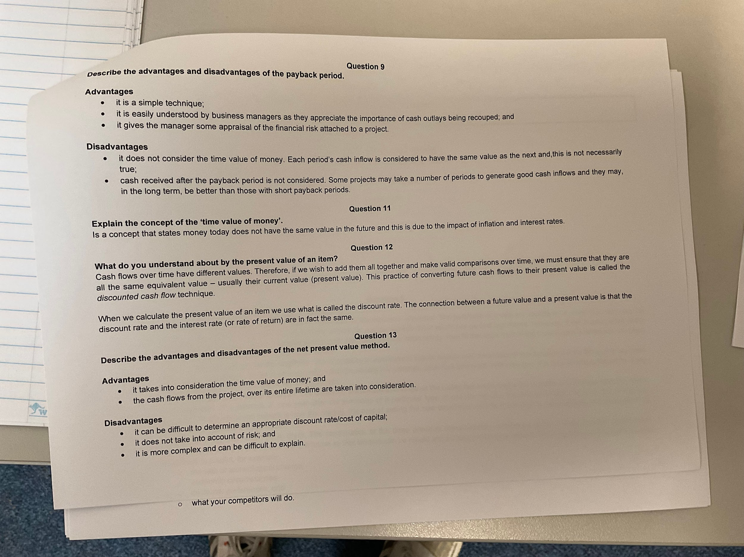

3.3
A: 40000 / 11000 = 3 years 8 months
B: 50000 / 13000 = 3 years 11 months
A has more risk

10/5/24

